Harold’s Statistics
Linear Regression Analysis
Cheat Sheet
24 June 2022

Simple Linear Regression (SLR)

Term | Formula | Description
Problem Statement | Predictive Analytics: How do we make predictions on quantitative variables from historical data using a single predictor variable?
Response Variable | $$Y$$ | Output, outcome, dependent variable
Predictor Variable | $$X$$ | Input, covariate, independent variable
Least-Squares Regression Line | $$E\left(Y\right)=β_{0}+β_{1}X$$  $$\hat{Y}=b_{0}+b_{1}X$$ | $\hat{Y}$ is the sample estimate  $β_{0} and b_{0}$ are y-intercepts (population vs. sample)  $β_{1} and b_{1}$ are slopes (population vs. sample)  $\left(\overline{x},\overline{y}\right)$ is always a point on the line
Regression Error | $$ε=\hat{Y}-E(Y)$$  $$Y=b_{0}+b_{1}X+ε$$ | ε is a random variable with:  1) a normal distribution  2) that has a zero mean,  3) constant variance, and  4) the values are independent.  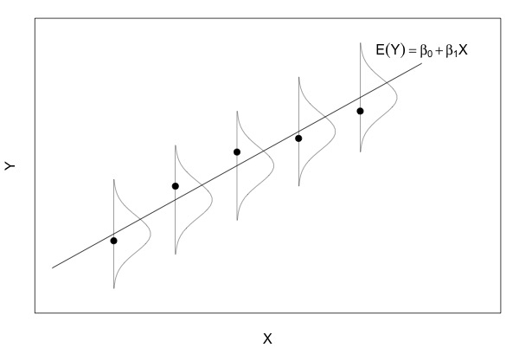
Method of Absolute Errors | $$\sum_{i=1}^{n}{\left|Y_{i}-β_{0}-β_{1}X_{i}\right|}$$ | Minimize the sum of the magnitude of errors
Method of Least Squares | $$\sum_{i=1}^{n}{{\left(Y_{i}-β_{0}-β_{1}X_{i}\right)}^{2}}$$ | Minimize the sum of squared errors
Regression Coefficient (Slope) | $$b_{1}=\frac{\sum{\left(X_{i}-\overline{X}\right)\left(Y_{i}-\overline{Y}\right)}}{\sum{{\left(X-\overline{X}\right)}^{2}}}$$  $$b_{1}=R\frac{s_{y}}{s_{x}}$$ | $b_{1}$ is the slope
Regression Slope Intercept | $$b_{0}=\overline{Y}-b_{1}\overline{X}$$ | $b_{0}$ is the y-intercept
Residual Standard Error | $${\hat{e}}_{i}=Y_{i}-{\hat{Y}}_{i}$$  $$\sum{e_{i}}=\sum{\left(Y_{i}-{\hat{Y}}_{i}\right)=0}$$  $${\hat{e}}_{i}=Y_{i}-\left(b_{0}+b_{1}X\right)$$ | Linear Regression Residual = Observed – Predicted  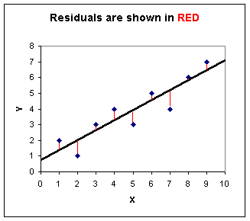
Python | import numpy as np  import scipy.stats as st  x = np.array([0, 3, 7, 10])  y = np.array([5, 5, 27, 31])  print(st.linregress(x,y)) |  | LinregressResult (slope=3.0, intercept=2.0, rvalue=0.9454288003008773, pvalue=0.054571199699122705, stderr=0.7310832774866965, intercept_stderr=4.594787151274503)
Standard Error of Regression Slope (s) | $$s_{b_{1}}=\frac{\sqrt{\frac{\sum{e_{i}^{2}}}{n-2}}}{\sqrt{\sum{{\left(X_{i}-\overline{X}\right)}^{2}}}}= \frac{\sqrt{\frac{\sum{{\left(Y_{i}-Y_{i}\right)}^{2}}}{n-2}}}{\sqrt{\sum{{\left(X_{i}-\overline{X}\right)}^{2}}}}$$ |  | Measures how spread out the Y variables are around the mean, μ.  The smaller the “s” value, the closer the values are to the regression line.

SLR Correlation and Coefficient Determination

Term | Formula | Description
Problem Statement | How well does our regression line predict the actual data?
Correlation | Describes the association or dependence between two variables
Perfect Positive Correlation | Strong Positive Correlation | Weak Positive Correlation
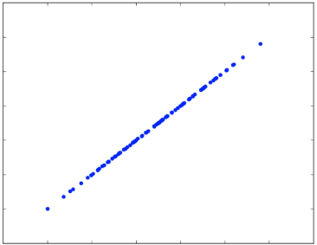 | 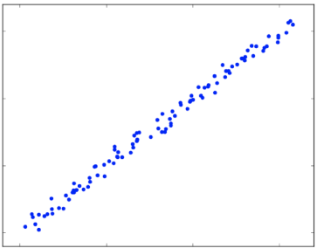 | 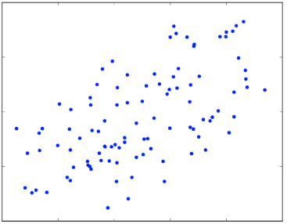
Linear Correlation Coefficient (Sample) | $$R=\frac{1}{n-1}\sum{\left(\frac{X-\overline{X}}{s_{x}}\right)\left(\frac{Y-\overline{Y}}{s_{y}}\right)}$$  $$R=\frac{g}{s_{x}s_{y}}$$ | Strength and direction of linear relationship / dependence between x and y.  $R=±1$ Perfect correlation  $R=+0.9$ Positive linear relationship  $R=-0.9$ Negative linear relationship  $R=\sim 0$ No relationship  Correlation Strength |R|:  $0.80<|R|≤1.00$ Strong  $0.40<|R|≤0.80$ Moderate  $0<|R|≤0.40$ Weak  Correlation DOES NOT imply causation.
Pearson Correlation Coefficient | $$R=\frac{n\sum{xy}-\left(\sum{x}\right)\left(\sum{y}\right)}{\sqrt{n\left(\sum{x^{2}}\right)-{\left(\sum{x}\right)}^{2}} \sqrt{n\left(\sum{y^{2}}\right)-{\left(\sum{y}\right)}^{2}}}$$
Correlation Matrix | A table that shows the correlation coefficients between each pair of variables.
Python | import pandas as pd  scores = pd.read_csv("ExamScores.csv")  print(scores[['Exam1','Exam2']].corr())
 | Exam1 | Exam2
Exam1 | 1.000000 | 0.078613
Exam2 | 0.078613 | 1.000000

t-test for the Population Correlation Coefficient (ρ) | $$t=\frac{R\sqrt{n-2}}{\sqrt{1-R^{2}}}$$ | A t-distribution with n-2 degrees of freedom.  Hypotheses:  H₀ : ρ = 0  H_{a} : ρ > 0 (right-tailed)  H_{a} : ρ < 0 (left-tailed)  H_{a} : ρ ≠ 0 (two-tailed)
Python | import pandas as pd  import scipy.stats as st  scores = pd.read_csv("ExamScores.csv")  st.pearsonr(scores['Exam1'],scores['Exam4'])
(R=0.2613,
two-tailed-p-value=0.06681)
Coefficient of Determination (R²) | $$R^{2}=\frac{explained variance}{total variance}$$  $$R^{2}=\frac{\sum{{\left({\hat{Y}}_{i}-\overline{Y}\right)}^{2}}}{\sum{{\left(Y_{i}-\overline{Y}\right)}^{2}}}$$  $$0≤R^{2}≤1$$ | A measure of how closely the regression line follows the pattern of the data, or how well the line ﬁts the data.  Measures the amount of variation in the dependent variable that is explained by the model.  Represents the percent of the data that is the closest to the line of best fit. Determines how certain we can be in making predictions.  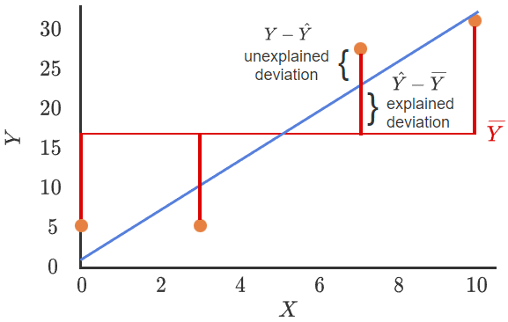
Python | import pandas as pd  import statsmodels.api as sm  from statsmodels.formula.api import ols  scores = pd.read_csv('ExamScores.csv')  # Creates a linear regression model  results = ols('Exam4 ~ Exam1', data=scores).fit()  print(results.summary())  NOTE: Exam4 is the response variable, Exam1 is the predictor variable

Analysis of Variance (ANOVA)

Term | Formula | Description
Problem Statement | How do we measure both the explained and unexplained variances?
Residual Sum of Squares (SSE) | $$SSE=\sum{e_{i}^{2}}=\sum{{\left(Y_{i}-{\hat{Y}}_{i}\right)}^{2}}$$ | Estimator errors
Residual Degrees of Freedom (df) | $$df=n-p$$ | Number of regression parameters
Residual Mean Square (MSE) | $$MSE=\frac{SSE}{n-p}$$ | Measures the amount of error in statistical models. 0 = no error.  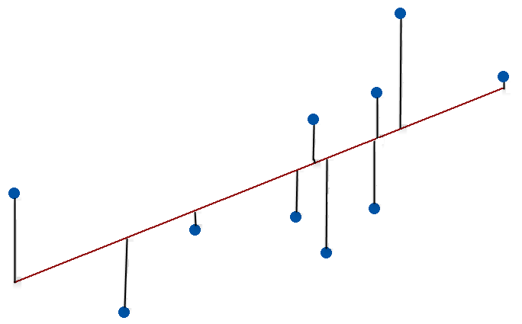
Residual Standard Error (s) | $$s=\sqrt{MSE}$$ | Estimates the standard deviation of the residuals
Python | import pandas as pd  import statsmodels.api as sm  from statsmodels.formula.api import ols  scores = pd.read_csv('ExamScores.csv')  # Creates a linear regression model  results = ols('Exam4 ~ Exam1', data=scores).fit()  print(results.summary())  # The explained and unexplained variance can be obtained from the analysis of variance table  aov_table = sm.stats.anova_lm(results, typ=2)  print(aov_table)
sum_sq df F PR(>F)
Exam1 217.166351 1.0 3.517655 0.066808
Residual 2963.333649 48.0 NaN NaN

Testing Simple Linear Regression Parameters

Parameter | Formula | Description
Problem Statement | Does the predictor variable actually contribute to accurate regression line response predictions?
Slope Parameter (b₁) | b₁ | b₁ estimates β₁.  If β = 0, then no linear relationship exists.  Sampling uncertainty could lead to a b₁ ≠ 0.
Test | 1. Hypotheses  H₀ : β₁ = 0  H_{a} : β₁ ≠ 0  2. t-statistic (t)  3. p-value (P>|t|)  4. Significance level α = 0.05 | If p-value < α, then reject H₀.  If p-value > α, then favor H₀.
Python | import pandas as pd  import statsmodels.formula.api as smf  df = pd.read_csv('Disease.csv')  model = smf.ols('Disease ~ Time', df).fit()  print(model.summary())
coef std err t P>|t|
-------------------------------------------------------
Intercept 21.0000 2.286 9.187 0.000
Time -2.0000 0.406 -4.924 0.001
Intercept Parameter (b₀) | Same as above. | This test is rare.
ANOVA F-test | The association between two variables can be tested using the ANOVA -test.  Since the population regression line E(Y) = β₀ + β₁X, determining whether an association exists between X and Y is equivalent to determining whether β ≠ 0.
Regression Sum of Squares (SSR) | $$SSR=\sum{e_{i}^{2}}=\sum{{\left({\hat{Y}}_{i}-\overline{Y}\right)}^{2}}$$ | A measure that describes how well our line fits the data.
Regression Degrees of Freedom (df) | $$df=p-1$$ | Number of regression parameters.  SLR has p = 2.
Regression Mean Square (MSR) | $$MSR=\frac{SSR}{p-1}$$ | Predicted mean-squared-anomaly.
Total Sum of Squares (SSTO) | $$SSTO=\sum{e_{i}^{2}}=\sum{{\left(Y_{i}-\overline{Y}\right)}^{2}}$$  $$SSTO=SSR+SSE$$ | Quantifies how much the data points, Y_{i}, vary around their mean, $\overline{Y}$.
Total Degrees of Freedom | $$df=n-1$$  $$n-1=\left(p-1\right)+(n-p)$$ | Total degrees of freedom = regression degrees of freedom + residual degrees of freedom.
Coefficient of Determination (R²) | $$R^{2}=\frac{SSTO-SSE}{SSTO}=\frac{SSR}{SSTO}$$ | Can also be calculated using ANOVA table.

Multiple Linear Regression (MLR)

Term | Formula | Description
Problem Statement | How do we make predictions on quantitative variables from historical data using multiple predictor variables?
Response Variable | $$Y$$ | Output, outcome, dependent variable
Predictor Variables | $$X_{1}, X_{2}, …, X_{n}$$ | Inputs, covariates, independent variables
Model Assumptions | 1. Mean of zero  2. Independence  3. Normality  4. Constant variance
Least-Squares Regression Model | Population: $Y=β_{0}+β_{1}X_{1}+β_{2}X_{2}+…+β_{n}X_{n}+ε$  Sample: $\hat{Y}=b_{0}+b_{1}X_{1}+b_{2}X_{2}+…+b_{n}X_{n}+ε$
Python | import pandas as pd  import statsmodels.formula.api as sms  cars = pd.read_csv('cars.csv')  Y = cars['Quality']  model = sms.ols('Y ~ speed + angle', data = cars).fit()  print(model.summary())  print(model.fittedvalues)  print(model.resid)
OLS Regression Results
==============================================================================
Dep. Variable: Y R-squared: 0.978
Model: OLS Adj. R-squared: 0.975
Method: Least Squares F-statistic: 332.2
Date: Mon, 15 Jul 2019 Prob (F-statistic): 3.80e-13
Time: 20:48:21 Log-Likelihood: -21.142
No. Observations: 18 AIC: 48.28
Df Residuals: 15 BIC: 50.95
Df Model: 2
Covariance Type: nonrobust
==============================================================================
coef std err t P>|t| [0.025 0.975]
------------------------------------------------------------------------------
Intercept 0.5382 0.473 1.137 0.273 -0.471 1.547
Speed -1.9046 0.176 -10.834 0.000 -2.279 -1.530
Angle 4.0280 0.178 22.574 0.000 3.648 4.408
==============================================================================
Omnibus: 4.358 Durbin-Watson: 2.121
Prob(Omnibus): 0.113 Jarque-Bera (JB): 1.414
Skew: 0.082 Prob(JB): 0.493
Kurtosis: 1.637 Cond. No. 14.4
==============================================================================

Prediction Equation: $\hat{Y}=0.5382-1.9046 X_{1}+4.0280 X_{2}$

Coefficient of Multiple Determination (R²) | $$R^{2}=\frac{SSR}{SSTO}$$ | Measures the ratio of total variance in the response variable, Y, that is explained by the predictor variables X₁, … ,X_{n}.
Adjusted Coefficient of Multiple Determination (R_{adj}²) | $$R_{adj}^{2}=1-(1-R^{2})\left[\frac{N-1}{N-(k+1)}\right]$$ | Allows alternative models for the same response variable to be compared.  k = # predictor variables.

Testing Multiple Linear Regression Parameters

Test | Hypotheses | Research Question
Overall F-test | Multiple regression overall F-test.  Determines whether a linear relationship exists with at least one predictor variable.
 | 1. Hypotheses  H₀ : β₁ = β₂ = … = β_{n} = 0  H_{a} : At least one β_{i} ≠ 0 for i = 1, 2, …, n  2. F-test (F-statistic)  3. p-value (Prob (F-statistic))  4. Significance level α = 0.05 | If p-value < α, then reject H₀.  If p-value > α, then favor H₀.
Individual t-test | Multiple regression individual t-test.  Determines whether a single variable has an effect.
 | 1. Hypotheses  H₀ : β_{i} = 0  H_{a} : β_{i} ≠ 0  2. t-statistic (t)  3. p-value (P>|t|)  4. Significance level α = 0.05 | If p-value < α, then reject H₀.  H_{a} : A significant linear relationship does exist.  If p-value > α, then favor H₀.  H₀ : A significant linear relationship does not exist.

