Harold’s Sets Cheat Sheet
26 October 2022

Set Definitions

Term | Definition | Examples
Set | A well-defined collection of distinct mathematical objects | C = {2, 4, 5} denotes a set of three numbers: 2, 4, and 5  D = {(2, 4), (−1, 5)} denotes a set of two ordered pairs of numbers
Element | Objects, members | a, 3, (x, y)
Pair | Ordered pair.  An element with two members.  Order matters. | (x, y)
Tuple | Ordered tuple.  A column of three mathematical objects.  Order matters. | $$\left(a, b, c\right) or \left[\begin{aligned}a \\ b \\ c\end{aligned}\right]$$
n-Tuple | Ordered n-tuple.  $Z^{3}$ Is the set of all 3-tuples whose entries are integers.  Order matters. | $$Z^{3}=\left\{ \left[\begin{aligned}a \\ b \\ c\end{aligned}\right] :a, b, c ∈ Z \right\}$$
Set-Builder Notation | Set $Uppercase_letter=\{number_type [: or |]formula ∧ restrictions or conditions\}$ | $$F=\{n ∈ Z :n^{3}∧1≤n≤100\}$$  The set of cubes of the first 100 positive integers.
Roster Notation | A list of the elements enclosed in curly braces with the individual elements separated by commas | A = {1, 2, 3, 4, 5, 6, 7, 8, 9, 10}

Set-Builder Notation

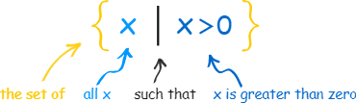 | 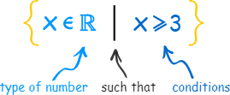
Set-Builder Notation: { x ∈ ℝ | x ≤ 2 or x > 3 }
Number Line:
Interval Notation: (−∞, 2] U (3, +∞)
Number Sets

Symbol | Definition | Set Notation | Examples | Equations
∅ | Empty or null set | { } | ∅ ∈ {∅} | $$1=2$$
ℕ | Natural numbers | {x ∈ ℤ : x > 0} | {1, 2, 3, …} or  {0, 1, 2, 3, …}  (per ISO 80000-2 2-6.1) | $$x-3=0$$
𝕎 | Whole numbers | {x ∈ ℤ : x ≥ 0} | {0, 1, 2, 3, …} | n ≥ 0
ℙ | Prime numbers | {a, b ∈ ℤ⁺ : (p∖ab ⟶ p∖a ∨ p∖b)} | {2, 3, 5, 7, 11, 13, ...} | unofficial
ℤ | Integers | {x : x = ±ℕ ∨ x = 0} | {…, −3, −2, −1, 0, 1, 2, 3, …} | $$x+7=0$$
ℚ | Rational numbers | {p/q : p, q ∈ ℤ ∧ q ≠ 0} | {0, ¼, ½, ¾, 1} | $$4x-1=0$$
𝕀 | Irrational numbers | {x ∈ ℝ : x ∉ ℚ} | {0, ¼, ½, ¾, 1} | $$4x-1=0$$
𝔸 | Algebraic numbers | { x ∈ ℝ : x = root of a one variable polynomial ∧ coefficients ∈ ℚ} | {5, -7, ½, $\sqrt{2}$} | $${2x}^{2}+4x-7=0$$
𝕋 | Transcendental numbers | {x ∈ ℝ : x ∉ 𝔸, x ∉ ℚ} | {π, e, e^{π}, sin(x), log_{b} a} | 𝕋 = 𝕌 − 𝔸
ℝ | Real numbers | {x : x corresponds to a number on the number line} | { π , 3.1415, -1, ⅞, $\sqrt{2}$} | $$x^{2}-2=0$$
𝕀 | Imaginary numbers | {b : bi where $i=\sqrt{-1}$} | {2i, $\sqrt{-1}$} | $$x^{2}+1=0$$
ℂ | Complex numbers | {a, b ∈ ℝ : a + bi} | {1 + 2i, -3.4i, ⅝} | $$x^{2}-4x+5=0$$
𝕌 | Universal set | all possible values in a particular context
{0} | Zero integer | {x ∈ ℤ : x = 0} | {0} | n = 0
ℤ − {0} | Non-zero integers | {x ∈ ℤ : x ≠ 0} | {…, −3, −2, −1, 1, 2, 3, …} | n ≠ 0
ℤ⁺ | Positive integers | {x ∈ ℤ : x > 0} | {1, 2, 3, ...} | n > 0
ℤ⁻ | Negative integers | {x ∈ ℤ : x < 0} | {..., −3, −2, −1} | n < 0
ℕ ⋃ {0} | Non-negative integers | {x ∈ ℤ : x ≥ 0} | {0, 1, 2, 3, …} | n ≥ 0
ℤ⁻ ⋃ {0} | Non-positive integers | {x ∈ ℤ : x ≤ 0} | {..., −3, −2, −1, 0} | n ≥ 0
{0}, ℝ˟ | Zero real | {x ∈ ℝ : x = 0} | {0.0} | x = 0
ℝ − {0}  ℝ \ {0} | Non-zero real numbers | {x ∈ ℝ : x ≠ 0} | {-0.001, 0.002} | x ≠ 0
ℝ⁺  (0, ∞) | Positive real numbers | {x ∈ ℝ : x > 0} | {0.0001, 0.0002, ...} | x > 0
ℝ⁻  (−∞, 0) | Negative real numbers | {x ∈ ℝ : x < 0} | {..., −0.0002, −0.0001} | x < 0
[0, ∞) | Non-negative real numbers | {x ∈ ℝ : x ≥ 0} | {0, 0.0001, 0.0002, ...} | x ≥ 0
(−∞, 0] | Non-positive real numbers | {x ∈ ℝ : x ≤ 0} | {..., −0.0002, −0.0001, 0} | x ≤ 0
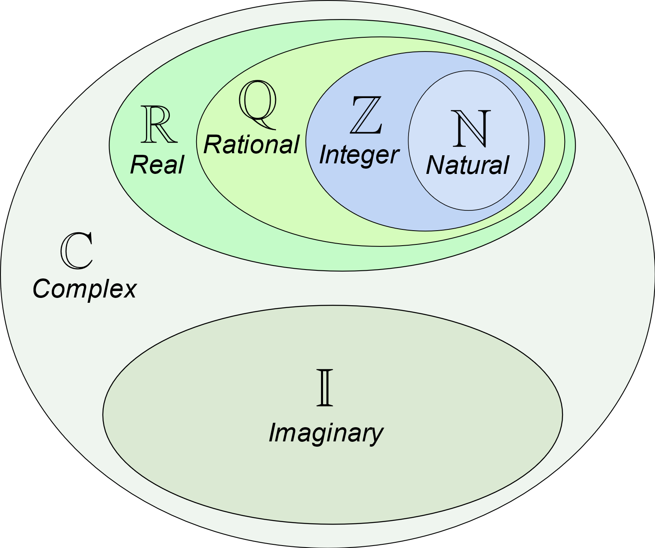
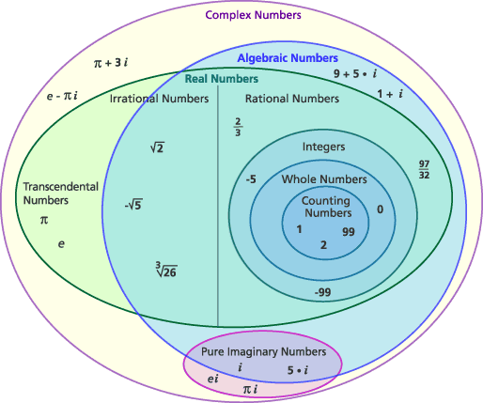

Set Laws

Law | Union Example | Intersection Example
Idempotent Laws | A ⋃ A = A | A ⋂ A = A
Associative Laws | (A ⋃ B) ⋃ C = A ⋃ (B ⋃ C) | (A ⋂ B) ⋂ C = A ⋂ (B ⋂ C)
Commutative Laws | A ⋃ B = B ⋃ A | A ⋂ B = B ⋂ A
Distributive Laws | A ⋃ (B ⋂ C) = (A ⋃ B) ⋂ (A ⋃ C) | A ⋂ (B ⋃ C) = (A ⋂ B) ⋃ (A ⋂ C)
Identity Laws | A ⋃ ∅ = A | A ⋂ 𝕌 = A
Domination Laws | A ⋃ 𝕌 = 𝕌 | A ⋂ ∅ = ∅
Double Complement Law | (A^{c})^{c} = A
Complement Laws | A ⋃ A^{c} = 𝕌 | A ⋂ A^{c} = ∅
Complements of 𝕌 and ∅ | 𝕌^{c} = ∅ | ∅^{c} = 𝕌
De Morgan’s Laws | (A ⋃ B)^{c} = A^{c} ⋂ B^{c} | (A ⋂ B)^{c} = A^{c} ⋃ B^{c}
Absorption Laws | A ⋃ (A ⋂ B) = A | A ⋂ (A ⋃ B) = A
Set Difference Law |  | A \ B = A ⋂ B^{c}  A - B = A ⋂ B^{c}

Set Properties

Property | Description | Examples
Composition | Objects may be of various types.  A set may contain elements of different varieties. | A = {2, strewberry, monkey}
Order | The order in which the elements are listed is unimportant | A = { 10, 6, 4, 2 }
Duplicates | Repeating an element does not change the set | A = { 2, 2, 4, 6, 10 }
Notation | Typically, capital letters will be used as variables denoting sets, and lower case letters will be used for elements in the set | A = {a, b}
Range | Every set A | ∅ ⊆ A ⊆ U
Empty Set | Set with no members. | ∅ is a subset of every set.

Set Notation

Term | Definition | Examples
{ }  ｛ ｝ | Denotes a set | A = {a, e, i, o, u}
|  : | ‘Such that’ or ‘for which’ | B = {x| x ∈ ℕ and x ≤ 5 }  B = {x: x ∈ ℕ and x ≤ 5 }
⇒  ≡ | Is equivalent or identical to | (C ∩ E) ⇒ (x ∊ C ∧ x ∊ E)
|A|  $$n(A)$$ | Cardinality of A, the number of elements in set A | if A = {(1,2), (3,4), (5,6)},  then |A| = 3
A = B | If and only if they have precisely the same elements. A is equal to b. | if A = {4, 9} and B = {n² : n=2 or n=3}, then A = B
A ⊆ B | If and only if every element of A is also an element of B. A is a subset of B. | {1, 8, 1107} ⊆ ℕ
A ⊈ B | A is not a subset of B.  A is not contained in B. | {-1, -8, -1107} ⊈ ℕ
A ⊂ B | A is a proper subset of B.  A is a subset of B that is not equal to B. | {1, 8, 1107} ⊂ ℕ
A ⊄ B | A is not a proper subset of B.  A is not contained in B. | {-1, -8, -1107} ⊄ ℕ
B ⊇ A | If and only if every element of A is in B.  B is a superset of A. | {1, 8, 1107} ⊆ ℕ
a ∊ A  A ∈ B  a ∈ A | A is a member of, an element of, or in A | ¾ ∈ ℚ
a ∉ A | A is not a member of A, is not an element of A | 3.14 ∉ ℤ
A ∩ B  A ⋂ B  A ∩ B | The set containing elements that are in both A and B.  A∩B is the intersection of A and B. | if A = {1, 2} and B = {2 ,3},  then A ⋂ B = {2}
A ∪ B  A ⋃ B  A ∪ B | The set containing elements that are in either A or B or both.  A∪B is the union of A and B. | if A = {1, 2} and B = {2, 3},  then A ⋃ B = {1, 2, 3}
A ∖ B  A − B | Set difference. The set containing elements that are in A but not in B.  A∖B is “A drop B”. A−B is “A difference B”. | if A = {1, 2} and B = {2, 3},  then A ∖ B = {1}
A ⊕ B | Symmetric difference is the set of elements that are a member of exactly one of A and B, but not both | A ⊕ B = ( A - B ) ∪ ( B - A )
A ⋂ B = ∅ | A and B are disjoint sets.  No elements in common. | A ⋂ B = ∅
A^{k} | Cartisian product of a set A with itself | A^{k} = A x A x ... x A k times

Logical Form of Set Notation

Set Notation | Logical Statement | Description
A | x ∈ A  ∀x {x ∈ A} | - Is an element of
¬A | x ∉ A  ∀x {x ∉ A} | - Is not an element of
A = B  A ﹦ B | A ⟷ B  ∀x [(x ∈ A ⟶ x ∈ B) ∧ ( x ∈ B ⟶ x ∈ A)]  A ⊆ B ∧ B ⊆ A | - Equal  - Equivalence  - Iff  - ≝
A ≠ B  A ≠ B | ∀x (x ∈ A ∧ x ∉ B) | - Not equal
A ⊆ B | ∀x (x ∈ A ⟶ x ∈ B)  ∀x ∈ A (x ∈ B)  x ∉ A \ B | - Subset of  - A ∩ B = A ⟶ A ⊆ B
A ⊈ B | ∃x (x ∈ A ∧ x ∉ B) | - Not a subset of
A ∩ B | ∀x (x ∈ A ∧ x ∈ B) | - Intersection
A ⋃ B | ∀x (x ∈ A ∨ x ∈ B) | - Union
A \ B | ∀x (x ∈ A ∧ x ∉ B) | - Difference  - But Not
A ⊕ B | ∀x { x ∈ A - B ∨ x ∈ B - A } | - Exactly one
A ⟶ B | ∀x (x ∉ A ∨ x ∈ B) | - If – Then
A ⋂ B = ∅ | ¬∃x (x ∈ A ∧ x ∈ B)  ∀x ¬ (x ∈ A ∧ x ∈ B)  ∀x (x ∉ A ∨ x ∉ B)  ∀x (x ∈ A ⟶ x ∉ B) | - A nd B are disjoint, having no elements in common
ℱ | {A_{i} | i ∈ I} | - Family of sets
x ∈ ⋂ℱ | {x | ∀A ∈ ℱ ( x ∈ A)}  {x | ∀A (A ∈ ℱ ⟶ x ∈ A)} | - Intersection of family of sets
x ∈ ⋃ℱ | {x | ∃A ∈ ℱ ( x ∈ A)}  {x | ∃A (A ∈ ℱ ∧ x ∈ A)} | - Union of family of sets
⋂ℱ | ⋂_{i ∈ I} A_{i} = {x | ∀i ∈ I (x ∈ A_{i})}  ⋂_{i ∈ I} A_{i} = A₁ ⋂ A₂ ⋂ A₃ ⋂ A₄ ⋂ ... | - Intersection of an indexed family of sets
⋃ℱ | ⋃_{i ∈ I} A_{i} = {x | ∃i ∈ I (x ∈ A_{i})}  ⋃_{i ∈ I} A_{i} = {x ∈ I | ∃i ∈ I A (i, x)}  ⋂_{i ∈ I} A_{i} = A₁ ⋃ A₂ ⋃ A₃ ⋃ A₄ ⋃ ... | - Union of an indexed family of sets
x ∈ ℘(A) | x ⊆ A  ∀y (y ∈ x ⟶ y ∈ A) | - Power Set  - All subsets of set A, including ∅  - |P(A)| = 2^{|A|}

Logical Form of Numbers

Definition | Logical Statement | Description
Even | ∃k ∈ ℤ (x = 2k)  Set E = {2k : k ∈ ℤ}  2ℤ | - Definition of Even
Odd | ∃k ∈ ℤ (x = 2k + 1)  Set O = {2k + 1 : k ∈ ℤ} | - Definition of Odd
Prime | ∀a, b ∈ ℤ⁺ | (p∖ab ⟶ p∖a ∨ p∖b) | - A positive integer p > 1 that has no positive integer divisors other than 1 and p itself is prime.  - Here \ means ”is a divisor of”
Not Prime | ∃a, b ∈ ℤ⁺ (ab = n ∧ a < n ∧ b < n) | - a and b are factors of n, so not prime
Divides | x | y ⟷ ∃k ∈ ℤ (y = kx) | - Divisability  - Divides  - Divides into  - x divides y evenly  - x | y to mean “x divides y,”  - x ∤ y means “x does not divide y”
Rational | r ∈ ℝ ∃x, y ∈ ℤ ((y ≠ 0) ∧ (r = x/y)) ⟶ r ∈ ℚ | - Definition of Rational number  - A fraction composed of two integers, but no division by 0

Logical Form of Geometry

Definition | Logical Statement | Description
Line | {(x, y) ∈ ℝ × ℝ | y = mx + b}  = {(0, b), (1, m + b), (2, 2m + b), …} | - You can think of the graph of the equation as a picture of its truth set!
Plane | ℝ × ℝ = {(x, y) | x and y are real numbers} | - These are the coordinates of all the points in the plane  - ℝ² = ℝ × ℝ
3D Space | ℝ³ = {(x, y, z) | x, y and z are real numbers} | - These are the coordinates of all the points in 3D space  - ℝ³ = ℝ × ℝ × ℝ
Spacetime | ℝ⁴ = {(x, y, z, t) | x, y, z and t are real numbers} | - These are the coordinates of all the points in 3D space and 1D time  - ℝ⁴ = ℝ × ℝ × ℝ × ℝ

Logical Form of Functions

Definition | Logical Statement | Description
Function | f : x ⟶ y  ∀x ∈ X ∃!y ∈ Y ((x, y) ∈ f)  f = {(a, b) ∈ A × B | b = f(a)} | - Function  - f is a relation frrom A to B  - Example : f = {(x, y) ∈ ℝ × ℝ | y = x²}
Domain | Dom(f )  X | - Domain of f
Range | Ran(f )  {f (a) | a ∈ A}  Y | - Range ⊆ co-domain  - Co-domain  - Image of f (linear algebra term)
Surjection | f = ∀y ∈ Y {∃ at least one x ∈ X such that f(x) = y}  ∀y ∈ Y, ∃x ∈ X | (f(x) = y)  Ran(f ) = Y | - Onto  - Surjective f  - Every y is mapped to by at least one x  - No orphan y’s  - e.g., y is dating at least one x
Injection | f = ∀y ∈ Y {∃ at most one x ∈ X such that f(x) = y}  ¬∃a₁ ∈ A ∃a₂ ∈ A (f (a₁) = f (a₂) ∧ a₁ ≠ a₂)  ∀a₁, a₂ ∈ A | (f (a₁) = f (a₂) ⟶ a₁ = a₂)  f(x) = f(y) ⟷ x = y  f(x) ≠ f(y) ⟷ x ≠ y | - One-to-one  - Injective f  - For any y there is at most one x  - Can have orphan y’s  - e.g., y is either married or single
Bijection | f = iff ∀y ∈ Y {∃ a unique x ∈ X such that f(x) = y}  $$f(Y)=y⟷f^{-1}(y)=Y$$ | - Bijective = surjective and injective  - One-to-one correspondence  - Bijective f  - Invertible f  - Iff has a well-defined inverse (f⁻¹)  - Iff both surjective and injective  - One-to-one and onto  - e.g., Everyone is married to a spouse
Inverse | f⁻¹: B ⟶ A  ∀b ∈ B ∃!a ∈ A ((b, a) ∈ f⁻¹)  f(g(x)) = x  f⁻¹ ◦ f = i_{A} and f ◦ f⁻¹ = i_{B} | - Inverse f
k-to-1 Correspondence | Let X and Y be finite sets. The function f:X→Y is a k-to-1 correspondence if for every y ∈ Y, there are exactly k different x ∈ X such that f(x) = y. | - Bijection is k = 1

Cartesian Product
Set Notation | Logical Statement | Description
A × B  A ⨯ B  A × B  A × B | {(a, b) | a ∈ A ∧ b ∈ B}  {(a, b) | a ∈ A, b ∈ B} | - Cartesian product  - Cross product  - Set of all ordered pairs in which the first entry is in A and the second entry is in B

Properties of Cartesian Products

Law | Logical Statement | Description
Distributive | A × (B ⋂ C) = (A × B) ⋂ (A × C) | - ×⋂
 | A × (B ⋃ C) = (A × B) ⋃ (A × C) | - ×⋃
Commutative | (A × B) ⋂ (C × D) = (A ⋂ C) × (B ⋂ D) | - ×⋂×
 | ​(A × B) ⋃ (C × D) ⊆ (A ⋃ C) × (B ⋃ D) | - ×⋃×
Domination | ​A × ∅ = ∅  ∅ × A = ∅ | - ×∅

Relations

Property | i_{A} | Equivalence  (=) | Partial Order  (Poset) | Total Order  (Linear)
Reflexive
Symmetric
Anti-Symmetric
Asymmetric
Transitive
Total
Density
Binary Relation

Set Relations (xRy)

Set Notation | Logical Statement | Description
Relation | R ⊆ A × B  ∀x (x ∈ R ⟶ x ∈ A × B)  R = {(a, b) ∈ A × B | conditions}  xRy = (x, y) ∈ R  Example: D_{r} = {(x, y) ∈ ℝ × ℝ | x and y differ by less than r} ⇒ |x − y| < r} | - Relation from A to B  - R is a subset of the cross product
Domain | Dom(R)  {a ∈ A | ∃b ∈ B ((a, b) ∈ R)}  Dom(A) ⊆ A | - The domain of R is the set containing all the first coordinates of its ordered pairs
Codomain  (Target) | 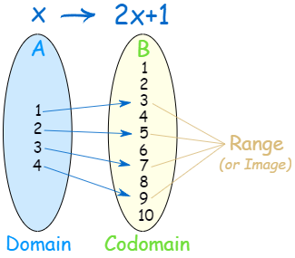 | - All possible values in the range set  - Ran(R) is a subset of the Target  - The set of the possible output values of a function  - The definition of a function
Range  (Image) | Ran(R)  {b ∈ B | ∃a ∈ A ((a, b) ∈ R)}  Ran(B) ⊆ B | - The range of R is the set containing all the second coordinates of its ordered pairs  - The actual or most accurate output values of a function  - The image of a function
Inverse  (R⁻¹) | {(y, x) ∈ Y × X | (x, y) ∈ R}  (y, x) ∈ R⁻¹ ⟷ (x, y) ∈ R  (x, y) ∈ R⁻¹ ⟶ (x, y) ∈ R | - The inverse of R is the relation R⁻¹ from B to A with the order of the coordinates of each pair reversed
Composition  (S ∘ R) | S ◦ R = (a, c) ∈ S ◦ R ⟷ ∃b | (a, b) ∈ R and (b, c) ∈ S  {(a, c) ∈ A × C | ∃b ∈ B ((a, b) ∈ R and (b, c) ∈ S)}  aRb and bSc  {(a, c) ∈ A × C | ∃b ∈ B (aRb ∧ bSc)} | - The composition of S and R is the relation S ◦ R from A to C  - aRb and bSc, meaning R:a ⟶ R:b ⟶ S:b ⟶ S:c, so (R:a, S:c)  - Ring operator
Identity  (i_{A}) | {(x, y) ∈ A × A | x = y}  {(x, x) | x ∈ A} | - Identity relation

Order Properties of Binary Relations with Two Sets

Property | Logical Statement | Description
Reflexive | xRx  (x, x) ∈ R  ∀x ∈ A (xRx)  ∀x ∈ A ((x, x) ∈ R) | - i_{A} ⊆ R  where i_{A} is the identity relation of set A or i_{A} = {(x, x) | x ∈ A}  - Directed graph: Loop
Anti-Reflexive | ¬ (xRx)  ∀x ∈ A ¬ (xRx) | - Directed graph: No loops
Symmetric | xRy ⟶ yRx  ∀x ∈ A ∀y ∈ A (xRy ⟶ yRx) | - R = R⁻¹  - Directed graph: 2-way arrow (edges come in pairs) or no arrows
Anti-Symmetric | (xRy ∧ yRx) ⟶ (x = y)  (x ≠ y) ⟶ ¬ (xRy) ∨ ¬ (yRx)  ∀x ∈ A ∀y ∈ A ((xRy ∧ yRx) ⟶ (x = y)) | - Equivalence  - Directed graph: An arrow from x to y implies that there is no arrow from y to x
Asymmetric | xRy ⟶ ¬ (yRx)  ∀x ∈ A ∀y ∈ A ∀z ∈ A (xRy ⟶ ¬ (yRx)) | - Fails the vertical line test, so not a proper function, f(x)  - Directed graph: 1-way arrow
Transitive | (xRy ∧ yRz) ⟶ xRz  ∀x ∀y ∀z ((xRy ∧ yRz) ⟶ xRz)  ∀x ∈ A ∀y ∈ A ∀z ∈ A ((xRy ∧ yRz) ⟶ xRz) | - R ◦ R ⊆ R  - Similar to S ◦ R  - Directed graph: Two routes from every vertex A to every vertex B, 1-hop and 2-hops  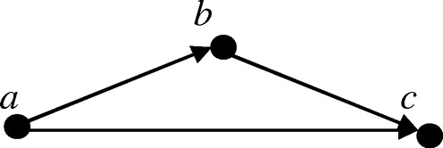
Total | xRy ∨ yRx  ∀x ∈ A ∀y ∈ A (xRy ∨ yRx) | - Either-or
Density | xRy ⟶ ∃z | xRz ∧ zRy  ∀x ∈ A ∀y (xRy) ⟶ ∃z | xRz ∧ zRy | - A middle-man exists
Binary | R⁻¹ ◦ R = Relation on set A  R ◦ R⁻¹ = Relation on set C | - Relation on set <set>  - Binary relation on set <set>
Identity | i_{A} = {(x, y) ∈ A × A | x = y}  i_{A} = {(x, x) | x ∈ A} | - Similar to a diagonal matrix

Mathematical Number Sets Computer Science Data Types

Symbol | Definition | C Data Type | C++ Data Type
∅ | empty set,  set with no members | void
ℕ | natural numbers | enum  unsigned  unsigned char  unsigned short  unsigned int  unsigned long  unsigned long long
ℤ | integers | char  short  int  long  long long
ℚ | rational numbers | NA | std::ratio<1, 10>
ℝ | real numbers | float  double  long double
𝕀 | imaginary numbers | (see complex below)  double complex z1; im = cimag(z1); | (see complex below)  std::complex <double> z1;  im = std::imag(z1);
ℂ | complex numbers | #include <complex.h>  float complex  double complex  long double complex | #include <complex>  std::complex<float>  std::complex <double>  std::complex <long double>

Sources:
- SNHU MAT 470 - Real Analysis, The Real Numbers and Real Analysis, Ethan D. Bloch, Springer New York, 2011.
- See also “Harold’s Logic Cheat Sheet”.
- https://www.storyofmathematics.com/set-notation
- https://math24.net/set-identities.html

