Harold’s Series
Cheat Sheet
22 September 2025

Sigma Notation
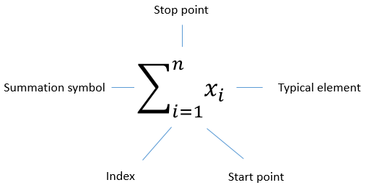

Sequence | $$\lim_{n→∞}{a_{n}}=L$$ | $$a_{n}, a_{n+1}, a_{n+2}, …$$  A sequence separates terms with a comma
Series | $$\sum_{n=1}^{∞}{ a_{n}}=S$$ | $$a_{n}+a_{n+1}+a_{n+2}+…$$  A series adds up the sequence terms
Finite Series | $$S_{4}=\sum_{i=1}^{4}{ x_{i}}=x_{1}+x_{2}+x_{3}+x_{4}$$ | From $i, j,$ or $k$ to $n=4$
Infinite Series | $$S_{∞}=\sum_{n=1}^{∞}{ x_{n}}=x_{1}+x_{2}+x_{3}+…$$ | From $n=1$ to ∞
Convergent | $$\sum_{n=1}^{∞}{ a_{n}}=S$$ | Approaches a constant value
Divergent | $$\sum_{n=1}^{∞}{ a_{n}}→±∞$$ | Grows to infinity

Related cheat sheets:
- Harold’s Infinite Series Cheat Sheet
- Harold’s Infinite Products Cheat Sheet
- Harold’s Series Convergence Tests Cheat Sheet
Arithmetic and Geometric Series

Operation | Arithmetic Series | Geometric Series
Summation Notation | $$S_{n}=\sum_{k=1}^{n}{a_{k}}$$ | $$S_{n}=\sum_{k=0}^{n-1}{a_{0}r^{k}}=\sum_{k=1}^{n}{a_{0}r^{k-1}}$$
Summation Expanded | $$S_{n}=a_{1}+a_{2}+…+a_{n-1}+a_{n}$$ | $$S_{n}=a_{1}+a_{1}r+a_{1}r^{2}+…+a_{1}r^{n-1}$$
Recursive n^{th} Term of Sequence | $$a_{n}=a_{n-1}+d$$ | $$a_{n}=a_{n-1}r$$
Explicit n^{th} Term of Sequence | $$a_{n}=a_{1}+(n-1)d$$ | $$a_{n}=a_{1}r^{n-1}$$
Sum of n Terms  (Finite Series) | $$S_{n}=\frac{n}{2}\left(a_{1}+a_{n}\right)$$  $$S_{n}=\frac{n}{2}\left[2a_{1}+\left(n-1\right)d\right]$$ | $$S_{n}=a_{1}\frac{\left(1-r^{n}\right)}{1-r}$$
Sum of $∞$ Terms  (Infinite Series) | $$S_{∞}→∞$$ | $$S_{∞}=\frac{a_{1}}{1-r} if \left|r\right|<1$$
Archimedes Geometric Series Example | $$S_{4}=\sum_{k=1}^{4}{{\left(\frac{1}{2}\right)}^{2k}}=\sum_{k=1}^{4}{{\left(\frac{1}{4}\right)}^{k}}$$  $$={\left(\frac{1}{4}\right)}^{1}+{\left(\frac{1}{4}\right)}^{2}+{\left(\frac{1}{4}\right)}^{3}+{\left(\frac{1}{4}\right)}^{4}$$  $$S_{4}=\frac{85}{256}≈0.3320$$  $$S_{∞}=\frac{a_{1}}{1-r}-1=\frac{1}{1-\frac{1}{4}}-1=\frac{1}{3}$$ | 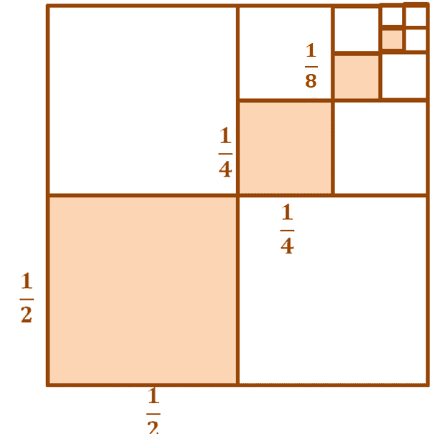
Another Geometric Series Example | $$S_{∞}=\sum_{n=1}^{∞}{{\left(\frac{1}{2}\right)}^{n}}$$  $$=\frac{1}{2}+\frac{1}{4}+\frac{1}{8}+\frac{1}{16}+…=1$$  $$S_{∞}=\frac{a_{1}}{1-r}-1=\frac{1}{1-\frac{1}{2}}-1=1$$ | 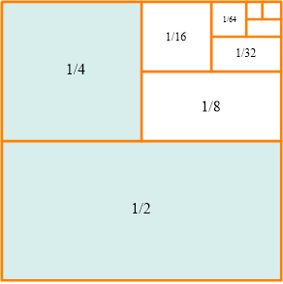

Summation Formulas

Type | Summation Formulas
Constant Multiple Rule | $$\sum_{i=1}^{n}{ca_{i}}=c\sum_{i=1}^{n}{a_{i}}$$
Sum Rule | $$\sum_{i=1}^{n}{a_{i}} ± \sum_{i=1}^{n}{b_{i}}=\sum_{i=1}^{n}{\left(a_{i}±b_{i}\right)}$$
Index Shift | $$\sum_{i=m}^{n}{a_{i}}=\sum_{i=p}^{(p-m)+n}{a_{i+m-p}}$$
Sum of Powers  (Arithmetic Series) | $$\sum_{i=1}^{n}{c}=cn$$  $$\sum_{i=1}^{n}{i}=\frac{n(n+1)}{2}=\frac{n^{2}}{2}+\frac{n}{2}$$  $$\sum_{i=1}^{n}{i^{2}}=\frac{n(n+1)(2n+1)}{6}=\frac{n^{3}}{3}+\frac{n^{2}}{2}+\frac{n}{6}$$  $$\sum_{i=1}^{n}{i^{3}}={\left(\sum_{i=1}^{n}{i}\right)}^{2}=\frac{n^{2}{(n+1)}^{2}}{4}=\frac{n^{4}}{4}+\frac{n^{3}}{2}+\frac{n^{2}}{4}$$  $$\sum_{i=1}^{n}{i^{4}}=\frac{n(n+1)(2n+1)(3n^{2}+3n-1)}{30}=\frac{n^{5}}{5}+\frac{n^{4}}{2}+\frac{n^{3}}{3}-\frac{n}{30}$$  $$\sum_{i=1}^{n}{i^{5}}=\frac{n^{2}{(n+1)}^{2}(2n^{2}+2n-1)}{12}=\frac{n^{6}}{6}+\frac{n^{5}}{2}+\frac{5n^{4}}{12}-\frac{n^{2}}{12}$$  $$\sum_{i=1}^{n}{i^{6}}=\frac{n(n+1)(2n+1)(3n^{4}+6n^{3}-3n+1)}{42}$$  $$\sum_{i=1}^{n}{i^{7}}=\frac{n^{2}{\left(n+1\right)}^{2}\left(3n^{4}+6n^{3}-n^{2}-4n+2\right)}{24}$$  $$\sum_{i=1}^{n}{i^{8}}=\frac{n\left(n+1\right)\left(2n+1\right)\left(5n^{6}+15n^{5}+5n^{4}-15n^{3}-n^{2}+9n-3\right)}{90}$$  $$S_{k}\left(n\right)=\sum_{i=1}^{n}{i^{k}}=\frac{{\left(n+1\right)}^{k+1}}{k+1}-\frac{1}{k+1}\sum_{r=0}^{k-1}{\left({k+1 \atop r}\right)S_{r}(n)}$$
Interesting Summation Formulas | $$\sum_{i=1}^{n}{i(i+1)}=\sum_{i=1}^{n}{i^{2}}+\sum_{i=1}^{n}{i}=\frac{n(n+1)(n+2)}{3}$$  $$\sum_{i=1}^{n}{\frac{1}{i\left(i+1\right)}}=\frac{n}{n+1}$$  $$\sum_{i=1}^{n}{i(i+1)(i+2)}=\frac{n(n+1)(n+2)(n+3)}{4}$$  $$\sum_{i=1}^{n}{\frac{1}{i(i+1)(i+2)}}=\frac{n(n+3)}{4(n+1)(n+2)}$$  $$\sum_{i=1}^{n}{2i-1}=n^{2} (odd numbers)$$  $$\sum_{i=1}^{∞}{\frac{{\left(-1\right)}^{i+1}}{i^{2}}}=\frac{π^{2}}{12}$$

Binomial Theorem

Binomial Series |  | Expanded
Pascal’s Triangle | 1  1 1  1 2 1  1 3 3 1  1 4 6 4 1  1 5 10 10 5 1 | $${{}_{0}^{ }C}_{0}$$  $${{}_{1}^{ }C}_{0} {{}_{1}^{ }C}_{1}$$  $${{}_{2}^{ }C}_{0} {{}_{2}^{ }C}_{1} {{}_{2}^{ }C}_{2}$$  $${{}_{3}^{ }C}_{0} {{}_{3}^{ }C}_{1} {{}_{3}^{ }C}_{2} {{}_{3}^{ }C}_{3}$$  $${{}_{4}^{ }C}_{0} {{}_{4}^{ }C}_{1} {{}_{4}^{ }C}_{2} {{}_{4}^{ }C}_{3} {{}_{4}^{ }C}_{4}$$  $${{}_{5}^{ }C}_{0} {{}_{5}^{ }C}_{1} {{}_{5}^{ }C}_{2} {{}_{5}^{ }C}_{3} {{}_{5}^{ }C}_{4} {{}_{5}^{ }C}_{5}$$ | $$\left({0 \atop 0}\right)$$  $$\left({1 \atop 0}\right) \left({1 \atop 1}\right)$$  $$\left({2 \atop 0}\right) \left({2 \atop 1}\right) \left({2 \atop 2}\right)$$  $$\left({3 \atop 0}\right) \left({3 \atop 1}\right) \left({3 \atop 2}\right) \left({3 \atop 3}\right)$$
Example | $${\left(a±b\right)}^{0}=$$  $${\left(a±b\right)}^{1}=$$  $${\left(a±b\right)}^{2}=$$  $${\left(a±b\right)}^{3}=$$  $${\left(a±b\right)}^{4}=$$  $${\left(a±b\right)}^{5}=$$ | $$1$$  $$a±b$$  $$a^{2}±2ab+b^{2}$$  $$a^{3}±3a^{2}b+3ab^{2}±b^{3}$$  $$a^{4}±4a^{3}b+6a^{2}b^{2}±4ab^{3}+b^{4}$$  $$a^{5}±5a^{4}b+10a^{3}b^{2}±10a^{2}b^{3}+5ab^{4}±b^{5}$$
Binomial Theorem | $${\left(a+b\right)}^{n}=\sum_{k=0}^{n}{\left({n \atop k}\right)a^{n-k}b^{k}}=$$  $$\left({n \atop 0}\right)a^{n}+\left({n \atop 1}\right)a^{n-1}b+…+\left({n \atop r}\right)a^{n-r}b^{r}+…+\left({n \atop n-1}\right)ab^{n-1}+\left({n \atop n}\right)b^{n}$$
$${(1+x)}^{r}=\sum_{n=0}^{+∞}{\left({r \atop n}\right) x^{n}}$$ |  | $${(1+x)}^{r}=1+\sum_{n=1}^{+∞}{\frac{r\left(r-1\right)\left(r-2\right)…(r-n+1)}{n!} x^{n}}$$  $$=1+rx+\frac{r\left(r-1\right)}{2!} x^{2}+\frac{r\left(r-1\right)(r-2)}{3!} x^{3}+…$$
Factorials and Constants

Operation | Formula
Termial (T_{n}) | $n?=n+\left(n-1\right)+\left(n-2\right)+…+3+2+1$
Factorial | $$n!=n ⦁ \left(n-1\right) ⦁ \left(n-2\right) ⦁…⦁ 3 ⦁ 2 ⦁ 1$$
Double Factorial | $n!!=n ⦁ \left(n-2\right) ⦁ \left(n-4\right) ⦁…⦁ 4 ⦁ 2$ (Even n)  $n!!=n ⦁ \left(n-2\right) ⦁ \left(n-4\right) ⦁…⦁ 3 ⦁ 1$ (Odd n)
Gamma Function  (Continuous Factorial) | $$Γ\left(n+1\right)=n Γ\left(n\right)=n!$$  $$Γ(x)=\int_{0}^{∞}{t^{x-1}}e^{-t} dt$$
Combination | $${{}_{n}^{ }C}_{r}=\frac{n!}{r!\left(n-r\right)!}$$  $$=\left({n \atop r}\right)=\prod_{k=1}^{r}{\frac{n-k+1}{k}}=\frac{n\left(n-1\right)\left(n-2\right)…(n-r+1)}{r!}$$  Converges for $\left|x\right|<1$ and all complex r , r ≠ 0, where
Permutation | $${{}_{n}^{ }P}_{r}=\frac{n!}{\left(n-r\right)!}$$
Fibonacci Sequence | F = {0, 1, 1, 2, 3, 5, 8, 13, 21, 34, 55, 89, 144, 233, 377, 610, 987, 1597, 2584, …}  Recursive:  F₀ = 0, F₁ = 1  F_{n} = F_{n-1} + F_{n-2}  Explicit:  $$F_{n}= \frac{1}{\sqrt{5}}\left({\left(\frac{1+\sqrt{5}}{2}\right)}^{n}- {\left(\frac{1-\sqrt{5}}{2}\right)}^{n}\right), n∈N$$
Fibonacci Numbers vs. Pascal’s Triangle | 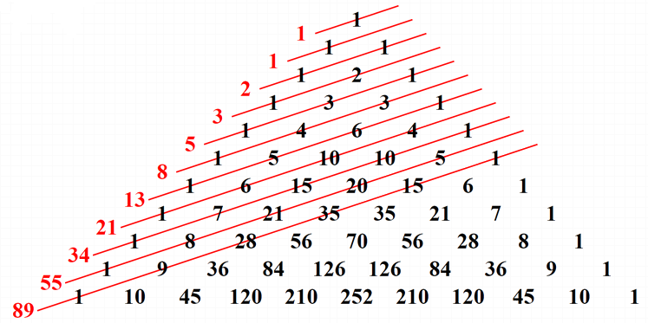  The Fibonacci numbers are the sums of the “shallow” diagonals (shown in red) of Pascal’s triangle
Golden Ratio | $φ$ ≅ 1.6180 33988 74989 48482 04586 83436 56381 17720 30917 98057 …  $$\frac{a+b}{a}=\frac{a}{b}$$  Solve for $x^{2}-x-1=0$  $$φ=\frac{1+\sqrt{5}}{2} ≅ \frac{F_{n}}{F_{n-1}}$$  $$F_{n}≅\frac{φ^{n} +{(1-φ)}^{n}}{\sqrt{5}}$$
Fibonacci Numbers vs. Golden Ratio | 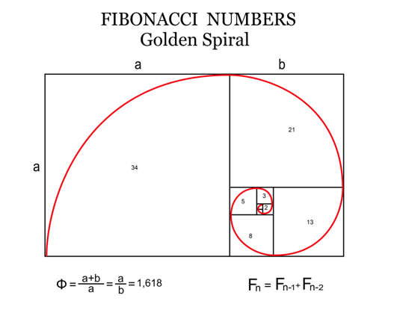
Euler’s Identity | $$e^{iπ}+1=0$$  Since $x=π$ in $e^{ix}=\cos{(x)}+i∙\sin{(x)}$
Euler’s Number | e ≅ 2.71828 18284 59045 23536 02874 71352 66249 77572 47093 69995 ....
Imaginary Unit | $$i=\sqrt{-1}=0+i$$
Archimedes’ Constant (pi) | π ≅ 3.14159 26535 89793 23846 26433 83279 50288 41971 69399 37510 ...  $$π ≅ \frac{22}{7}, \frac{333}{106}, \frac{355}{113}, \frac{52,163}{16,604}, \frac{103,993}{33,102}, \frac{104,348}{33,215}, \frac{245,850,922}{78,256,779}$$

Sources
- Dawkins, Paul (2023). Section 10 : Series And Sequence, Paul’s Online Notes. https://tutorial.math.lamar.edu/Classes/CalcII/SeriesIntro.aspx
- MedCalc (2025). TERMIAL function. https://www.medcalc.org/manual/termial-function.php
- Story of Mathematics (2024). What is a geometric series? https://www.storyofmathematics.com/geometric-series/
- Wireless Pi (2025). Rapid Skill Acquisition. https://wirelesspi.com/sdr-course/

