Harold’s Probability
Cheat Sheet
11 December 2024

Probability
Rule | Formula | Definition
Notation | $∩$ = “and”, Intersection, “$∧$”  $∪$ = “or”, Union, “$∨$”  $\overline{˽}=$“not”, negation, “$¬$” | “and” implies multiplication.  “or” implies addition.  “not” implies negation.
Independent | If $P\left(A | B\right)=P(A)$ | The occurrence of one event does not affect the probability of the other, or vice versa.
Dependent | If $P\left(A∩B\right)≠∅$ | The occurrence of one event affects the probability of the other event.
Disjoint  (“mutually exclusive”) | If $P\left(A∩B\right)=∅$  Then $P\left(A∪B\right)=P\left(A\right)+P\left(B\right)$ | The events can never occur together.
Probability  (“likelihood”) | $$0≤P\left(E\right)≤1$$  $$P\left(E\right)=\frac{\# Events (E)}{Sample Space \left(S\right)} = \frac{\# of Favorable Outcomes}{Total \# of Possible Outcomes}$$
Addition Rule  (“or”) | $$P\left(A∪B\right)=P\left(A\right)+P\left(B\right)-P(A∩B)$$ | 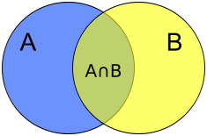  S
Multiplication Rule  (“and”) | if independent or disjoint:  $$P\left(A∩B\right)=P\left(A\right) P(B)$$  $$P\left(A∩B∩C\right)=P\left(A\right) P\left(B\right) P(C)$$  if dependent:  $$P\left(A∩B\right)=P\left(A\right) P\left(B | A\right)$$  $$P\left(A∩B\right)=P\left(B\right) P(A|B)$$  $$P\left(A∩B\right)=P\left(A\right)-P\left(A∩\overline{B}\right)$$
Complement Rule / Subtraction Rule  (“not”) | $$P\left(S\right)=P\left(A∪\overline{A}\right)=$$  $$P\left(A\right)+P\left(\overline{A}\right)=1$$  $$P(A)=1-P\left(\overline{A}\right)$$  $$P(\overline{A})=1-P\left(A\right)$$  $$P\left(A | B\right)+P\left(\overline{A} | B\right)=1$$ | The complement of event A (denoted $\overline{A} or A^{c})$ means “not A”; it consists of all simple outcomes that are not in A.
Conditional Probability  (“given that”) | $$P\left(A | B\right)=\frac{P(A∩B)}{P(B)}$$  if independent or disjoint:  $$P\left(A | B\right)=P(A)$$  $$P\left(B | A\right)=P(B)$$ | Means the probability of event A given that event B occurred. Is a rephrasing of the Multiplication Rule. P(A|B) is the proportion of elements in B that are ALSO in A.
Total Probability Rule | $$P\left(A\right)=P(A∩B_{1})+…+P(A∩B_{n})$$  $$=P\left(B_{1}\right) P\left(A | B_{1}\right)+…+P\left(B_{n}\right) P\left(A | B_{n}\right)$$  $$P\left(A\right)=P(A∩B)+P(A∩\overline{B})$$  $$=P\left(B\right) P\left(A | B\right)+P\left(\overline{B}\right) P\left(A | \overline{B}\right)$$ | To find the probability of event A, partition the sample space into several disjoint events. A must occur along with one and only one of the disjoint events.
Bayes’ Theorem | $$P\left(A | B\right)=\frac{P\left(A∩B\right)}{P\left(B\right)}=\frac{P\left(A\right) P\left(B | A\right)}{P\left(B\right)}$$  $$=\frac{ P\left(A\right) P\left(B | A\right)}{P\left(A\right) P\left(B | A\right)+P\left(\overline{A}\right) P\left(B | \overline{A}\right)}$$ | Allows P(A|B) to be calculated from P(B|A).  Meaning it allows us to reverse the order of a conditional probability statement, and is the only generally valid method!
De Morgan’s Law | $$\overline{P\left(A∪B\right)}≡\overline{P(A)}∩\overline{P(B)}$$  $$\overline{P\left(A∩B\right)}≡\overline{P(A)}∪\overline{P(B)}$$ | Uses negation to convert an “or” to an “and”.  Uses negation to convert an “and” to an “or”.

Venn Diagrams
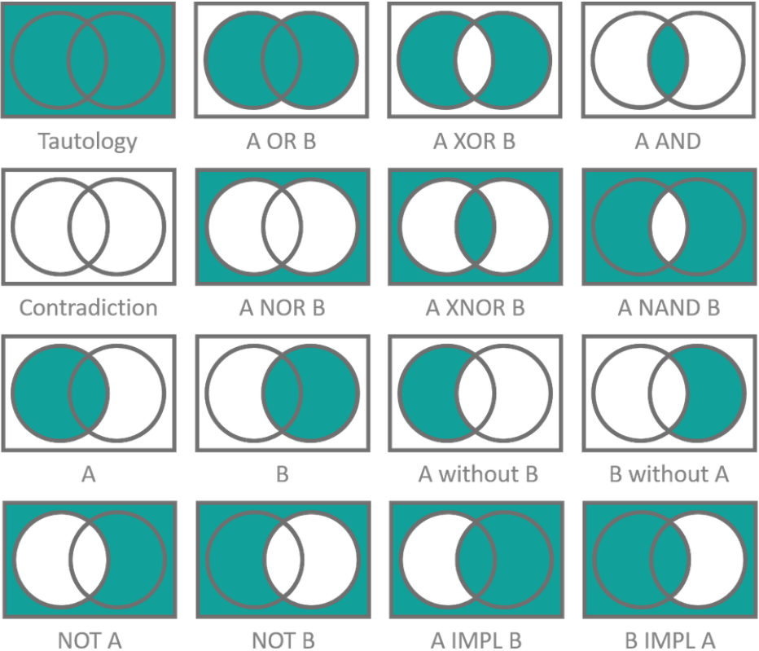
B
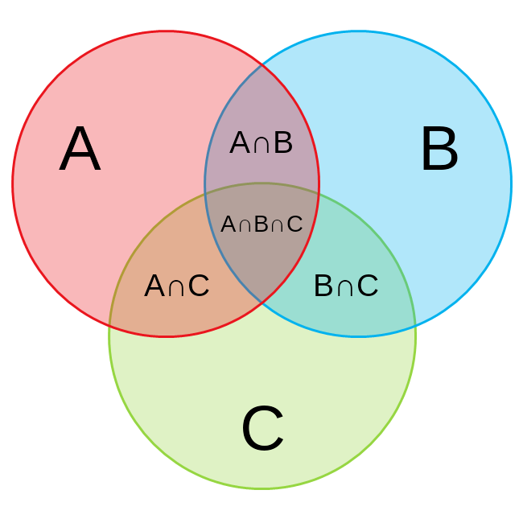
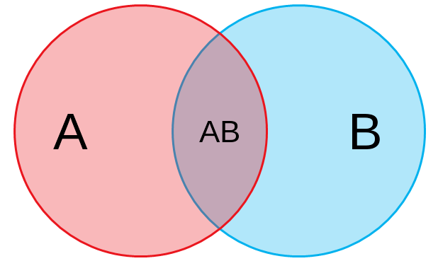

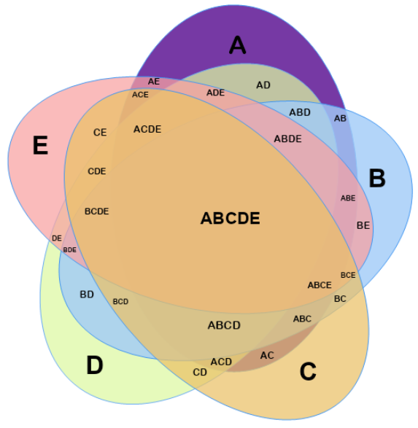
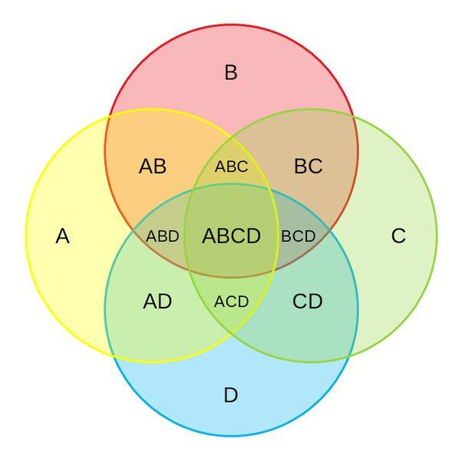
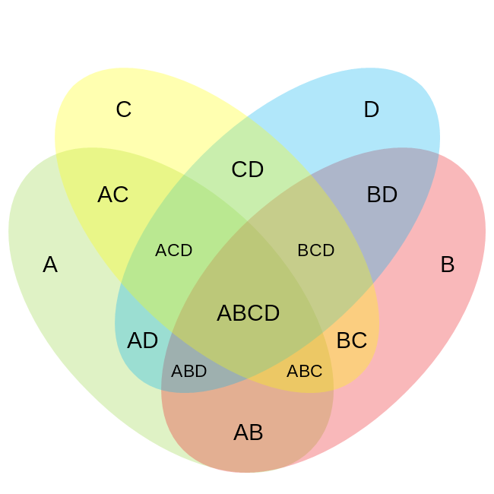

Sources:
- SNHU MAT 229 - Mathematical Proof and Problem Solving, How To Prove It - A Structured Approach, 3rd Edition - Daniel J. Vellman, Cambridge University Press, 2019.

- SNHU MAT 230 - Discrete Mathematics, zyBooks.

- Learn more about probability distributions here: http://blog.cloudera.com/blog/2015/12/common-probability-distributions-the-data-scientists-crib-sheet/

