Image Formation by Lenses and Mirrors
7 April 2014

1. Convex (Converging) Lenses

1.1
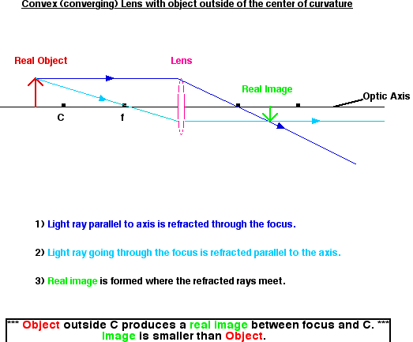

1.2
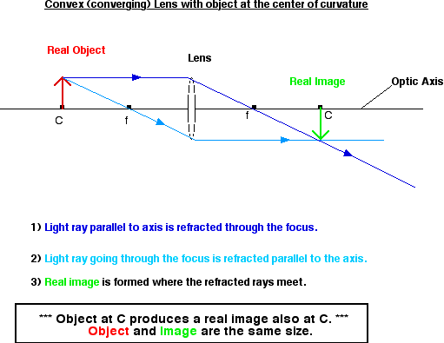

1.3
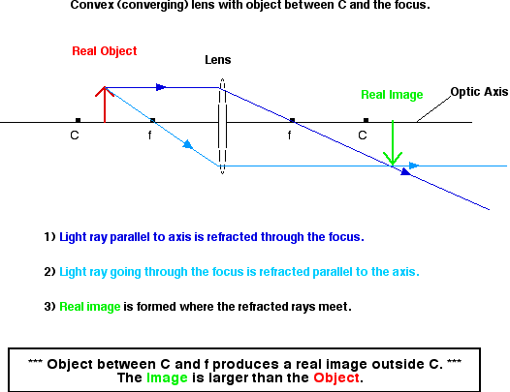

1.4
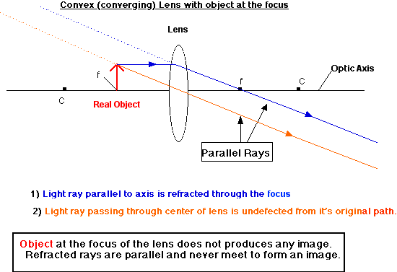

1.5
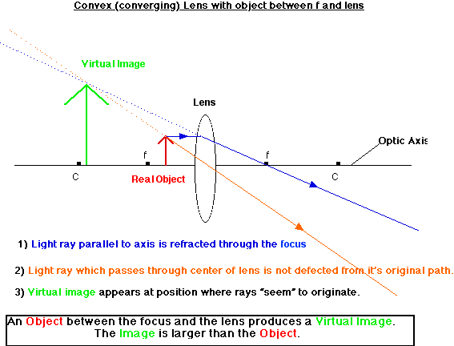

Source: http://www.physics.mun.ca/~jjerrett/lenses/convex.html
2. Concave (Diverging) Lens

2.1
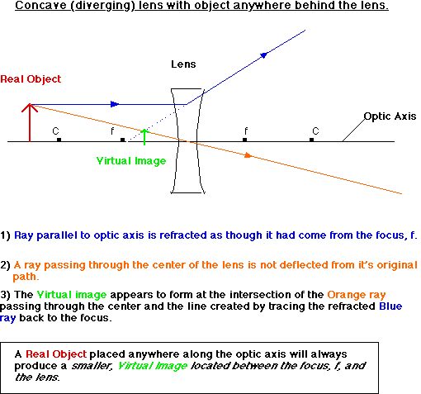

Source: http://www.physics.mun.ca/~jjerrett/lenses/concave.html

3. Convex (Converging) Mirror

3.1

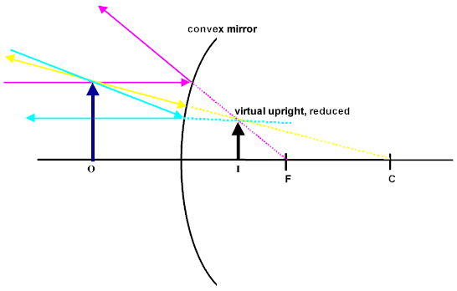

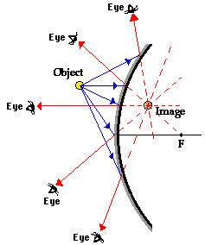

4. Concave (Diverging) Mirror
4.1.) For a real object very far away from the mirror, the real image is formed at the focus.
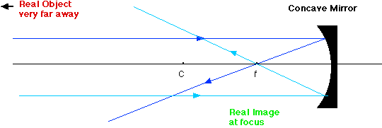

4.2.) For a real object close to the mirror but outside of the center of curvature, the real image is formed between C and f. The image is inverted and smaller than the object.
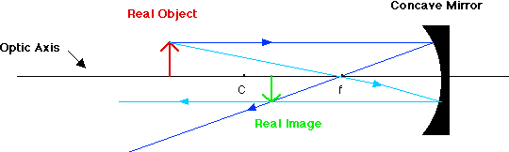

4.3.) For a real object at C, the real image is formed at C. The image is inverted and the same size as the object.
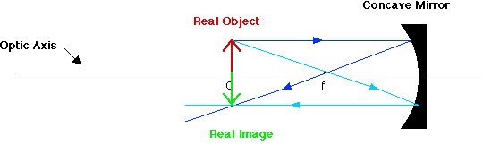

4.4.) For a real object between C and f, a real image is formed outside of C. The image is inverted and larger than the object.
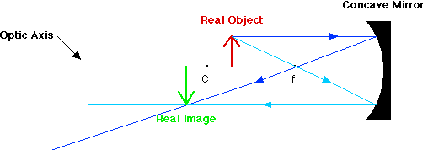

4.5.) For a real object at f, no image is formed. The reflected rays are parallel and never converge.
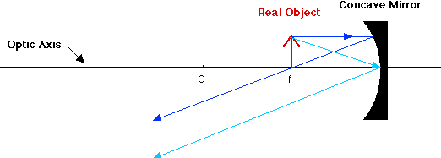

4.6.) For a real object between f and the mirror, a virtual image is formed behind the mirror. The position of the image is found by tracing the reflected rays back behind the mirror to where they meet. The image is upright and larger than the object.
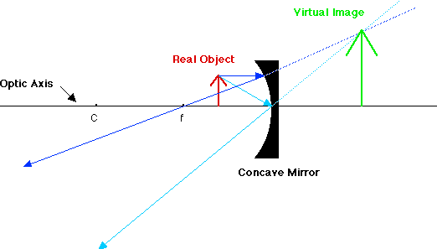
Source: http://www.physics.mun.ca/~jjerrett/mirror/concavem.html
5. Two Convex (Converging) Lenses

5.1 Two Convex Lenses Far Apart - Foci Do Not Overlap

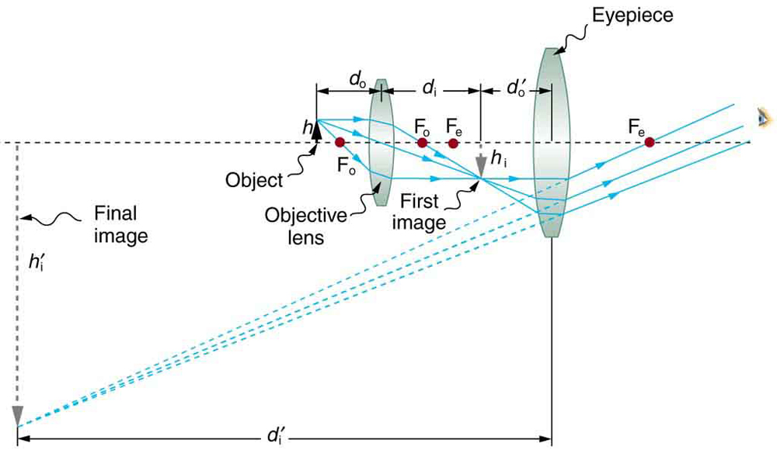

5.2 Two Convex Lenses Far Apart - Foci Overlap
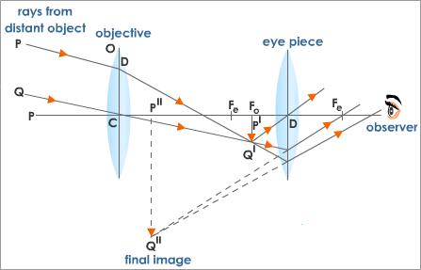
5.3 Two Convex Lenses Close Together
