Harold’s Physics of Forces with Pully
“Cheat Sheet”
23 April 2021

Incline Plane with a Pully
Physical Setup | 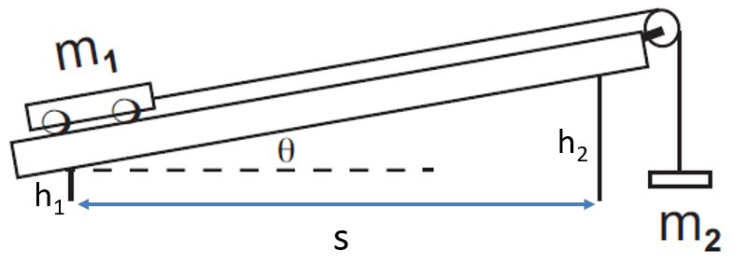
Free Body Diagrams | 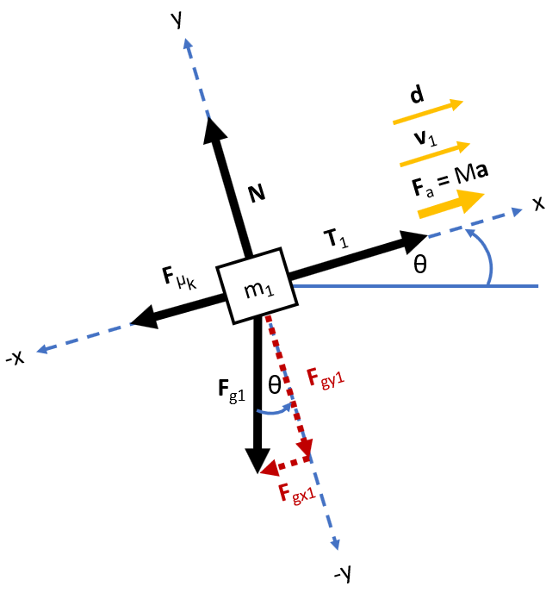 | 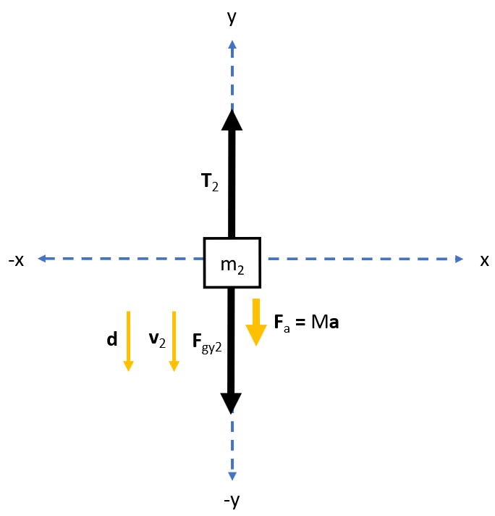
Givens | $$m_{1}=560 g=0.560 kg$$  $$θ={13.5}^{°}$$  $$μ_{k}=0.003895$$  $$μ_{pully}=0$$  $$m_{string}=0 kg$$  $$h_{1}, h_{2}, and s=ramp leg heights and length$$ | $$m_{2}=140 g=0.140 kg$$  $$x_{0}=16.2 cm=0.162 m$$  $$x=78.7 cm=0.787 m$$  $$v_{0}=0.127\frac{cm}{s}=0.00127 \frac{m}{s}$$  $$v=145\frac{cm}{s}=1.45 \frac{m}{s}$$
Observations | $$g=9.80 \frac{m}{s^{2}}$$  $$θ=\tan^{-1}\left(\frac{h_{2}-h_{1}}{s}\right)$$ | $$\left|d_{1}\right|=\left|d_{2}\right|$$  $$\left|v_{1}\right|=\left|v_{2}\right|$$  $$\left|T_{1}\right|=\left|T_{2}\right|$$  $$T_{1}-T_{2}=0$$
Unknowns | $$T_{1}= ? N$$  $$W_{net}= ? J$$  $$∆K= ? J$$ | $$T_{2}= ? N$$  $$F_{a}= ? N$$  $$a= ? \frac{m}{s^{2}}$$
Equations | $$\sum{F}=F_{a}=ma$$
 | $$\sum{F_{x1}}=T_{1}- F_{gx1}-F_{μ_{k}}=F_{a}$$  $$\sum{F_{y1}}=N-F_{gy1}=0$$ | $$\sum{F_{x2}}=0$$  $$\sum{F_{y2}}=T_{2}- F_{gy2}=F_{a}$$
 | $$F_{g1}=m_{1} g$$  $$F_{gx1}=F_{g1} \sin{θ}$$  $$F_{gy1}=F_{g1} \cos{θ}$$  $$F_{μ_{k}}=μ_{k} N$$  $$W_{net}=W_{μ1}+W_{g1}+W_{g2}+W_{T1}+W_{T2}$$  $$W=Fd\cos{θ}$$  $$∆K=K_{f}-K_{0}$$  $$K=\frac{1}{2}mv^{2}$$  $$W_{net}=∆K$$ | $$F_{gy2}=m_{2} g$$  $$F_{a}=Ma$$  $$M=m_{1}+m_{2}$$  $$d=x-x_{0}$$
Solve  1) Forces | $$F_{gx1}=m_{1} g\sin{θ}$$  $$F_{gy1}=m_{1} g\cos{θ}$$  $$\sum{F_{y1}}=N-F_{gy1}=0$$  $$N=F_{gy1}$$  $$N=m_{1} g\cos{θ}$$  $$F_{μ_{k}}=μ_{k} N$$  $$F_{μ_{k}}=μ_{k} m_{1} g\cos{θ}$$  $$\sum{F_{x1}}=T_{1}- F_{gx1}-F_{μ_{k}}=F_{a}$$  $$F_{a}=T_{1}- F_{gx1}-F_{μ_{k}}$$  $$F_{a}=T_{1}- m_{1} g\sin{θ}-μ_{k} m_{1} g\cos{θ}$$ | $$\sum{F_{y2}}=T_{2}- F_{gy2}={-F}_{a}$$  $$T_{2}-F_{gy2}={-F}_{a}$$  $${-T}_{2}+m_{2} g=F_{a}$$  $$F_{a}=m_{2} g-T_{2}$$  $$T_{1}-T_{2}=0$$  $$T=\left|T_{1}\right|=\left|T_{2}\right|$$  $$F_{a}=Ma$$  $$F_{a}=\left(m_{1}+m_{2}\right) a$$  $$a=\frac{F_{a}}{m_{1}+m_{2}}$$  $$d=x-x_{0}=0.787 m-0.162 m$$  $$d=0.625 m$$
2) Tension | $$T- m_{1} g\sin{θ}-μ_{k} m_{1} g\cos{θ}=F_{a}$$  $$m_{2} g-T=F_{a}$$  $$T- m_{1} g\sin{θ}-μ_{k} m_{1} g\cos{θ}=m_{2} g-T$$  $$2 T=m_{2} g+ m_{1} g\sin{θ}+μ_{k} m_{1} g\cos{θ}$$  $$2 T=g \left[m_{2}+ m_{1}\sin{θ}+μ_{k} m_{1}\cos{θ}\right]$$  $$T=\left(\frac{g}{2}\right)\left[m_{2}+ m_{1}\sin{θ}+μ_{k} m_{1}\cos{θ}\right]$$  $$T=\left|T_{1}\right|=\left|T_{2}\right|$$
3) Work-Energy | $$W_{μ1}= F_{μ_{k}}d\cos{{180}^{°}}={-F}_{μ_{k}} d$$  $$W_{g1}=F_{gx1} d\cos{{180}^{°}}={-F}_{gx1} d$$  $$W_{g2}=F_{gy2} d\cos{0^{°}}=F_{gy2} d$$  $$W_{T1}=T_{1} d\cos{0^{°}}=T_{1} d$$  $$W_{T2}=T_{2} d\cos{{180}^{°}}={-T}_{2} d$$  $$W_{net}=W_{μ1}+W_{g1}+W_{g2}+W_{T1}+W_{T2}$$  $$W_{net}={-F}_{μ_{k}} d {- F}_{gx1} d+F_{gy2} d+T_{1} d-T_{2} d$$  $$W_{net}=d \left[{-F}_{μ_{k}}{- F}_{gx1}+F_{gy2}+T_{1}-T_{2}\right]$$  $$T_{1}-T_{2}=0$$  $$W_{net}=d \left[F_{gy2}-F_{μ_{k}}{- F}_{gx1}\right]$$  $$W_{net}=d \left[{m_{2} g-μ}_{k} m_{1} g\cos{θ}-m_{1} g \sin{θ}\right]$$  $$W_{net}=d g \left[{m_{2}-μ}_{k} m_{1}\cos{θ}-m_{1}\sin{θ}\right]$$  $$∆K=K_{f}-K_{0}$$  $$∆K=\frac{1}{2}mv_{f}^{2}-\frac{1}{2}mv_{0}^{2}$$  $$∆K=\frac{1}{2}m\left(v_{f}^{2}-v_{0}^{2}\right)$$
Substitute | $$T=\left(\frac{g}{2}\right)\left[m_{2}+ m_{1}\sin{θ}+μ_{k} m_{1}\cos{θ}\right]=T_{1}=T_{2}$$  $$T=\left(\frac{9.8 \frac{m}{s^{2}}}{2}\right)\left[(0.140 kg)+\left(0.560 kg\right)\sin{{13.5}^{°}}+\left(0.003895\right)\left(0.560 kg\right)\cos{{13.5}^{°}}\right]$$  $$T=T_{1}=T_{2}=1.337 N$$
$$F_{a}=m_{2} g-T_{2}$$
$$F_{a}=\left(0.140 kg\right)\left(9.80 m/{s^{2}}\right)-1.337 N$$
$$F_{a}=0.0350 N$$
$$or$$
$$F_{a}=T- m_{1} g\sin{θ}-μ_{k} m_{1} g\cos{θ}$$
$$F_{a}=1.358 N-\left(0.560 kg\right)\left(9.80\frac{m}{s^{2}}\right)\sin{{13.5}^{°}}-\left(0.003895\right)\left(0.560 kg\right)\left(9.80\frac{m}{s^{2}}\right)\cos{{13.5}^{°}}$$
$$F_{a}=0.0350 N$$

$$a=\frac{F_{a}}{m_{1}+m_{2}}$$

$$a=\frac{0.0350 N}{\left(0.560 kg\right)+\left(0.140 kg\right)}$$
$$a=0.0500\frac{m}{s^{2}}$$

Substitute | $$W_{net}=d g \left[{m_{2}-μ}_{k} m_{1}\cos{θ}-m_{1}\sin{θ}\right]$$  $$W_{net}=\left(0.625 m\right)\left(9.8\frac{m}{s^{2}}\right)\left[0.140 kg-\left(0.003895\right)\left(0.560 kg\right)\cos{{13.5}^{°}}-\left(0.560 kg\right)\sin{{13.5}^{°}}\right]$$  $$W_{net}=0.0438 J$$
$$∆K=\frac{1}{2}M\left(v_{f}^{2}-v_{0}^{2}\right)$$
$$∆K=\frac{1}{2}\left(m_{1}+m_{2}\right)\left(v_{f}^{2}-v_{0}^{2}\right)$$
$$∆K=\frac{1}{2}\left(0.560 kg+0.140 kg\right)\left({\left(1.45\frac{m}{s}\right)}^{2}-{\left(0.00127\frac{m}{s}\right)}^{2}\right)$$
$$∆K=0.7359 J$$
Box Your Answers | $$\boxed{T_{1}=1.337 N}$$  $$\boxed{W_{net}=0.0438 J}$$  $$\boxed{∆K=0.7359 J}$$ | $$\boxed{T_{2}=1.337 N}$$  $$\boxed{F_{a}=0.0350 N}$$  $$\boxed{a=0.0500 \frac{m}{s^{2}}}$$
Check Your Answers | https://amesweb.info/Physics/Inclined-Plane-Calculator.aspx
Analysis | $$Ideally, W_{net}=∆K$$  $$W_{net}=Theoretical=0.0438 J$$  $$∆K=Experimental=0.7359 J$$  $$\% Error= \left|\frac{Theoretical-Experimental}{Theoretical}\right|$$  $$\% Error= \left|\frac{W_{net}-∆K}{W_{net}}\right|\left(100\%\right)$$  $$\% Error= \left|\frac{0.0438 J -0.7359 J}{0.0438 J}\right|\left(100\%\right)$$  $$\% Error= 1,580 \%$$  - $Measurements are off by a factor of \sim 17.$  - $Theoretical value grossly under estimates$  $$expirimental value.$$  - $Probably due mostly to pully rotational$  $$energy not being added to W_{net}.$$ |  | Possible sources of error:  - The pully really does have friction.  [The pully friction pulls Work (-W) out of the system in the form of heat energy]  - The pully spins and has rotational energy.  [$K=\frac{1}{2}I⍵^{2} should be added to W_{net}]$  - The string really does have mass.  [$W=F d=\left(m_{1}+m_{2}+m_{string}\right) g d]$  - Accumulating string mass contributes to vertical $W_{Fgy}$. [$F_{gy2}=\left(m_{2}+m_{string}\right) g$]  - Gravity (g) varies by altitude and geo location. [9.8 vs. 9.81]  - Measuring equipment margin of error.  [±0.0001]  - Human error in measurements. [±0.01]  - Air resistance as the masses move.

