Harold’s Physics Doppler Effect
“Cheat Sheet”
19 April 2016

Doppler Effect – Sound
Diagram | 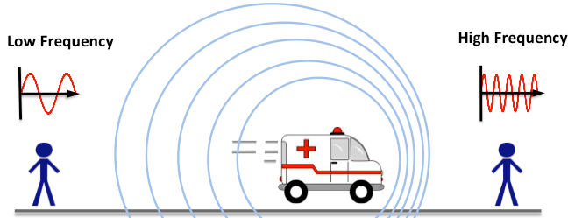
$$f=frequency \left(pitch\right)of sound wave$$  $v=speed of sound in the medium$  [343.2 m/s; 1,126 ft/s; 1,236 km/h; 768 mph]  $$v_{s}=speed of the sound source$$  $v_{r}=speed of the listener$ / receiver | Source Velocity ($v_{s}$) | Receiver Velocity ($v_{r}$) | Observed Frequency Equation
Source and receiver are both stationary | • | • | $$f_{r}=f_{s}$$
Source moving away from the receiver | ← | • | $$f_{r}=f_{s}\left(\frac{v}{v+v_{s}}\right)$$
Source moving towards the receiver | → | • | $$f_{r}=f_{s}\left(\frac{v}{v-v_{s}}\right)$$
Receiver moving towards the source | • | ← | $$f_{r}=f_{s}\left(\frac{v+v_{r}}{v}\right)$$
Receiver moving away from the source | • | → | $$f_{r}=f_{s}\left(\frac{v-v_{r}}{v}\right)$$
General Equation | ← → | ← → | $$f_{r}=f_{s}\left(\frac{v±v_{r}}{v∓v_{s}}\right)$$
Tip: Towards use top sign, away use bottom sign
Pick sign so observed frequency increases when towards (big numerator, small denominator)

Doppler Effect – Light
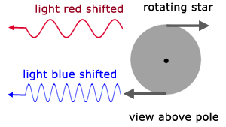 | 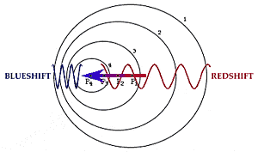
$$f=frequency of light wave at the source$$  $$c=speed of light$$  $$v=speed difference between two objects$$ | Source Velocity Relative to Receiver ($v$) | Receiver Velocity (0) | Observed Frequency Equation
Both objects are moving at the same velocity | • | • | $$f_{r}=f_{s}$$
Redshift: Source object moving away from the earth | ← | • | $$∎ f_{red}=f_{s}\left(\frac{c}{c+v}\right)$$
Blueshift: Source object moving towards the earth | → | • | $$∎ f_{blue}=f_{s}\left(\frac{c}{c-v}\right)$$
$$f=\frac{c}{λ}$$ | $$λ=\frac{c}{f}$$
$$λ=wavelength of light wave at the source$$  $$c=speed of light$$  $$v=speed difference between two objects$$ | Source Velocity Relative to Receiver ($v$) | Receiver Velocity (0) | Observed Wavelength Equation
Both objects are moving at the same velocity | • | • | $$λ_{r}=λ_{s}$$
Redshift: Source object moving away from the earth | ← | • | $$∎ λ_{red}=λ_{s}\left(\frac{c+v}{c}\right)$$
Blueshift: Source object moving towards the earth | → | • | $$∎ λ_{blue}=λ_{s}\left(\frac{c-v}{c}\right)$$

