Harold’s High School Physics
Cheat Sheet
13 October 2025

The 7 Base Units of Measure

Quantity Name | Symbol  (Value) | Metric Units (SI) | Imperial Units (English)
1. Length / Distance | $$w, x, y, z$$ | meter ($m$) | foot ($ft$)
2. Mass | $$m$$ | kilogram ($kg$) | slug (or $lb$)
3. Time | $$t$$ | second ($s$)
4. Temperature | $$T$$ | Kelvin ($K$)  Celsius ($⁰C$) | Fahrenheit ($⁰F$)
5. Electrical Current | $$i$$ | Ampere ($A$)
6. Amount of Substance | $$M, χ$$ | mole ($mol$) | 1 mol ≈ 6.02214076 × 10²³
7. Luminous Intensity | $$lv$$ | Candela ($cd$)
Note: The 7 base units are mutually independent from each other.
All other units of measurement can be derived from them.

Derived Units of Measure

Quantity Name | Symbol  (Value) | Metric Units  (SI) |  | Imperial Units  (English)
Length / Displacement | $$d, l, h, r, s$$ | meter ($m$) | $$m$$ | foot ($ft$) | $$ft$$
Area | $$A, SA$$ |  | $$m^{2}$$ |  | $$ft^{2}$$
Volume | $$V$$ | liter ($l$) | $$m^{3}$$ | fluid ounce (fl) | $$ft^{3}$$
Velocity / Speed | $$v, s$$ |  | $$\frac{m}{s}$$ |  | $$\frac{ft}{s}$$
Acceleration | $$a, g$$ |  | $$\frac{m}{s^{2}}$$ |  | $$\frac{ft}{s^{2}}$$
Impulse | $$I$$ |  | $$N∙s$$  $$kg∙\frac{m}{s}$$ |  | $$lb∙\frac{ft}{s}$$
Linear Momentum | $$p$$ |  | $$kg∙\frac{m}{s}$$ |  | $$lb∙\frac{ft}{s}$$
Force | $$F$$ | Newton ($N$) | $$kg∙\frac{m}{s^{2}}$$ | pound ($lb$) | $$slug∙\frac{ft}{s^{2}}$$
Energy / Work / Heat | $$E, W,$$  $$K or KE,$$  $$U_{g}, U_{s}, U_{E},$$  $$Q$$ | Joule ($J$) | $$N∙m$$  $$C∙V$$  $$W∙s$$  $$kg∙\frac{m^{2}}{s^{2}}$$ | calorie ($cal$) | $$ft∙lb$$
Power | $$P$$ | Watt ($W$) | $$\frac{J}{s}$$  $$V∙A$$  $$kg∙\frac{m^{2}}{s^{3}}$$ | horsepower ($hp$) | $$ft∙\frac{lb}{s}$$
Constants and Conversions

Constant Name | Symbol | Metric Units (SI) | Imperial Units (English)
Length | $$x$$ | $$1.0 m$$ | $$39.37 in$$  $$3.281 ft$$
Length | $$x$$ | $$2.54 cm$$ | $$1.0 in$$
Length | $$x$$ | $$30.48 cm$$ | $$1.0 ft$$
Length | $$x$$ | $$1.61 km$$ | $$1.0 mi$$
Length | $$x$$ | $$1.0 km$$ | $$0.621 mi$$
Length | $$x$$ | $$1 km=1,000 m$$ | $$1 mi=5,280 ft=1,760 yd$$
Mass | $$m$$ | $$1.0 kg$$ | $$2.205 lb$$
Mass | $$m$$ | $$0.454 kg$$ | $$1.0 lb$$
Mass | $$m$$ | $$1.0 g$$ | $$0.035 oz$$
Mass | $$m$$ | $$14.594 kg$$ | $$1 slug$$
Mass | $$m$$ | (standard gravity) | $$1 slug=32.174 lb$$
Time | $$t$$ | $$1 yr=365.24 d$$  $$1 d=24 h$$ | $$1 h=60 min$$  $$1 min=60 s$$
Acceleration
Earth’s Gravity | $$g$$ | $$-9.81\frac{m}{s^{2}}$$ | $$-32.2\frac{ft}{s^{2}}$$
Moon’s Gravity  (16.6% of Earth’s) | $$g_{m}$$ | $$-1.625 \frac{m}{s^{2}}$$ | $$-5.35\frac{ft}{s^{2}}$$
Temperature | $$T$$ | $$0 ℃$$ | $$32 ℉$$
Temperature | $$T$$ | $$100 ℃$$ | $$212 ℉$$
Temperature | $$T$$ | $$-17.8 ℃$$ | $$0 ℉$$
Temperature | $$T$$ | $$37.8 ℃$$ | $$100 ℉$$
Force | $$F$$ | $$1.00 N$$ | $$0.225 lb$$
Force | $$F$$ | $$4.45 N$$ | $$1.00 lb$$
Volume | $$V$$ | $$3.785 L$$ | 1.0 $gallon$
Volume | $$V$$ | $$1.0 L$$ | $$1.057 quarts$$  $$0.264 gallons$$

How to Solve Physics Word Problems
Modified GUESS Method |  | - Read  - Diagram  - Givens  - Observations  - Unknowns | - Equations  - Solve  - Substitute  - Double-Check |  | 
Scenario

A marching band cadet marches on a football field.
First, he marches 10 yards East, then 40 feet North.
What is the shortest distance he must march to return to where he started?
# | Step |  |  | Example
 | 1. Carefully read the problem.  Translate each word of each sentence into math. |  |  | Reread the problem several times to make sure you did not miss anything.
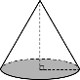 | 2. Draw a diagram.  Clearly label everything. |  |  | a  b  c  N
G | 3. Write down the givens as variables with units.  What information did they provide?  Are any of them extraneous? |  |  | a = 10 yards East  b = 40 feet North
 | 4. Calculate observations or easily derived information.  Don’t forget unit conversions for consistency. |  |  | $$10 yards×\left(\frac{3 feet}{1 yard}\right)=30 feet$$
U | 5. Write down the unknowns.  What are they asking for? |  |  | The shortest distance is a straight line, or the hypotenuse. ‘$c$’.  $c$ = ____?____ <units>
E | 6. Recall relevant equations and formulas. |  |  | Since the path marched is a right triangle, we can use the Pythagorean Theorem: $a^{2}+b^{2}=c^{2}$
S | 7. Solve symbolically for the unknown variable.  Reduce algebraically to the simplest form.  Do not substitute until fully solved. |  |  | $$a^{2}+b^{2}=c^{2}$$  $$c=\sqrt{c^{2}}=\sqrt{a^{2}+b^{2}}$$
S | 8. Substitute the givens into the solved formula.  Use a calculator as needed to calculate the answer. |  |  | $a$ = 30 feet  $b$ = 40 feet  $$c=\sqrt{{(30 feet)}^{2}+{(40 feet)}^{2}}=50 feet$$
✓✓ | 9. Double-check your work.  Ask yourself if the answer is reasonable and makes  sense. Don’t forget the units. Box in your answer. |  |  | The shortest distance the cadet must march is 50 feet.

See also: GUESS Method for problem-solving.

Chapter 1: Let’s Move! (Velocity)

Term | Equation | Description
Vector Quantity | $$\vec{x}=10\frac{m}{s} East$$ | A quantity that includes direction.  (e.g., magnitude and direction)
Scalar Quantity | $$b$$ | A quantity that does not include direction.
Friction | $$F_{μ}$$ | A force that resists motion when two bodies are in contact.
Inertia | $$I$$ | The tendency of a body to resist changes in its velocity.
Average Velocity | $$v_{ave}=\frac{v_{f}-v_{i}}{Δt}$$ | The average of the velocity over a given time interval.
Instantaneous Velocity | $$v=\frac{Δx}{Δt}$$ | The velocity at a given instant in time.
Acceleration | $$a=\frac{Δv}{Δt}$$ | A change in an object’s velocity.
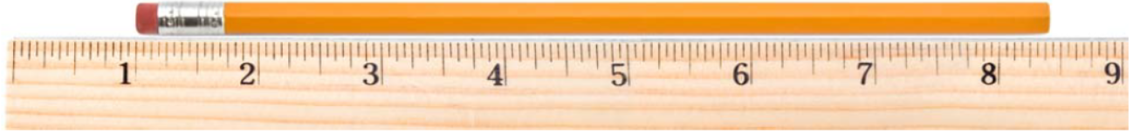
Rulers | When using a ruler that is marked off in 16ths of an inch, report your answers to a hundredth of an inch.
Units | $$g=-9.81\frac{m}{s^{2}}$$ | You must always list the units after the number.  (The units are just as important as the number.)
Significant Figures | - All non-zero figures (1, 2, 3, 4, 5, 6, 7, 8, & 9) are significant.  - A zero (0) is significant if it is between two significant digits.  - A zero (0) is also significant if it is at the end of the number and to the right of the decimal point.
Using SigFigs | - When adding and subtracting measurements, you must report your answer to the same precision as the least precise number in the problem.  - When multiplying and dividing measurements, you must report your answer with the same number of significant figures as the measurement that has the fewest significant figures.  - There is always some error in the last significant figure of a measurement.
Precision vs. Accuracy | - Precision: The consistency and reproducibility of measurements (e.g., 10 decimal places).  - Accuracy: How close a measurement is to the true or accepted value.
Scientific Notation | 14,000,000 = 1.4⨯10⁷ = 1.4E7 |  | 0.00000014 = 1.4⨯10⁻⁷ = 1.4E–7
Systematic Errors | “Science cannot prove anything.”  There is always a possibility that our experiments are wrong since they contain systematic errors.
Unit Conversion (Train Track Method) | 17 years = ? sec
  17 yr | 365.24 days | 24 hours | 60 min | 60 sec | 536,464,512 sec
   | 1 yr | 1 day | 1 hour | 1 min
Prefixes
  Prefix | Abbreviation | Meaning | Scientific
  giga | G | 1,000,000,000 | 10⁹
  mega | M | 1,000,000 | 10⁶
  kilo | k | 1,000 | 10³
  hector | H | 100 | 10²
  deca | Da | 10 | 10¹
  centi | c | 0.01 | 10⁻²
  milli | m | 0.001 | 10⁻³
  micro | μ | 0.000001 | 10⁻⁶
  nano | n | 0.000000001 | 10⁻⁹
Speed | $$s=\frac{Δd}{Δt}$$ | Speed ($s$) is a scalar quantity.
Velocity | $$v=\frac{Δx}{Δt}$$ | Velocity ($v$) is a vector quantity.
Relative Velocity | $$v_{relative}=v_{moving_object}-v_{reference_object}$$
Unit Consistency | Before solving a problem, look at the units and make sure they are consistent.  If they are not, convert the inconsistent units before you continue. ($ft$ vs. $m$)
Newton's First Law of Motion  (Law of Inertia) | An object will remain at rest, or in motion at a constant velocity ($v$ or constant speed in a straight line), unless acted upon by a net external force ($F$). |  |  | 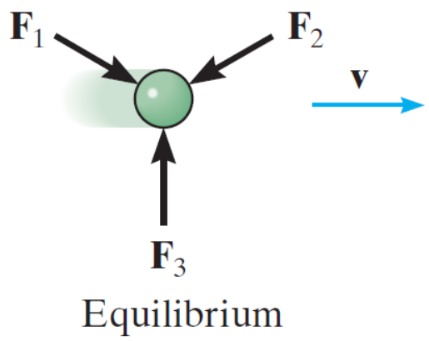
Velocity with Acceleration | - When acceleration and velocity are in the same direction $(⇉)$, an object’s speed increases. $(↑)$  - When acceleration and velocity are in opposite directions $(⇄)$, an object’s speed decreases. $(↓)$
Velocity Graph | 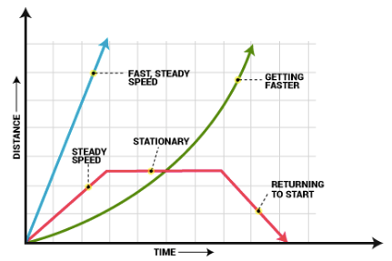
Slope = Velocity | The slope of a position ($x$) versus time ($t$) graph is the velocity ($v$).

Chapter 2: Force and Acceleration

Term | Equation | Description
Newton's Second Law of Motion  (Law of Acceleration) | At any instant of time, the net force on an object is equal to the object's mass multiplied by its acceleration $(F=ma)$ or, equivalently, the rate at which the object's momentum changes with time $\left(∆p/∆t\right)$. |  | 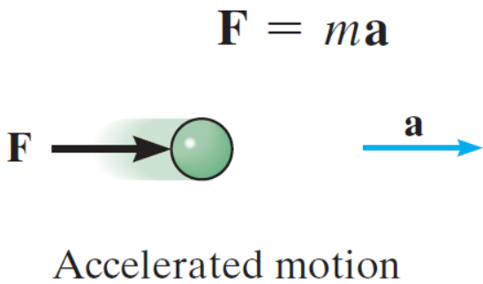
Free Fall | The motion of an object when the only force acting on it is the force due to gravity $(F_{g})$.
Air Resistance | The force with which air resists motion through it.
Acceleration | $$a=\frac{Δv}{Δt}$$ | A change in an object’s velocity.
Acceleration Graph | 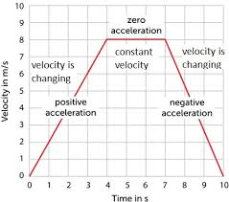
Slope = Acceleration | The slope of a velocity ($v$) versus time ($t$) graph is the acceleration ($a$).
Force | $$F=ma$$ | Force ($F$) is any interaction that, when unopposed, changes the motion of an object.
Acceleration | $$v=v_{0}+at$$ | $$a=\frac{Δv}{Δt}=\frac{v_{f}-v_{0}}{t}$$
Velocity | $$v^{2}=v_{0}^{2}+2a∙Δx$$ | Derivation: Solve for $t$, set $t=t$, then simplify.  $$\frac{v_{f}+v_{0}}{2}=\frac{Δx}{t} and v_{f}=v_{0}+at$$
Position  (Displacement) | $$x=x_{0}+v_{0}t+\frac{1}{2}at^{2}$$  $$Δx=v_{0}t+\frac{1}{2}at^{2}$$ | Displacement ($Δx$) is the area underneath a velocity versus time graph.
$a$ is Constant | $$J=\frac{Δa}{Δt}$$  (Jerk/Jolt) | These equations of motion apply only when the acceleration ($a$) is constant.
Gravity | $$g=-9.81\frac{m}{s^{2}}$$  $$g=-32.2\frac{ft}{s^{2}}$$ | The acceleration due to gravity ($g$) on the surface of the Earth is the same for all objects.  It is negative ($-$) since it is directed downwards $(↓)$.
Weight vs. Mass | $$weight=mg$$ | Weight is a force.  Since $F=ma,$ and $a$ on Earth is $g$, then $weight=mg$.

Chapter 3: Friction

Term | Equation | Description
Newton’s Third Law of Motion  (Law of Action and Reaction) | If object A exerts a force on object B, then B will exert an equal but opposite force on A. |  | 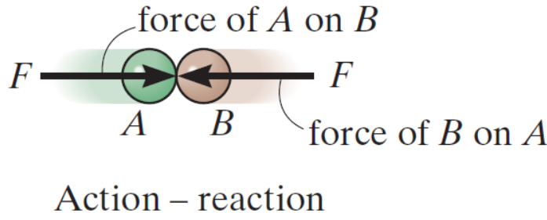
Static Friction ($μ_{s}$) | The frictional force between two surfaces that are stationary relative to each other.
Kinetic Friction ($μ_{k}$) | The frictional force between two surfaces that are moving relative to each other.
Tension ($T$) | A force transmitted through a rope or similar object (e.g., a thread or chain) when it is pulled.
Streamlined Shape | A shape that reduces air resistance.
Wind Resistance | The faster an object moves through the air, the stronger the air resistance.
Terminal Velocity | The maximum velocity $(v_{max})$ attained by a falling object.
Normal Force ($N or F_{n}$) | $$F_{f}=μ∙F_{n}$$ | 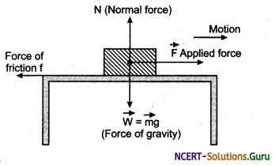
Coefficient of Friction ($μ$) | The coefficient of friction is unitless. It represents a percentage of the normal force that is opposing the applied force.  Static friction ($μ_{s}$) is generally larger than kinetic friction ($μ_{k}$).  $$0≤μ≤1$$
  Material | Static ($μ_{s}$) | Kinetic ($μ_{k}$)
  Zero friction | 0 | 0
  Ice or grease | 0.15 | 0.03
  Paper | 0.35 | 0.25
  Wood | 0.5 | 0.4
  Rubber | 0.9 | 0.8
Block and Tackle  (Pully System) | 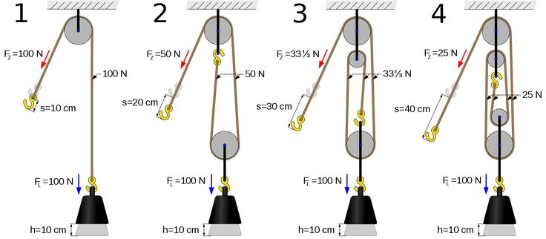

Chapter 4: Two-Dimensional Vectors

Term | Equation |  | Description
Vector Anatomy | An arrow is used to represent a two-dimensional vector.  The length of the arrow is the magnitude (a scalar quantity).  And the counterclockwise angle from the positive x-axis is the direction.  3D arrow symbols: ⊙ out of page (+), ⨂ into the page (–).
Vectors “Float” | Arrows representing vectors can be moved freely, as long as their length and direction are not changed.
Hypotenuse | The longest side of a right triangle.
Trig Review | 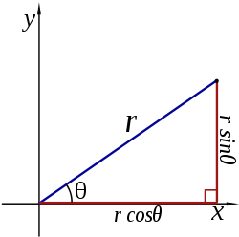
Converting Between Coordinate Systems | Polar Rect.  $r ∠ θ$ $(r , θ)$  $$x=r\cos{θ}$$  $$y=r\sin{θ}$$  $$\tan{θ}=\left(\frac{y}{x}\right)$$ | Rect. Polar  $(r , θ)$ $r ∠ θ$  $$r^{2}= x^{2}+y^{2}$$  $r= \sqrt{x^{2}+ y^{2}}$  $$θ=\tan^{-1}\left(\frac{y}{x}\right)$$
Vertical Component | $$A_{y}=A∙sin⁡(θ)$$
Horizontal Component | $$A_{x}=A∙cos⁡(θ)$$
Angle | $$θ=\tan^{-1}\left(\frac{A_{y} }{A_{x}}\right)$$
Magnitude | $$|A|=\sqrt{A_{x}^{2}+A_{y}^{2}}$$  $$a^{2}+b^{2}=c^{2}$$
Vector Addition | When adding vectors A and B to get C, add each dimension separately.  $$C_{x}=A_{x}+B_{x}$$  $$C_{y}=A_{y}+B_{y}$$
Vector Addition | 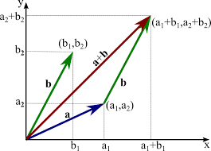
Chapter 5: Two-Dimensional Motion

Term | Equation | Description
Projectile | An object that has an initial velocity ($v_{0}$) but experiences only the force of gravity ($g$).
Parabolic Motion | Motion along a parabolic path, which is exhibited by projectiles.
Dimensions | Two-dimensional (2D) situations can often be analyzed as two one-dimensional (2x 1D) situations. Time (t) spans all dimensions.
Orthoganal | In two-dimensional (2D) motion, perpendicular ($⊥$) components of the motion operate independently.
Graph Orientation | The way we define the angle makes motion up ($↑$) and motion to the right ($→$) (or to the east) positive (+).  These are the best definitions to use with our one-dimensional (1D) motion equations.
Projectile Motion | 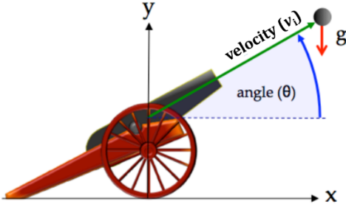  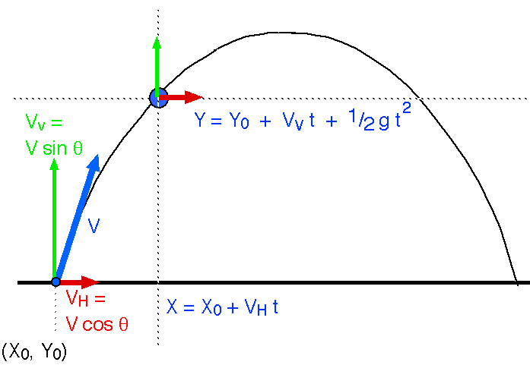  2
 | Horizontal (x-axis) | Vertical (y-axis)
Position Equations | $$x(t)= x_{0}+v_{x}t+\frac{1}{2}a_{x}t^{2}$$ | $$y(t)= y_{0}+v_{y}t-\frac{1}{2}gt^{2}$$
Velocity Equations | $$v_{x}=v cos(θ)$$ | $$v_{y}=v sin(θ)$$
Range Equations | $$range=x_{max}=\frac{v^{2}∙sin⁡(2θ)}{g}$$ | $$height=y_{max}=y\left(\frac{t_{max}}{2}\right)$$
Air Resistance | Assume no air/wind resistance (drag).  (If we factor in air/wind resistance, then differential calculus is needed.) | 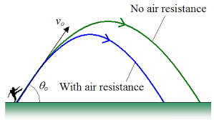

Chapter 6: Newton’s Second Law and Two-Dimensional Motion

Term | Equation | Description
Translational Equilibrium | The state in which the net force ($F$) acting on an object is equal to zero (0).
Static Translational Equilibrium | The state in which an object is in translational equilibrium and is not moving ($v=0$).
Dynamic Translational Equilibrium | The state in which an object is in translational equilibrium and is moving ($v≠0$).
Accelerometer | A device that measures acceleration ($a$).
Axis of Rotation | An imaginary line around which all points of a rotating body move in circles.
Lever Arm | The distance between the axis of rotation and the force used to produce rotational motion.
Rotational Equilibrium | Force ($F$) causes changes in translational motion, while  torque ($τ$) causes changes in rotational motion.
Tension | Tension ($T$) is a force.
Gravity Components | On an incline whose angle ($θ$) is defined relative to the horizontal, the component of the force due to gravity:  - Parallel to the incline is $mg∙\sin\left(θ\right).$  - Perpendicular to the incline is $mg∙cos(θ)$.
Gravity Components | $$F_{x}=mg∙\sin\left(θ\right)$$ | $$F_{y}=mg∙cos(θ)$$
Coefficient of Friction | $$μ=\frac{sin\left(θ\right)}{cos\left(θ\right)}=tan(θ)$$
Torque | $$τ=F_{⊥}∙r$$
Rigid Bodies | $$\sum{F}=\sum{ma}=0$$ | $$\sum{τ}=\sum{Fr}=0$$
 |  | 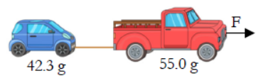
 |  | 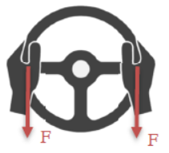
 | 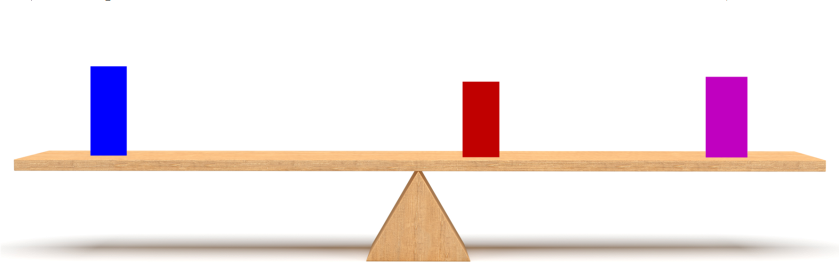

Chapter 7: Uniform Circular Motion and Gravity

Term | Equation | Description
Centripetal Force | A force directed to the center of a circle.
Period ($T$) | The time it takes to complete one full cycle.
Frequency ($f$) | The number of cycles that can be completed every second.
Gravity ($g$) | The acceleration of the attractive force that exists between all physical objects that have mass.
Satellite | A body that orbits another body.
Frequency | $$f=\frac{1}{T}$$  $$Units: Hertz (Hz)$$ | 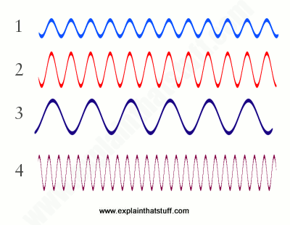
Speed | $$v=\frac{2πr}{T}$$  $$Units: \frac{m}{s}$$
Centripetal Force | $$F_{c}=\frac{mv^{2}}{r}$$  $$Units: Newtons (N)$$ | 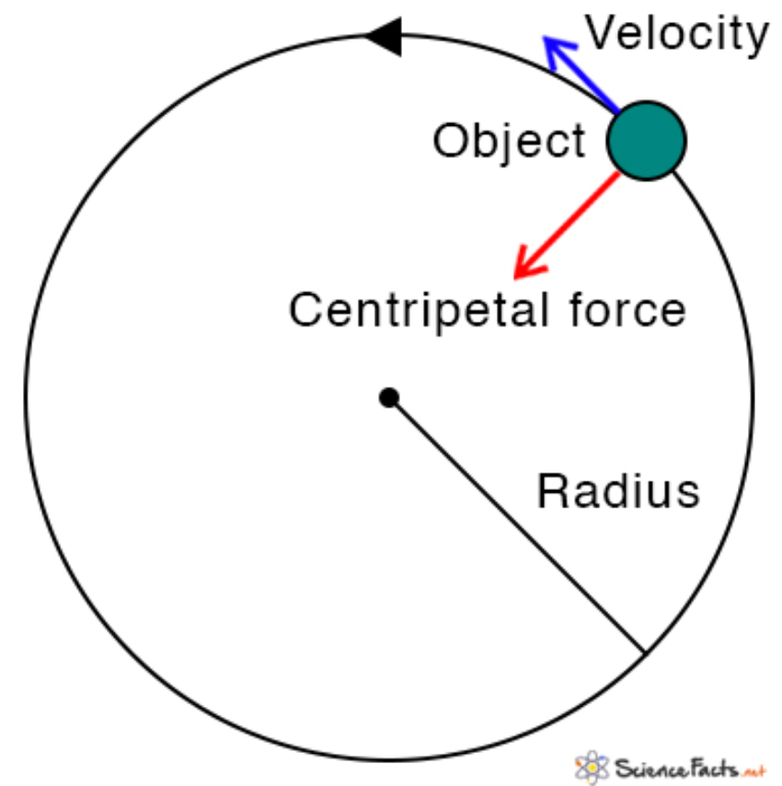
Centripetal Acceleration | $$a_{c}=\frac{v^{2}}{r}$$  $$Units: \frac{m}{s^{2}}$$ | 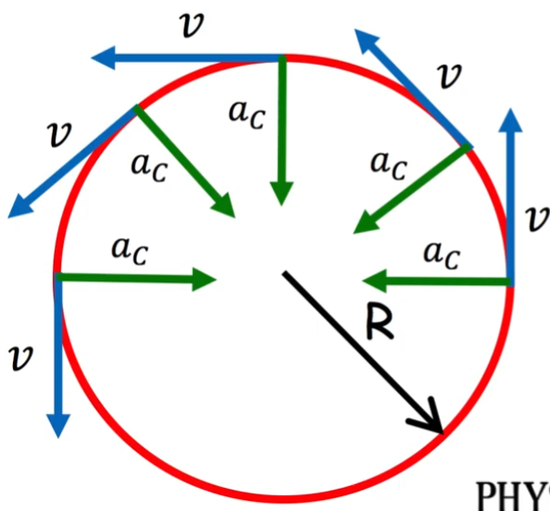
Gravitational Force | $$F_{g}=\frac{Gm_{1}m_{2}}{r^{2}}$$ | 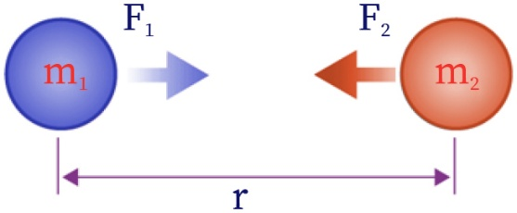
Gravitational Constant ($G$) | $$G=6.67×{10}^{-11}\frac{Nm^{2}}{kg^{2}}$$
Kepler’s Laws  (of planetary motion) | 1. Orbits: All planets move in elliptical orbits, with the sun at one focal point.  $$\frac{x^{2}}{a^{2}}+\frac{y^{2}}{b^{2}}=1$$ | 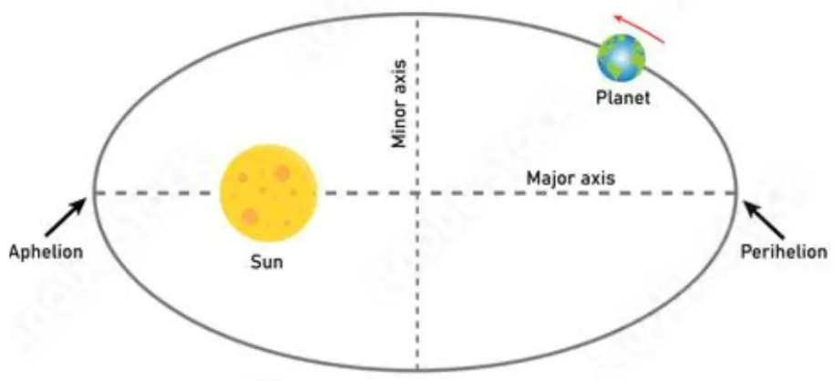
Kepler’s Laws  (of planetary motion) | 2. Areas: A line that connects a planet to the sun sweeps out equal areas in equal time intervals.  $$A_{1}=A_{2}$$ | 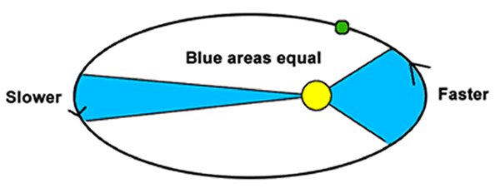
Kepler’s Laws  (of planetary motion) | 3. Periods: The square of a planet’s period is proportional to the cube of its orbit’s semi-major axis.  $$T^{2}∝a^{3}$$ | 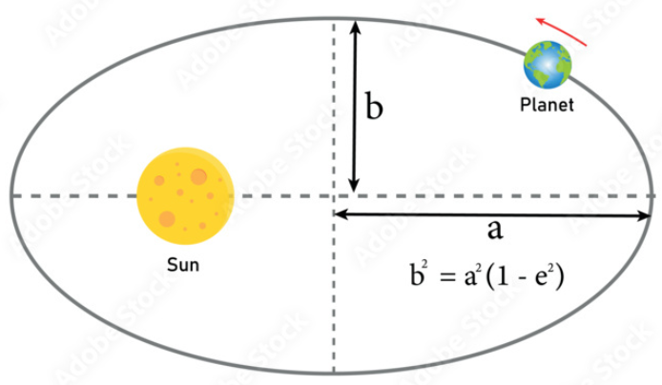

Chapter 8: Energy

Term | Equation | Description
Energy | $$E$$ | The ability to do work.
Work | $$W=Fd$$  $$W=F_{∥}∙∆x$$ | The magnitude of an object’s displacement times the parallel component of the applied force.
Work | $$W=Fd$$  $$W=F_{∥}∙∆x$$ | When a body does work, it loses energy.  When a body is worked on, it gains energy.
Potential Energy (PE) | $$PE=mgh$$ | Energy that is stored but not currently doing work.
Potential Energy (PE) | $$PE=mgh$$ | Potential energy is relative, so it must be defined relative to a reference point.
Kinetic Energy (KE) | $$KE=\frac{1}{2}mv^{2}$$ | Energy in the form of motion.
Total Energy (TE) | $$TE=PE+KE+W_{f}=constant$$  $$E=U_{g}+K+W_{f}+Q=constant$$
The First Law of Thermodynamics | Energy ($E$) cannot be created or destroyed. It can only change forms.
Power | $$P=\frac{∆W}{∆t}$$  $$P=Fv$$ | The amount of energy converted or transferred per unit time.
Units | $$E$$ | Joules ($J$)  ($kg∙m^{2}/s^{2}$)
Units | $$W$$ | Joules ($J$)  ($kg∙m^{2}/s^{2}$)
Units | $$PE$$ | Joules ($J$)  ($kg∙m^{2}/s^{2}$)
Units | $$KE$$ | Joules ($J$)  ($kg∙m^{2}/s^{2}$)
Units | $$TE$$ | Joules ($J$)  ($kg∙m^{2}/s^{2}$)
Units | $$P$$ | Watt ($W$)  ($J/s$)

Chapter 9: Momentum and Its Conservation

Term | Equation | Description
Momentum
Law of Momentum Conservation
Elastic Collision
Inelastic Collision
Law of Angular Momentum Conservation

Chapter 10: Periodic Motion

Term | Equation | Description
Periodic Motion
Hooke’s Law
Amplitude
Simple Harmonic Motion
Damped Harmonic Motion
 |  | 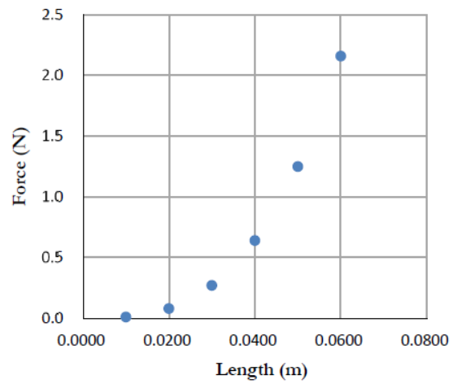

Chapter 11: Sound and Light

Term | Equation | Description
Oscillations
Transverse Wave
Wavelength
Longitudinal Wave
Doppler Effect
Sonic Waves
Ultrasonic Waves
Infrasonic Waves
Timbre
Wave-Particle Duality

Chapter 12: Optics

Term | Equation | Description
Law of Reflection
Virtual Image
Real Image
Refraction
Spherical Aberration
Chromatic Aberration
 |  | 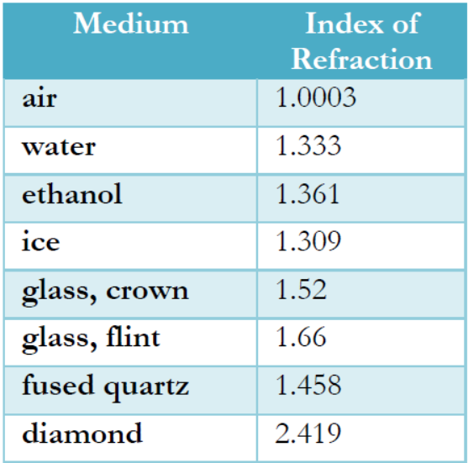

Chapter 13: The Electrostatic Force

Term | Equation | Description
Electrostatic Force
Triboelectric Charging
Charging by Conduction
Charging by Induction
Conductor
Insulator
 |  | 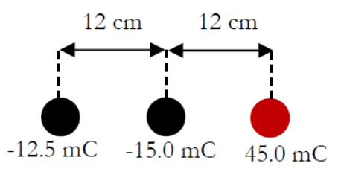
 |  | 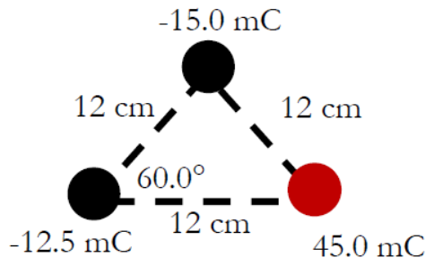
 |  | 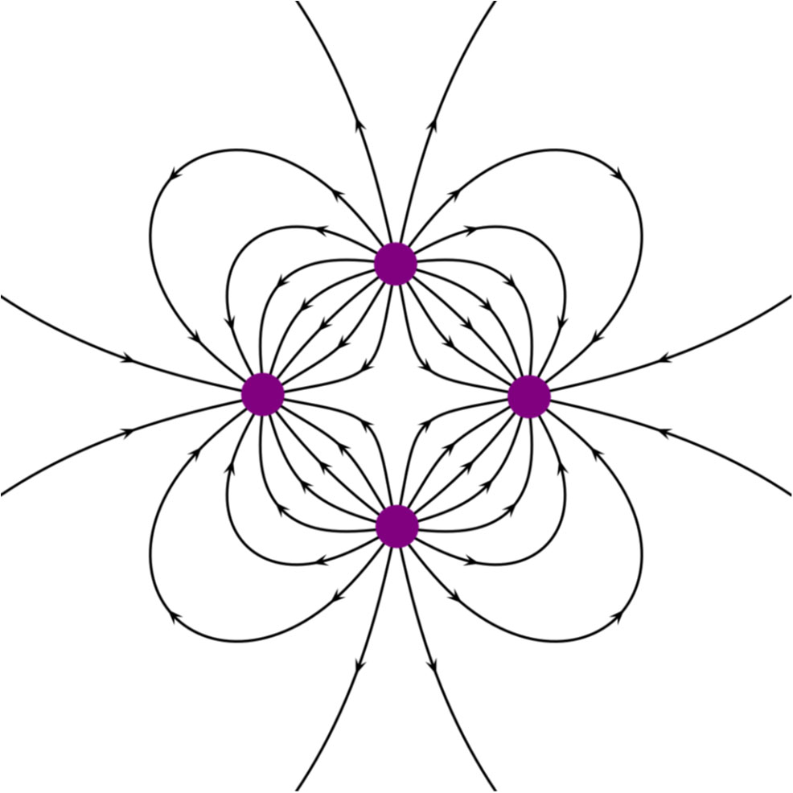

Chapter 14: Electricity Has Potential!

Term | Equation | Description
Electric Potential
Electron Volt
Capacitor
Capacitance
Electric Permittivity ($ε$)
Ground (Electrical)
Law of Charge Conservation
Electric Current
Electric Circuit
 |  | 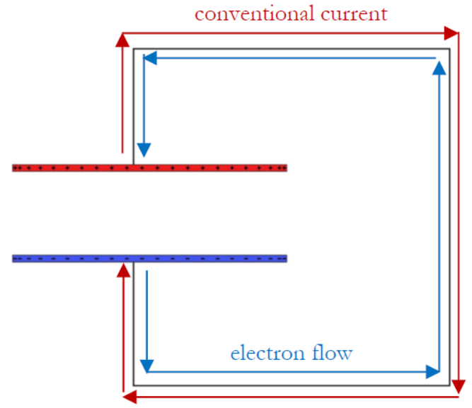

Chapter 15: Electric Circuits

Term | Equation | Description
Drift Velocity
Resistor
Battery
(Voltage source)
Fuse
Capacitor
Switch
 |  | 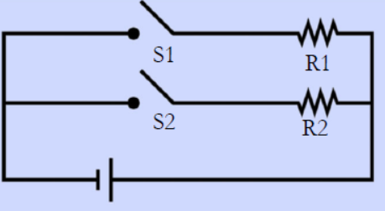
 |  | 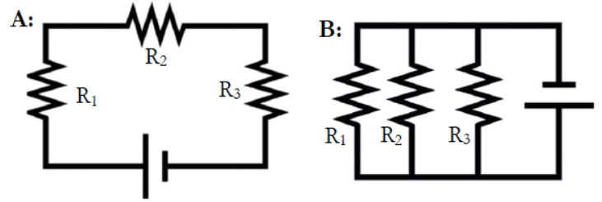
 |  | 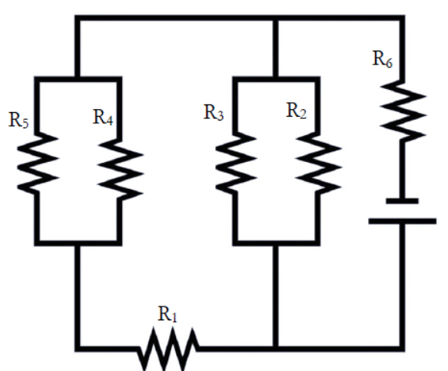
 |  | 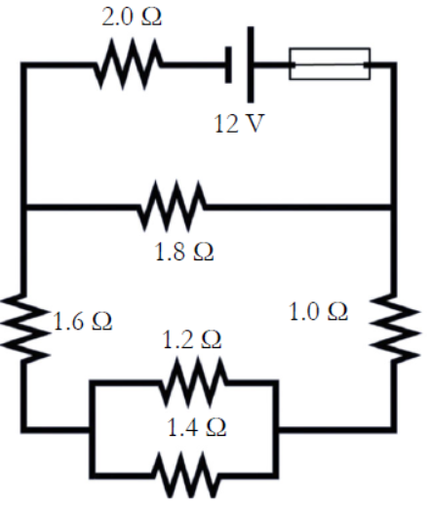
 |  | 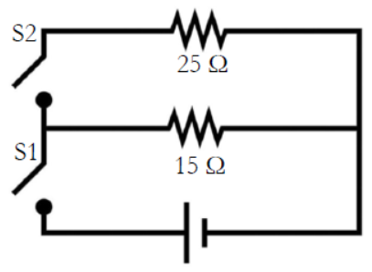
 |  | 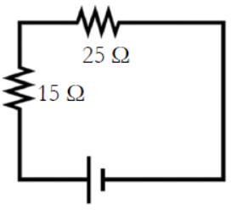
 |  | 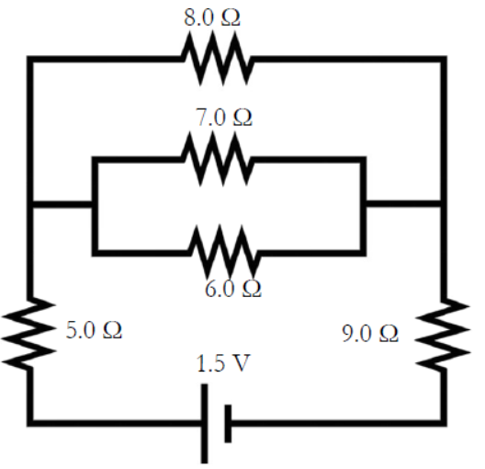
 |  | 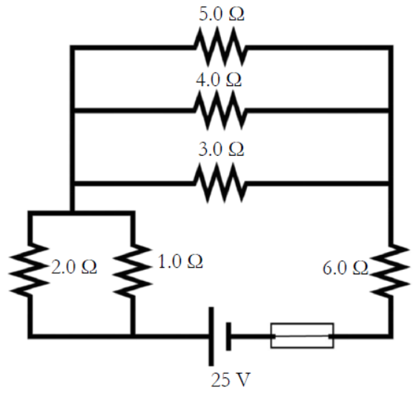

Chapter 16: Magnetism

Term | Equation | Description
Basic Law of Magnetism
Magnetic Permeability ($μ$)
Right-Hand Rule
Diamagnetic Substance
Paramagnetic Substance
Ferromagnetic Substance
Faraday’s Law of Magnetic Induction
Electromotive Force
Alternating Current
Direct Current
Rectifier
Inverter
Lenz’s Law

Sources
These chapters and content are from the textbook:
- Dr. Jay L. Wile (2023). Discovering Design with Physics, 1st Edition.

