Harold’s Physics - Waves
“Cheat Sheet”
13 February 2014

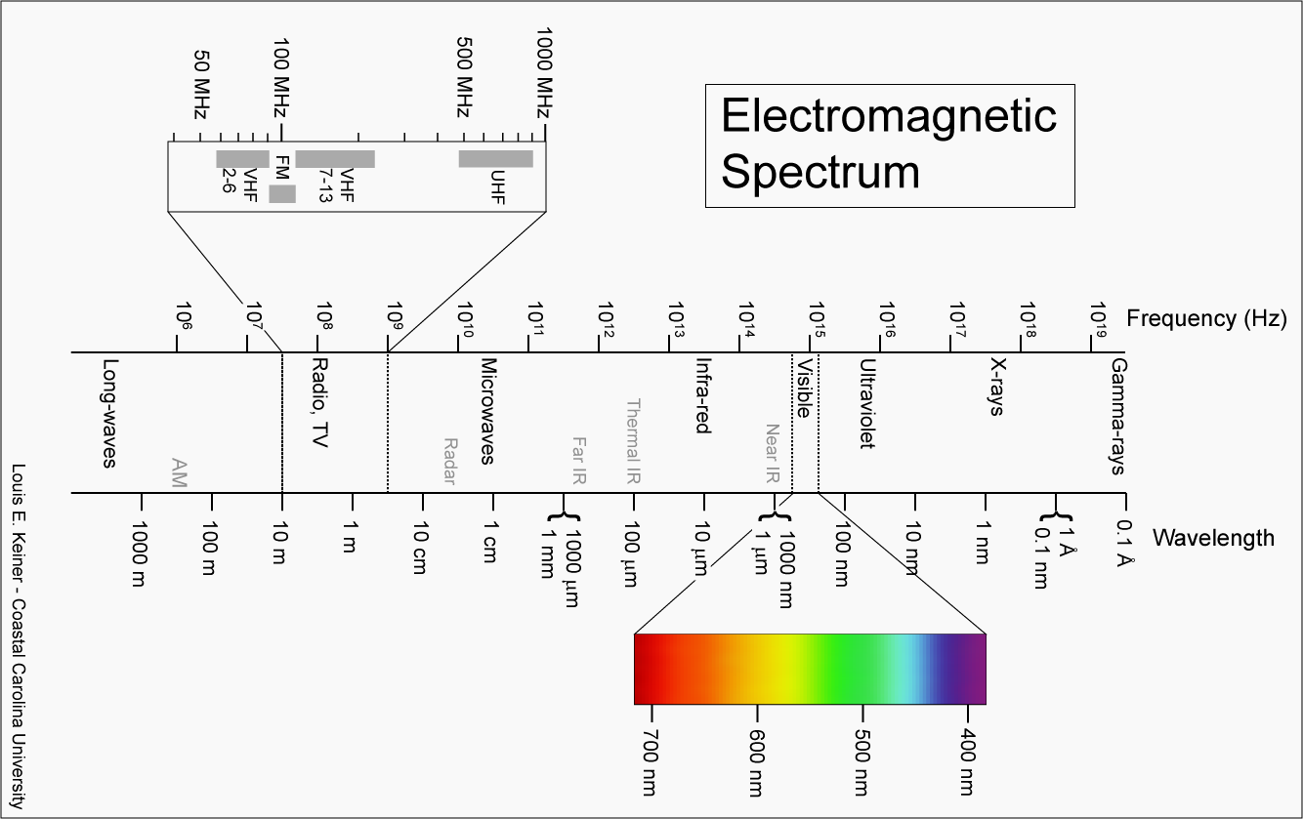
$$v=λf=\frac{λ}{T}$$
$$v=c=3.00×{10}^{8} m/s$$

