Harold’s Flip-Flops
Cheat Sheet
13 June 2020

S-R Flip-Flop (Edge-Triggered)
Style | NAND-NAND | AND-NOR
Circuit | 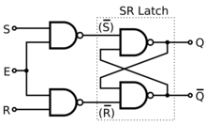 | 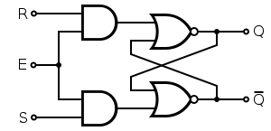
Symbol | 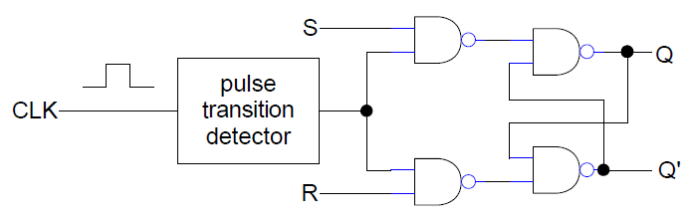  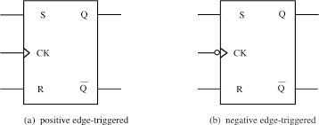
Truth Table | S R Q_{next} Action  0 0 Q No change, Hold  0 1 0 Reset (Q 0)  1 0 1 Set (Q 1)  1 1 X Invalid, Not allowed
Boolean Equation | $$Q_{next}=\overline{R}Q_{prev}+\overline{R}S=\overline{R}(Q_{prev}+S)$$
Name Origin | SR for Set-Reset
Observations | A Flip-Flop is a Latch with 2 AND/NAND gates added for clock input to trigger data flow from left to right
Applications | - Storing a single bit of data, 1 or 0
TTL Chips | 74x71, 74Lx74
D Flip-Flop (Edge-Triggered)
Style | NAND-NAND | AND-NOR
Circuit | 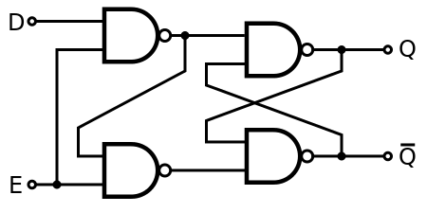 | 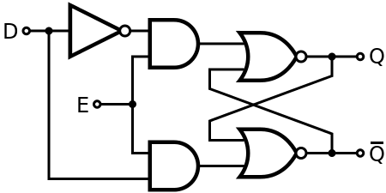
Symbol | 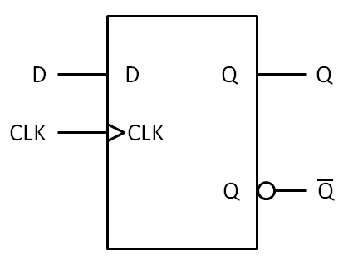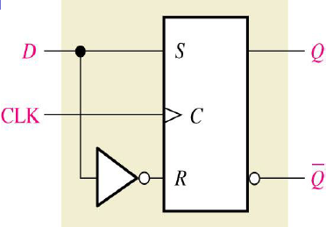
Truth Table | Inputs Outputs Action  D CLK Q_{next} Q’_{next}  0 ↑ 0 1 Reset (Q 0)  1 ↑ 1 0 Set (Q 1)
Boolean Equation | $$Q_{next}=D$$
Name Origin | D for Delays, since it delays the signal until the next active clock transition
Observations | - Made with S-R flip-flop with input S inverted for input R  - Stores a single bit after the edge-triggered clock pulse
Applications | - Storing Bits (memory) in a pipeline  - Event Detection
TTL Chips | 74x74, 74x79, 74x171, 74x173

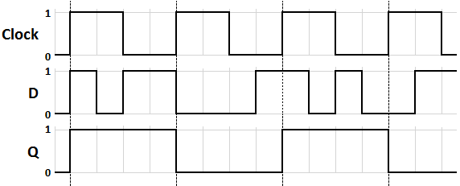
J-K Flip-Flop (Edge-Triggered)
Style | NAND-NAND | AND-NOR
Circuit | 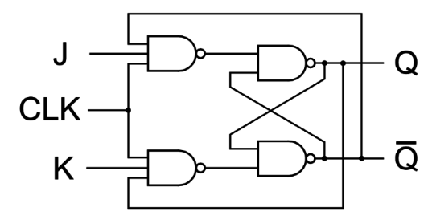 | 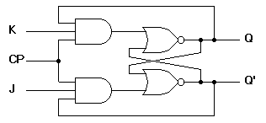
Symbol | 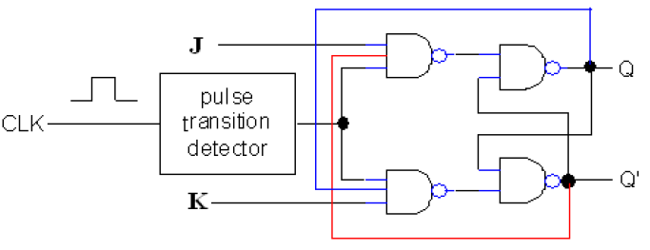  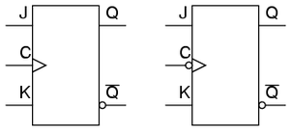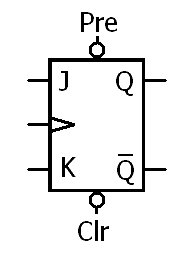
Truth Table | Inputs Outputs  J K CLK Q_{next} Q’_{next} Action  0 0 ↓ Q Q’ Hold, No change  0 1 ↓ 0 1 Reset (Q 0)  1 0 ↓ 1 0 Set (Q 1)  1 1 ↓ Q’ Q Toggle, Change (1 0)
Boolean Equation | $$Q_{next}=J\overline{Q} _{prev}+\overline{K}Q_{prev}$$
Name Origin | None, other than J and K are adjacent letters in the alphabet
Observations | - Same as S-R flip-flop except 2 feedback lines added  - Fixes the invalid 1-1 state
Applications | - Frequency Division: If $J=K=HIGH,$ then clock frequency divider $\left(f/2\right)$  - Counting: If cascaded with Q_{A} wired to JK_{B} CLK, then Q_{A} = LSB and Q_{B}=MSB  - Sequence Detection: If cascaded with Q_{A}J_{B} and Q’_{A}K_{B}, then tap Q/Q’s for 1/0 pattern, then AND for output
TTL Chips | 74x68, 74x69, 74x70, 74x73, 74x76, 74x101, 74x102, 74X103, 74x107
T Flip-Flop (Edge-Triggered)
Style | NAND-NAND | AND-NOR
Circuit | 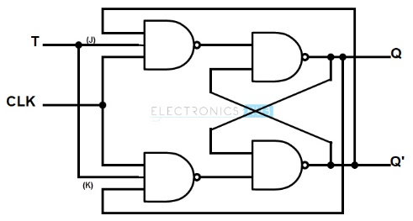 | 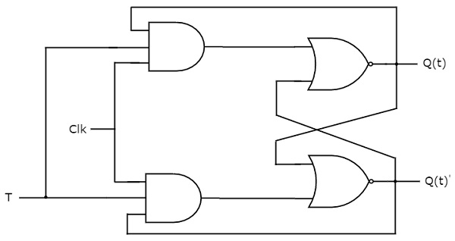
Symbol | 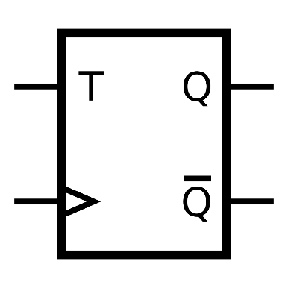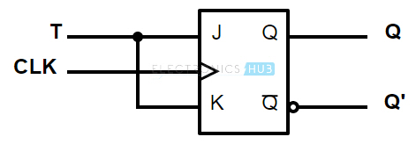
Truth Table | Inputs Outputs Action  T CLK Q_{next} Q’_{next}  0 ↑ Q Q’ No change, Hold  1 ↑ Q’ Q Change, Toggle
Boolean Equation | $$Q_{next}={\overline{Q}}_{prev}$$
Name Origin | T for Toggle, since it changes state on the triggering edge of the clock pulse
Observations | - Made with J-K flip-flop with input T connected to both J and K  - Implements the two middle rows of the J-K flip-flop truth table
Applications | - Frequency Division: If $J=K=HIGH,$ then clock frequency divider $\left(f/2\right)$
TTL Chips | 74x374 or use J-K flip-flop chips

J-K Flip-Flop Applications
Frequency Division | If $J=K=HIGH,$ then clock frequency divider $\left(f/2\right)$
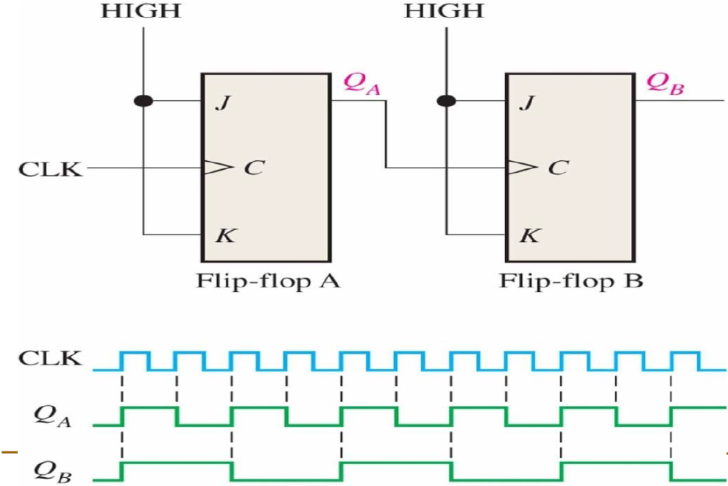

Counting | If cascaded with Q_{A} wired to JK_{B} CLK, then Q_{A} = LSB and Q_{B}=MSB
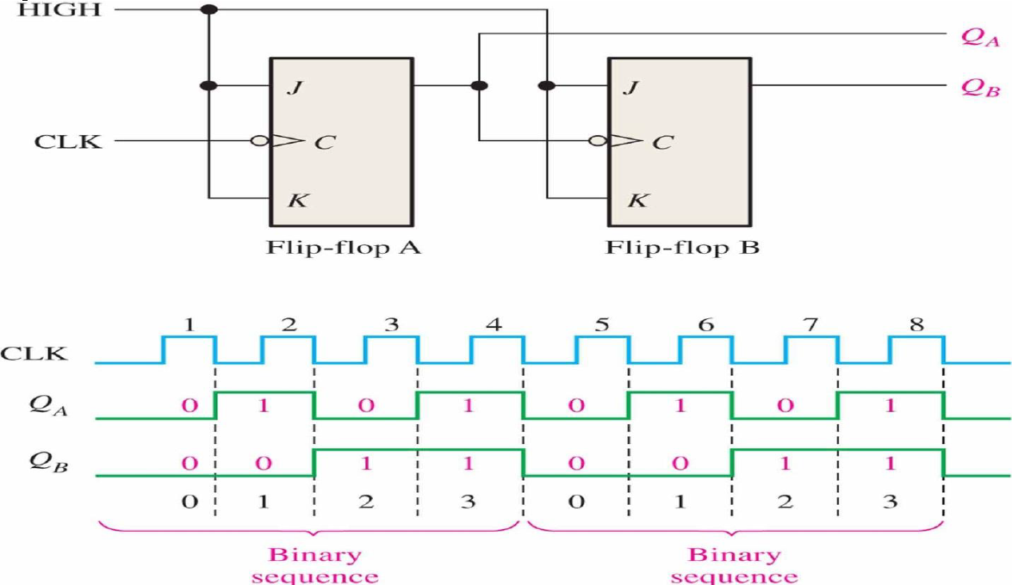

Sequence Detection | If cascaded with Q_{A}J_{B} and Q’_{A}K_{B}, then tap Q/Q’s for 1/0 pattern, then AND for output
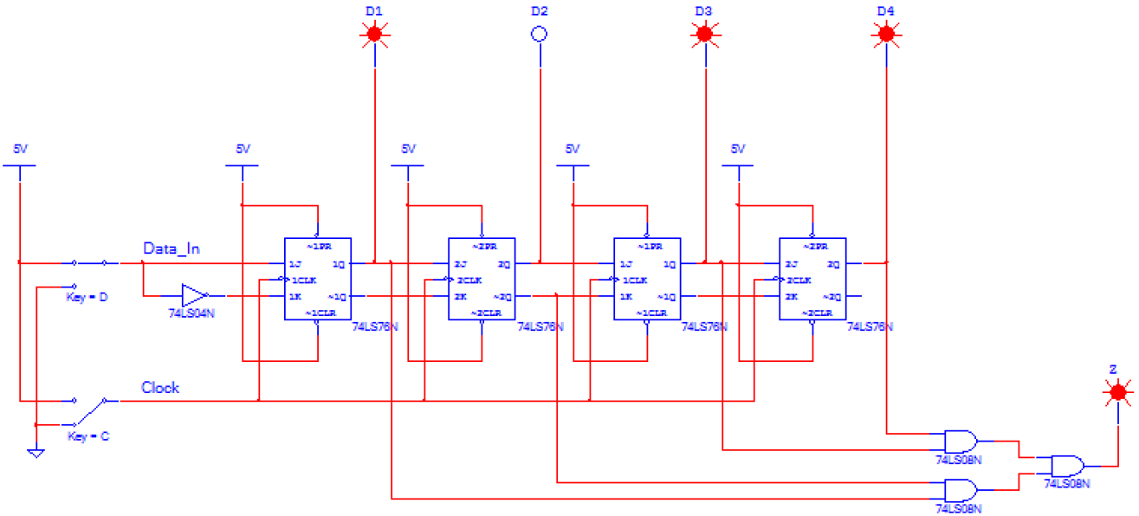

Credit: Diagrams taken from “ECPI University EET 230 – Digital Systems II”, Wikipedia, and Google images.

