Harold’s Complex Variables
Cheat Sheet
9 May 2024

Definitions

Name | Definition or Formula
Imaginary Number | $$i=\sqrt{-1}$$  $$i^{2}=-1$$  $$i^{3}=-i$$  $$i^{4}=1$$  $i$ is used by mathematicians.  $j$ is used by electrical engineers.
Complex Number | 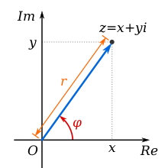  Rectangular Form $(x, y)$:  $$z=x+iy$$  $$z=\left(x,y\right) where x=Re z; y=Im z$$  Polar Form $(r, θ)$:  $$z=r\left(\cos{θ}+i\sin{θ}\right)$$  Exponential Form ($e^{x}$):  $$z=re^{iθ}$$  Parametric Form $(ρ, θ)$:  $$z=z_{0}+ρe^{iθ}$$  $$(0≤θ≤2π)$$  Shorthand:  $$e^{z}=\exp\left(z\right)=e^{x}e^{iy}$$
Complex Conjugate | $$\overline{z}=x-iy$$  $$\overline{z}=r\left(\cos{θ}-i\sin{θ}\right)$$  $$\overline{z}=re^{-iθ}$$
Modulus  (Magnitude/Absolute Value) | $$\left|z\right|=\sqrt{x^{2}+y^{2}}$$  $$\left|z\right|=r$$  $${\left|z\right|}^{2}={\left(Re z\right)}^{2}+{\left(Im z\right)}^{2}=z∙\overline{z}$$
Argument  (Angle) | $$θ=\tan^{-1}\left(\frac{y}{x}\right)$$  If $(-π<θ≤π)$ then principle value
Euler’s Formula | $$e^{iθ}=\cos{θ}+i\sin{θ}$$  Examples:  $$e^{i\frac{π}{2}}=i$$  $$e^{iπ}=-1$$  $$e^{-i\frac{π}{2}}=-i$$  $$e^{i2π}=1$$
De Moivre’s Formula | $$z^{n}={\left[r \left(\cos{θ}+i\sin{θ}\right)\right]}^{n}$$  $$z^{n}=r^{n}\left(\cos{nθ}+i\sin{nθ}\right)$$
Holomorphic Function  (Analytic Function) | A complex variable function whose derivative exists at any point.
Meromorphic Function | A complex variable function that is holomorphic except in set points, which are poles.
Entire | A holomorphic function that is holomorphic $∀z∈C$.
Reflection Principle | $$\overline{f\left(z\right)}=f\left(\overline{z}\right)$$  If the lower half is the reflection of the upper half over the x-axis.

Algebraic Properties

Property | Formula
Complex Numbers | $$z_{1}+z_{2}=\left(x_{1}+x_{2}\right)+i\left(y_{1}+y_{2}\right)$$  $$z_{1}-z_{2}=\left(x_{1}+x_{2}\right)-i\left(y_{1}+y_{2}\right)$$  $$z_{1}z_{2}=\left(x_{1}x_{2}-y_{1}y_{2}\right)+i\left(x_{1}y_{2}+{ x}_{2}y_{1}\right)$$  $$\frac{z_{1}}{z_{2}}=\frac{x_{1}x_{2}+y_{1}y_{2}}{x_{2}^{2}+y_{2}^{2}}+i\frac{y_{1}x_{2}-x_{1}y_{2}}{x_{2}^{2}+y_{2}^{2}}, z_{2}≠0$$  $$\left|z_{1}∙z_{2}∙z_{3}∙…{∙z}_{n}\right|=\left|z_{1}\right|∙\left|z_{2}\right|∙\left|z_{3}\right|∙…∙\left|z_{n}\right|$$  $$\left|\frac{z_{1}}{z_{2}}\right|=\frac{\left|z_{1}\right|}{\left|z_{2}\right|}$$
Additive Inverses | $$-z=(-x, -y)$$  $$-z=re^{i(θ+π)}$$
Multiplicative Inverses | $$z^{-1}=\left(\frac{x}{x^{2}+y^{2}}, i\frac{-y}{x^{2}+y^{2}}\right) , z≠0$$  $$z^{-1}=\frac{1}{r}e^{-iθ}$$
Complex Conjugates | $$\left|\overline{z}\right|=\left|z\right|$$  $$\overline{z_{1}+z_{2}}=\overline{z_{1}}+\overline{z_{2}}$$  $$\overline{z_{1}-z_{2}}=\overline{z_{1}}-\overline{z_{2}}$$  $$\overline{z_{1}z_{2}}=\overline{z_{1}}\overline{z_{2}}$$  $$\overline{\left(\frac{z_{1}}{z_{2}}\right)}=\frac{\overline{z_{1}}}{\overline{z_{2}}}, z_{2}≠0$$
Triangle Inequality | $$\left|z_{1}±z_{2}\right|≤\left|z_{1}\right|+\left|z_{2}\right|$$  $$\left|z_{1}±z_{2}\right|≥\left|z_{1}\right|-\left|z_{2}\right|$$  $$\left|z_{1}+z_{2}\right|≥\left|\left|z_{1}\right|-\left|z_{2}\right|\right|$$
Exponentials | $$z^{n}=r^{n}e^{inθ}$$  $$z^{c}=e^{c\log{z}}=exp⁡(c\log{z})$$
Roots | $$\sqrt[n]{z}=\sqrt[n]{r}\exp\left[i\left(\frac{θ}{n}+\frac{2πk}{n}\right)\right]$$
Arguments  (Angles) | $$arg\left(z_{1}z_{2}\right)=arg\left(z_{1}\right)+arg\left(z_{2}\right)$$  $$arg\left(z_{1}z_{2}\right)=\left(θ_{1}+θ_{2}\right)+2nπ$$  $$arg\left(\frac{z_{1}}{z_{2}}\right)=arg\left(z_{1}\right)-arg\left(z_{2}\right)$$  $$\arg\left(z_{2}^{-1}\right)=-\arg\left(z_{2}\right)$$

Transcendental Properties

Property | Formula
Power | $$z_{1}z_{2}=\left(r_{1}r_{2}\right)e^{i\left(θ_{1}+ θ_{2}\right)}$$  $$\frac{z_{1}}{z_{2}}=\left(\frac{r_{1}}{r_{2}}\right)e^{i\left(θ_{1}-{ θ}_{2}\right)}$$  $$e^{z}=e^{z+2πki}$$
Logarithms | $$\log{z}=\ln\left|z\right|+i\arg{z}$$  $$\log{e^{z}}=z+2nπi$$  $$\log\left(z_{1}z_{2}\right)=\log\left(z_{1}\right)+\log\left(z_{2}\right)$$  $$\ln\left|z_{1}z_{2}\right|=\ln\left|z_{1}\right|+\ln\left|z_{2}\right|$$  $$\ln\left|z_{1}z_{2}\right|+i arg\left(z_{1}z_{2}\right)= \left(\ln\left|z_{1}\right|+i arg\left(z_{1}\right)\right)+\left(\ln\left|z_{2}\right|+i arg\left(z_{2}\right)\right)$$
Trigonometric | $$\sin{z}=\frac{e^{iz}-e^{-iz}}{2i}$$  $$\cos{z}=\frac{e^{iz}+e^{-iz}}{2i}$$  $$\sin^{2}{z}+\cos^{2}{z}=1$$  $$\tan^{2}{z}+1=\sec^{2}{z}$$  $$1+\cot^{2}{z}=\csc^{2}{z}$$  $$\sin{(2z)}=2\sin{z}\cos{z}$$  $$\cos{(2z)}=\cos^{2}{z}-\sin^{2}{z}$$  $$\cos\left(2z\right)={2 cos}^{2}{z}-1$$  $$\cos\left(2z\right)=1-2\sin^{2}{z}$$
Hyperbolic | $$\sinh{z}=\frac{e^{z}-e^{-z}}{2}$$  $$\cosh{z}=\frac{e^{z}+e^{-z}}{2}$$  $$\sin\left(ix\right)=i\sinh{x}$$  $$\cos\left(ix\right)=\cosh{x}$$  $$\sin{z}=\sin{x}\cosh{y}+i\cos{x}\sinh{y}$$  $$\cos{z}=\cos{x}\cosh{y}-i\sin{x}\sinh{y}$$  $$\sinh{z}=\sinh{x}\cos{y}+i\cosh{x}\sin{y}$$  $$\cosh{z}=\cosh{x}\cos{y}-i\sinh{x}\sin{y}$$
Inverse Trigonometric | $$\sin^{-1}{z}=-i ln\left[iz+\sqrt{1-z^{2}}\right]$$  $$\cos^{-1}{z}=-i ln\left[z+\sqrt{z^{2}-1}\right]$$  $$\tan^{-1}{z}=\frac{i}{2} ln\left[\frac{i+z}{i-z}\right]$$  $$\frac{d}{dz}\sin^{-1}{z}=\frac{1}{\sqrt{1-z^{2}}}$$  $$\frac{d}{dz}\cos^{-1}{z}=\frac{-1}{\sqrt{1-z^{2}}}$$  $$\frac{d}{dz}\tan^{-1}{z}=\frac{1}{1+z^{2}}$$
Inverse Hyperbolic | $$\sinh^{-1}{z}=ln\left[z+\sqrt{1+z^{2}}\right]$$  $$\cosh^{-1}{z}=ln\left[z+\sqrt{z^{2}-1}\right]$$  $$\tanh^{-1}{z}=\frac{1}{2} ln\left[\frac{1+z}{1-z}\right]$$

Functions

Name | Formula
Functions | $$f\left(z\right)=f\left(x+iy\right)=u\left(x,y\right)+iv\left(x,y\right)=u+iv$$  $$f\left(z\right)=f\left(re^{iθ}\right)=u\left(r,θ\right)+iv\left(r,θ\right)=u+iv$$
Conic Mappings | Hyperbola (Rectangular Form):  $$w=z^{2}$$  $$u=x^{2}+y^{2}=c_{1}$$  $$v=2xy=-2y\sqrt{y^{2}+c_{1}}$$  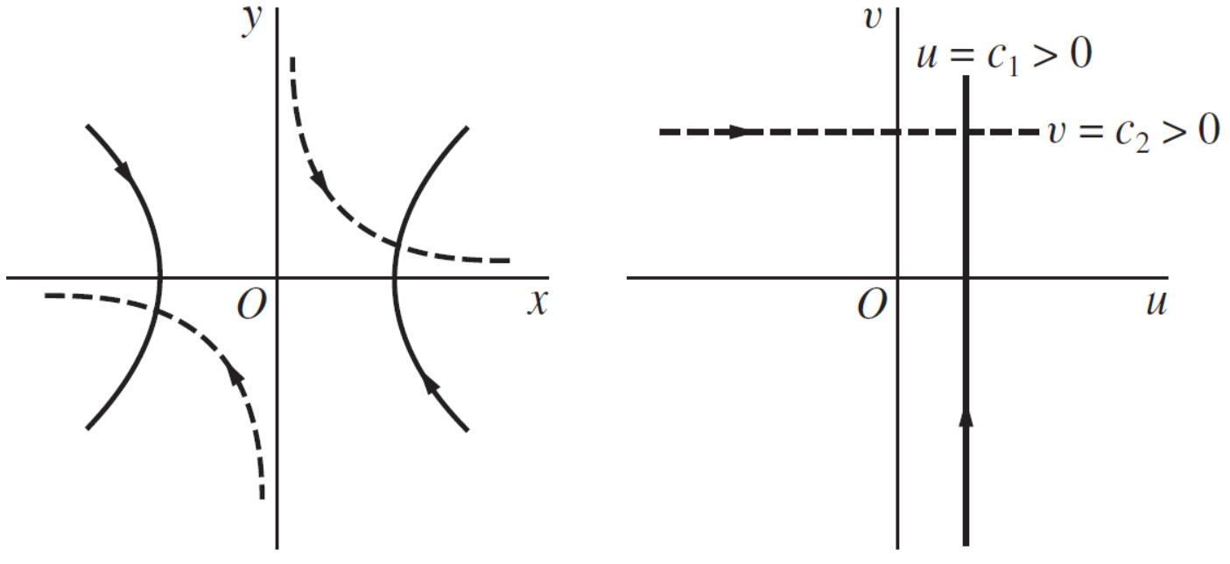  Circle (Polar Form):  $$w=z^{2}$$  $$w=r^{2}e^{i2θ}$$  $$ρ=r^{2}$$  $$φ=2θ$$  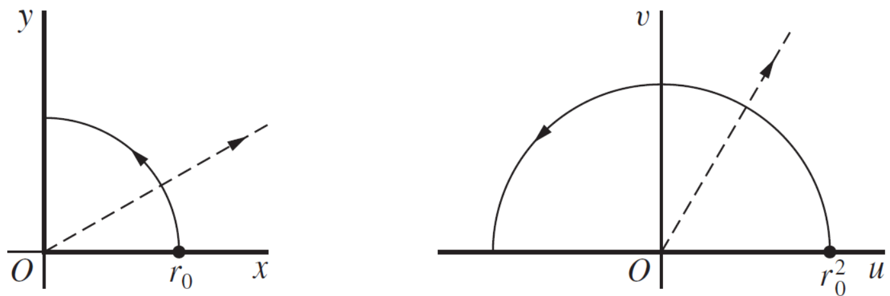

Differentiation

Name | Formula
Cauchy-Riemann Equations | Determines whether the given complex-valued function $f(z)=u+iv$ is analytic and differentiable.  Rectangular Form:  $$f\left(z\right)=u(x,y)+iv(x,y)$$  $${and f}^{'}\left(z\right) exists at point z_{0}=x_{0}+iy_{0}$$  $$u_{x}=v_{y}, u_{y}={-v}_{x}$$  $$f^{'}\left(z_{0}\right)=u_{x}+iv_{x}$$  $$where u_{x}=\frac{∂u}{∂x}$$  Polar Form:  $$f\left(z\right)=u(r, θ)+iv(r, θ)$$  $${ru}_{r}=v_{θ}, u_{θ}={-rv}_{r}$$  $$f^{'}\left(z_{0}\right)=e^{-iθ}\left(u_{r}+iv_{r}\right)$$
Laplace’s Equation  (Harmonic) | $$H_{xx}\left(x, y\right)+H_{yy}\left(x, y\right)=0$$

Contours

Name | Definition
Simple Arc (C)  (Jordan arc) | If arc C does not cross itself; that is, C is simple if $z(t_{1})≠z(t_{2})$ when $t_{1}≠t_{2}$. E.g., open.
Contour (C) | A closed path in the complex plane.  A piecewise smooth arc consisting of a finite number of smooth arcs joined end to end.
Simple Curve (C) | A simple arc where $z\left(b\right)=z(a)$. E.g., closed. | Simple closed curve  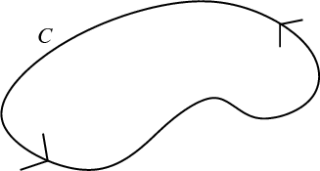
 | Simple closed curve C defaults to a circle, $\left|z-0\right|=r$, centered at 0 with radius $r$ and interval $[0, 2π]$, oriented counterclockwise.  $$C\left(r\right)=\left\{z∈C :\left|z\right|=r\right\}$$ | 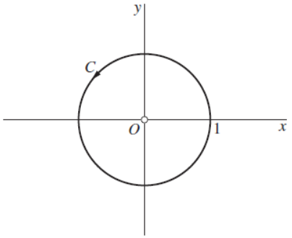
Positively Oriented | a simple closed curve, or a Jordan curve, is positively oriented when it is in the counterclockwise direction.
Simply Connected Domain | $D$ is a domain such that every simple closed contour within it encloses only points of $D.$
Branch Cut | A portion of a line or curve that is introduced to define a  branch $F$ of a multiple-valued function $f$.
Regions Bound by Curve C | $D_{int}$: Bounded  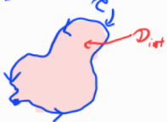 | $D_{out}$: Unbounded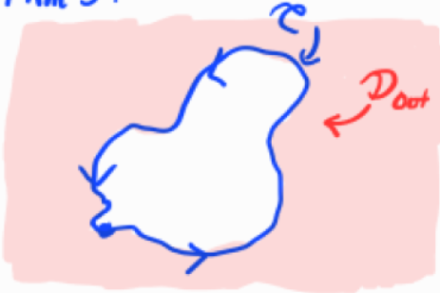
Closed, Simple, Counter-Clockwise Oriented Curve | One Point, Simple Pole:  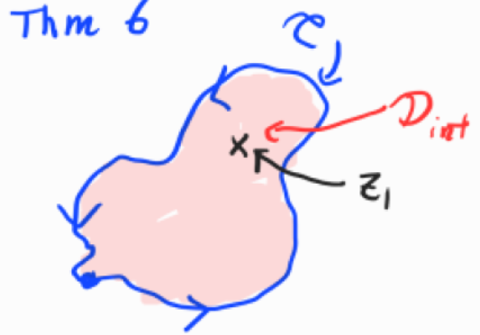 | Multiple Points, Simple Poles:  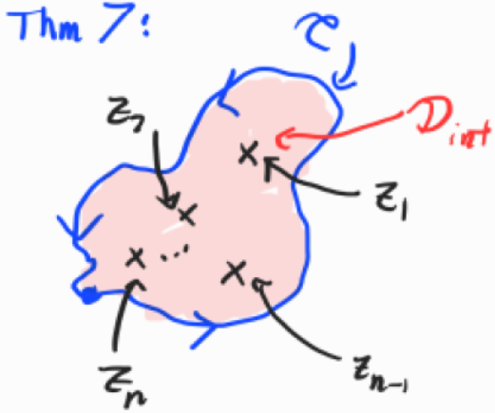
Integration

Name | Formula
Complex Integration | $$\int_{C}^{ }{f\left(z\right) dz}=\int_{C}^{ }{(u+iv)(dx+idy)}=\int_{C}^{ }{udx-vdy}+i\int_{C}^{ }{vdx-udy}$$  “No corresponding helpful interpretation, geometric or physical, is available for integrals in the complex plane.” (Brown & Churchill, p.125)
Contour Integral (Complex $C$) | Called a Line Integral if Real $R$ numbers.  $$\int_{C}^{ }{f\left(z\right) dz}=\int_{a}^{b}{f\left[z\left(t\right)\right]{ z}^{'}\left(t\right) dt}$$  Change of Contour direction:  $$\int_{-C}^{ }{f\left(z\right) dz}=-\int_{C}^{ }{f\left(z\right) dz}$$ | 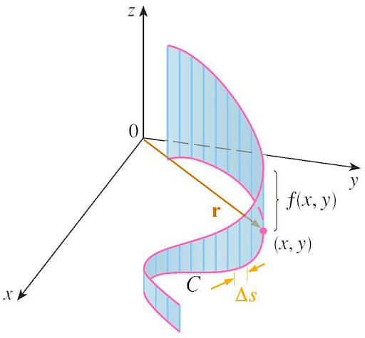
Fundamental Theorem of Calculus with Contour Integral | $$\int_{C}^{ }{f\left(z\right) dz}=\int_{a}^{b}{f\left(z\left(t\right)\right){ z}^{'}\left(t\right)dt}=\left.F\left(z\left(t\right)\right)\right]\begin{matrix}b \\ a\end{matrix}$$  $$=F\left(z(b)\right)-F\left(z(a)\right)=F\left(z_{2}\right)-F\left(z_{1}\right)$$  Since $z\left(b\right)=z_{2}$ and $z\left(a\right)=z_{1}$.  where $z_{0}$ is a point within the contour $C$.
Morera’s Theorem | If $\int_{C}^{ }{f\left(z\right) dz}=0$ then, $f$ is Holomorphic over $R$.
Cyclic Integral | $$\oint_{C}^{ }{f\left(z\right) dz}$$  Integral over a closed contour meaning the curve returns to its initial position ($a=b$).  For circular contours,  $$\oint_{C_{R}}^{ }{f\left(z\right) dz}=\int_{0}^{2π}{f\left(z\right) dz}$$  For non-circular contours,  $$\oint_{C}^{ }{f\left(z\right) dz}=\int_{C_{R}}^{ }{f\left(z\right) dz}+\int_{L_{1}}^{ }{f\left(z\right) dz}+\int_{L_{2}}^{ }{f\left(z\right) dz}$$  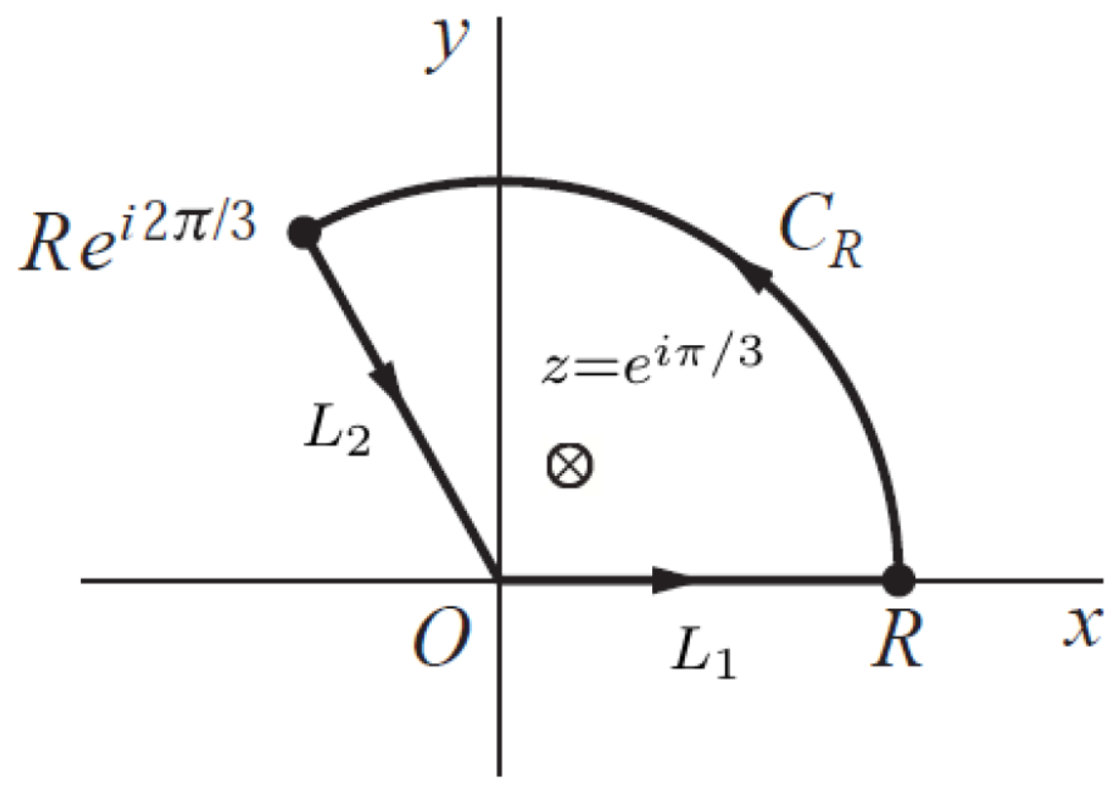  Parameterize the arcs and identify the bounds of integration.  $$L_{1}:z=re^{i0}, 0≤r≤R$$  $$L_{2}:z=re^{i2π/3}, R≤r≤0$$  $$C_{R}:z=Re^{iθ}, 0≤θ≤2π/3$$
Cauchy-Goursat Theorem  (Cauchy’s Integral Theorem) | $D_{int}$: If C is closed, i.e., $z_{0}=z_{1}$, then  $$\oint_{C}^{ }{f\left(z\right) dz}=0$$  $D_{out}$: Outside of closed C, at infinity ($∞$):  If  $$\lim_{z→∞}{f\left(z\right) z=0}$$  Then  $$\oint_{C}^{ }{f\left(z\right) dz}=0$$
Cauchy Integral Formula | Turns a contour integral into a derivative.  Simple:  $$f\left(z_{0}\right)=\frac{1}{2πi} \int_{C}^{ }{\frac{f\left(z\right)}{z-z_{0}}dz}$$  General:  $$f^{\left(n\right)}\left(z_{0}\right)=\frac{n!}{2πi} \int_{C}^{ }{\frac{f\left(z\right)}{{\left(z-z_{0}\right)}^{n+1}}dz}$$  $$where n=0, 1, 2, …; 0!=1; f^{\left(0\right)}\left(z_{0}\right)=f\left(z_{0}\right).$$
Jordan’s Lemma | Estimation Lemma:  $$\left|\int_{C}^{ }{f\left(z\right) dz}\right|≤length\left(C\right)∙\max_{z∈C}\left|f(z)\right|$$  Common Application:  If  $$\lim_{z→∞}{f\left(z\right) z=0}$$  Then  $$\int_{-∞}^{∞}{f\left(at+b\right) a dt}x=\int_{L}^{ }{f\left(z\right) dz}=\lim_{R→∞}{ \oint_{C_{R}}^{ }{f\left(z\right) dz}}$$  $$where line L=\left\{at+b\right\}, -∞<t<∞ and$$  $R=$ semi-circle radius along this line.

Poles and Residues

Name | Formula
Poles | Roots in the denominator of a complex function that is holomorphic (complex differential). E.g., Singularity, vertical asymptote. | 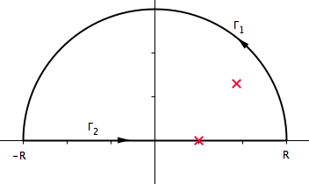
Poles are zeros in the denominator of $f\left(z\right)$.
$$f\left(z\right)=\frac{φ\left(z\right)}{{\left(z-z_{0}\right)}^{m}}$$
Simple Pole:
$$z_{0} is a pole of order 1 (m=1).$$

High-Order Pole:
$$z_{0} is a pole of order m (m=2, 3, 4, …).$$

Theorem: If $z_{0}$ is a pole of function $f$, then
$$\lim_{z→z_{0}}{f\left(z\right)=∞.}$$
Residue | $${Res}_{z_{1}}(f)=\lim_{z→z_{1}}\left(z-z_{1}\right) f\left(z\right)$$  Observation: Since $z_{1}$is a simple pole, then the ${Res}_{z_{1}}\left(f\right)$ turns the function $f$ into a function with a hole or hollow point. The limit makes the remaining function appear continuous. “Remove the pole and cover the hole.”  Tip: If Laurent Series centered at 0, then  ${Res}_{z_{1}}\left(f\right)=a$ the $z^{-1}$ term of $f\left(z\right)=… + az^{-1}+…$.
Cauchy’s Residue Theorem  (Simple Poles) | One Point, Simple Pole inside Contour C:  If exists  $${Res}_{z_{1}}(f)=\lim_{z→z_{1}}\left(z-z_{1}\right) f\left(z\right)$$  Then  $$\oint_{C}^{ }{f\left(z\right) dz}=2πi {Res}_{z_{1}}f(z)$$
Multiple Points, Simple Poles inside Contour C:
If these exist
$$\sum_{k=1}^{n}{\underset{z=z_{k}}{Res}}f\left(z\right)=$$
$$Res_{z_{1}}(f)=\lim_{z→z_{1}}\left(z-z_{1}\right) f\left(z\right)$$
+ ... +
$$Res_{z_{n}}(f)=\lim_{z→z_{n}}\left(z-z_{n}\right) f\left(z\right)$$
Then
$$\oint_{C}^{ }{f\left(z\right) dz}=2πi\sum_{k=1}^{n}{\underset{z=z_{k}}{Res}}f(z)$$
Special Case:
If $f(z)$ is even, then
$$\int_{-∞}^{∞}{f\left(z\right) dz}=\frac{1}{2}\int_{0}^{∞}{f\left(z\right) dz}$$
Residue of High-Order Poles | General:  Works with higher-order poles.  $$If f\left(z\right)=\frac{φ(z)}{{\left(z-z_{0}\right)}^{m}} (m=1, 2, 3, …)$$  $where φ\left(z\right) is analytic and nonzero at z_{0},$ then  $$\underset{z=z_{0}}{Res} f\left(z\right)=\frac{φ^{(m-1)}(z_{0})}{\left(m-1\right)!} (m=1, 2, …)$$  Simple:  $$\underset{z=z_{0}}{Res} f\left(z\right)=φ\left(z_{0}\right) when m=1$$  $$since φ^{\left(0\right)}\left(z_{0}\right)=φ\left(z_{0}\right) and 0!=1.$$  Tip:  $$If f\left(z\right)=\frac{g\left(z\right)}{{\left(z-z_{0}\right)}^{m}{\left(z-z_{1}\right)}^{p}∙∙∙{\left(z-z_{n-1}\right)}^{q}}$$  $$then choose φ\left(z\right)=\frac{g(z)}{{\left(z-z_{1}\right)}^{p}∙∙∙{\left(z-z_{n-1}\right)}^{q}}.$$
Residue of Simple Poles  (shortcut) | Theorem: Let two functions $p$ and $q$ be analytic at a point $z_{0}$. If  $$p\left(z_{0}\right)≠0,$$  $$q\left(z_{0}\right)=0, and$$  $$q^{'}(z_{0})≠0,$$  then $z_{0}$ is a simple pole of the quotient $p(z)/q(z)$ and  $$\underset{z=z_{0}}{Res}{ \frac{p(z)}{q(z)}}=\frac{p(z_{0})}{q^{'}(z_{0})}.$$
Zeros and Poles | Theorem: Suppose that:  (a) two functions $p$ and $q$ are analytic at a point $z_{0}$;  (b) $p(z_{0})≠0$ and $q$ has a zero of order $m$ at $z_{0}$.  Then the quotient $p(z)/q(z)$has a pole of order $m$ at $z_{0}$.

Series

Name | Formula
Liouville’s Theorem | If a function $f$ is entire and bounded in the complex plane, then $f(z)$  is constant throughout the plane.
Fundamental Theorem of Algebra | $$P\left(z\right)=a_{n}z^{n}+…+a_{2}z^{2}+a_{1}z+a_{0}, \left(a_{n}≠0, n≥1\right)$$  $$P\left(z\right)=c(z-z_{n})…\left(z-z_{2}\right)\left(z-z_{1}\right)$$  Any polynomial of degree $n$ has at least one zero in the complex plane. That is, there exists at least one point $z_{0}$ such that$P(z_{0})=0$.
Maximum Modulus Principle | Theorem: If a function $f$ is analytic and not constant in a given domain $D$, then the modulus $|f(z)|$ has no maximum value in $D$. That is, there is no point $z_{0}$ in the domain such that $|f(z)| ≤ |f(z_{0})|$ for all points $z$ in it.
 | Corollary: Suppose that a function $f$ is continuous on a closed bounded region $R$ and that it is analytic and not constant in the interior of $R$. Then the maximum value of $|f(z)|$ in $R$, which is always reached, occurs somewhere on the boundary of $R$ and never in the interior.
Complex Variable Convergence | $$\lim_{n→∞}{z_{n}}=z$$  $$iff \lim_{n→∞}{x_{n}}=x and \lim_{n→∞}{y_{n}}=y$$  $$where z_{n}=x_{n}+iy_{n}$$
Complex Series Convergence | $$\sum_{n=1}^{∞}{z_{n}}=S$$  $$iff \sum_{n=1}^{∞}{x_{n}}=X and \sum_{n=1}^{∞}{y_{n}}=Y$$  $$where S=X+iY$$
Series Convergence | Corollary 1: If a series of complex numbers converges, the n^{th} term converges to zero as n tends to infinity.  Corollary 2: The absolute convergence of a series of complex numbers implies the convergence of that series.
Annular Domain  $$R_{1}<\left|z-z_{0}\right|<R_{2}$$ | 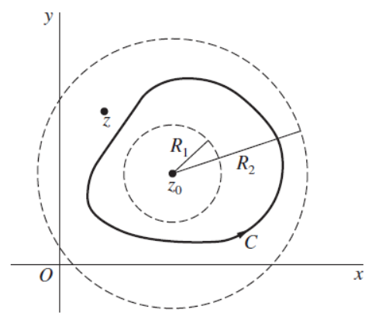
Transcendental Series | See Harold’s Taylor Series Cheat Sheet for a comprehensive list of the Maclaurin series of all transcendental functions.
Taylor Series | $$f\left(z\right)=\sum_{n=0}^{∞}{a_{n}}{\left(z-z_{0}\right)}^{n} where disk \left(\left|z-z_{0}\right|<R_{0}\right)$$  $$a_{n}=\frac{f^{(n)}(z_{0})}{n!} where (n=0, 1, 2,…)$$  Series converges to $f(z)$ when $z$ lies in the stated open disk.  If $z_{0}=0$, then Maclaurin series.  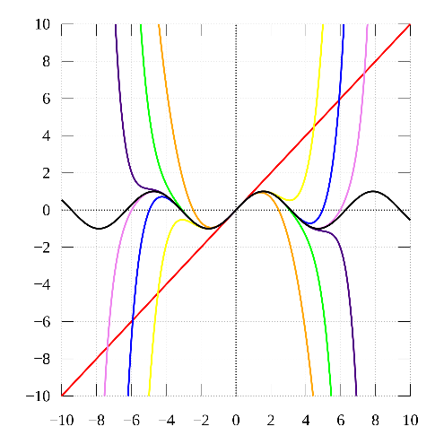
Laurent Series | $$f\left(z\right)=\sum_{n=0}^{∞}{a_{n}{\left(z-z_{0}\right)}^{n}}+\sum_{n=1}^{∞}{\frac{b_{n}}{{\left(z-z_{0}\right)}^{n}}}$$  $$a_{n}=\frac{1}{2πi}\int_{C}^{ }{\frac{f\left(z\right)}{{\left(z-z_{0}\right)}^{n+1}}dz} where \left(n=0, 1, 2,…\right)$$  $$b_{n}=\frac{1}{2πi}\int_{C}^{ }{\frac{f\left(z\right)}{{\left(z-z_{0}\right)}^{-n+1}}dz} where (n=1, 2, 3, …)$$  $$where \left(R_{1}<\left|z-z_{0}\right|<R_{2}\right)$$  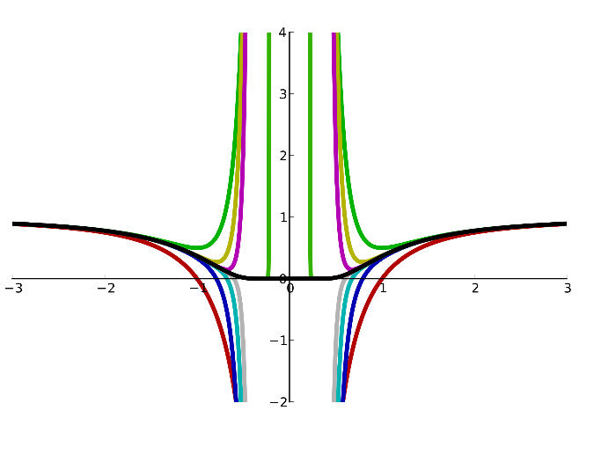  Taylor Series Form:  $$f\left(z\right)=\sum_{-∞}^{∞}{c_{n}{\left(z-z_{0}\right)}^{n}}$$  $$c_{n}=\frac{1}{2πi}\int_{C}^{ }{\frac{f\left(z\right)}{{\left(z-z_{0}\right)}^{n+1}}dz}=\frac{f^{(n)}(z_{0})}{n!} where \left(n=0, 1, 2,…\right)$$  $$and \left(R_{1}<\left|z-z_{0}\right|<R_{2}\right)$$  If no poles, then Taylor series.
Power Series

Name | Formula
Power Series | $$S\left(z\right)=\sum_{n=0}^{∞}{a_{n}{\left(z-z_{0}\right)}^{n}}$$  $$where (\left|z-z_{0}\right|< R)$$
Absolute and Uniform Convergence | Theorem 1: If a power series converges when  $$z=z_{1} \left(z_{1}≠z_{0}\right),$$  then it is absolutely convergent at each point $z$ in the open disk  $$\left|z-z_{0}\right|< R_{1}where R_{1}=|z_{1}-z_{0}|.$$
Theorem 2: If $z_{1}$ is a point inside the circle of convergence $|z-z_{0}|=R$ of a power series then that series must be uniformly convergent in the closed disk
$$\left|z-z_{0}\right|≤ R_{1}where R_{1}=\left|z_{1}-z_{0}\right|.$$
Continuity of Sums | Theorem: A power series represents a continuous function $S(z)$ at each point inside its circle of convergence $|z-z_{0}|=R$.
Integration | Theorem: Let $C$ denote any contour interior to the circle of convergence of the power series and let $g(z)$ be any function that is continuous on $C$. The series formed by multiplying each term of the power series by $g(z)$ can be integrated term by term over $C$; that is,  $$\int_{C}^{ }{g\left(z\right) S\left(z\right) dz}=\sum_{n=0}^{∞}{a_{n} }\int_{C}^{ }{{g\left(z\right) \left(z-z_{0}\right)}^{n}dz} .$$
Differentiation | Theorem: The power series can be differentiated term by term. That is, at each point $z$ interior to the circle of convergence of that series,  $$S^{'}\left(z\right)=\sum_{n=1}^{∞}{na_{n}{\left(z-z_{0}\right)}^{n-1}.}$$
Leibniz’s Rule for the n^{th} Derivative | $${\left[f\left(z\right) g\left(z\right)\right]}^{(n)}=\sum_{n=0}^{∞}{\left(\begin{matrix}n \\ k\end{matrix}\right)f^{(k)}\left(z\right) g^{(n-k)}(z)}$$  $$where \left(n=1, 2, …\right)$$  $$\left(\begin{matrix}n \\ k\end{matrix}\right)=\frac{n!}{k!(n-k)!} where (k=0, 1, 2, …, n)$$
Uniqueness Representations | Theorem 1: If a power series converges to $f(z)$ at all points interior to some circle $|z-z_{0}|=R$, then it is the Taylor series expansion for $f$ in powers of $z-z_{0}$.
Theorem 2: If a series
$$\sum_{n=-∞}^{∞}{c_{n}{\left(z-z_{0}\right)}^{n}}=\sum_{n=0}^{∞}{a_{n}{\left(z-z_{0}\right)}^{n}}+\sum_{n=1}^{∞}{\frac{b_{n}}{{\left(z-z_{0}\right)}^{n}}}$$
converges to $f(z)$ at all points in some annular domain about $z_{0}$, then it is the Laurent series expansion for $f$ in powers of $z-z_{0}$ for that domain.
Multiplication | $$Let f\left(z\right), g\left(z\right), h\left(z\right), and k\left(z\right) all be different power series.$$
 | $$f\left(z\right)g(z)=h(z)$$
Division | $$\frac{f\left(z\right)}{g(z)}=k(z)$$
College Course
- Course: NYU MATH-UY-4434: Applied Complex Variables.
- Textbook: Complex Variables and Applications, 9th Edition, Chapters 1-7, James Ward Brown & Ruel V. Churchill, McGraw-Hill Education, 2014.

