Harold’s AP Calculus Notes
Cheat Sheet
23 April 2024

Limits
Definition of Limit  Let f be a function defined on an open interval containing $c$ and let $L$ be a real number. The statement:  $$\lim_{x→c}{f\left(x\right)=L}$$  means that for each $ϵ>0$ there exists a $δ>0$ such that  if $\left|x-c\right|<δ,$  $$then \left|f\left(x\right)-L\right|<ϵ$$  Tip:  Direct substitution: Plugin $f\left(c\right)$ and see if it provides a legal answer. If so then $L=f\left(c\right)$. | 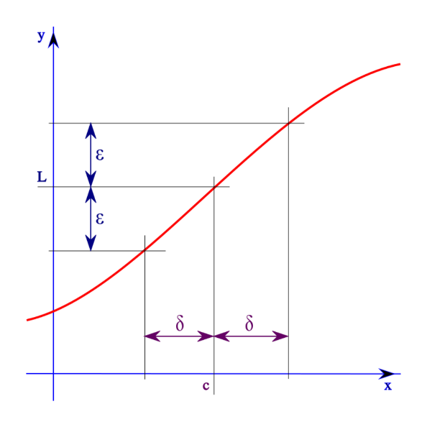
The Existence of a Limit  The limit of$f\left(x\right)$ as $x$ approaches c is L if and only if: | $\lim_{x→c^{-}}{f\left(x\right)=L}$ and $\lim_{x→c^{+}}{f\left(x\right)=L}$
Definition of Continuity  A function $f$ is continuous at $c$ if for every $ε>0$ there exists a $δ>0$ such that $\left|x-c\right|<δ$ and$\left|f(x)-f(c)\right|<ε$.  Tip:  Rearrange $\left|f\left(x\right)-f\left(c\right)\right|$ to have $\left|\left(x-c\right)\right|$ as a factor. Since $\left|x-c\right|<δ$ we can find an equation that relates both $δ$ and $ε$ together. | Prove that $f\left(x\right)=x^{2}-1$ is a continuous function.  $$\left|f\left(x\right)-f\left(c\right)\right|$$  $$=\left|\left(x^{2}-1\right)-\left(c^{2}-1\right)\right|$$  $$=\left|x^{2}-1-c^{2}+1\right|$$  $$=\left|x^{2}-c^{2}\right|$$  $$=\left|\left(x+c\right) \left(x-c\right)\right|$$  $=\left|\left(x+c\right)\right| \left|\left(x-c\right)\right|$  $=\left|x+c\right| \left|x-c\right|$  Since $\left|x+c\right|≤ \left|2c\right|$  $$\left|f\left(x\right)-f\left(c\right)\right|≤\left|2c\right| \left|x-c\right|<ε$$  So, given $ε>0$, we can choose $δ=\left|\frac{1}{2c}\right|ε>0$ in the Definition of Continuity. So, substituting the chosen $δ$ for $\left|x-c\right|$ we get:  $$\left|f\left(x\right)-f\left(c\right)\right|≤\left|2c\right|\left(\left|\frac{1}{2c}\right|ε\right)=ε$$  Since both conditions are met,$f\left(x\right)$ is continuous.
Two Special Trig Limits | $$\lim_{x→0}{\frac{\sin{x}}{x}=1} and \lim_{x→0}{\frac{1-cos{x}}{x}=0}$$

Derivatives | (See Larson’s 1-pager of common derivatives)
Definitions of a Derivative of a Function  (Slope Function) | $$f^{'}\left(x\right)=\lim_{h→0}{\frac{f\left(x+h\right)-f\left(x\right)}{h}}$$  $$f^{'}\left(c\right)=\lim_{x→c}{\frac{f\left(x\right)-f(c)}{x-c}}$$
Derivatives Notation | $$\frac{dy}{dx}, y^{'}, f^{'}\left(x\right), { f}^{(n)}\left(x\right), \frac{d}{dx}\left[f\left(x\right)\right], { D}_{x}[y]$$
1. Chain Rule | $$\frac{d}{dx}\left[f\left(g\left(x\right)\right)\right]=f^{'}\left(g\left(x\right)\right)∙g^{'}\left(x\right)$$  $$\frac{dy}{dx}=\frac{dy}{dt}·\frac{dt}{dx}$$
2. Constant Rule | $$\frac{d}{dx}\left[c\right]=0$$
3. Constant Multiple Rule | $$\frac{d}{dx}\left[cf(x)\right]=cf^{'}(x)$$
4. Sum and Difference Rule | $$\frac{d}{dx}\left[f\left(x\right)±g(x)\right]=f^{'}(x)±g^{'}(x)$$
5. Product Rule | $$\frac{d}{dx}\left[fg\right]=fg^{'}+g{ f}^{'}$$
6. Quotient Rule | $$\frac{d}{dx}\left[\frac{f}{g}\right]=\frac{gf^{'}-fg^{'}}{g^{2}}$$
7. Power Rule | $$\frac{d}{dx}\left[x^{n}\right]=nx^{n-1}$$
8. General Power Rule | $$\frac{d}{dx}\left[u^{n}\right]=nu^{n-1}{ u}^{'} where u=u(x)$$
9. Power Rule for x | $$\frac{d}{dx}\left[x\right]=1 (think x=x^{1} and x^{0}=1)$$
10. Absolute Value | $$\frac{d}{dx}\left[\left|x\right|\right]=\frac{x}{\left|x\right|}$$
11. Natural Exponential Rule | $$\frac{d}{dx}\left[e^{x}\right]=e^{x}$$
12. General Natural Exponential Rule | $$\frac{d}{dx}\left[e^{g(x)}\right]=e^{g(x)}g^{'}(x)$$
13. Exponential Rule | $$\frac{d}{dx}\left[a^{x}\right]=(ln{a)}a^{x}$$
14. General Exponential Rule | $$\frac{d}{dx}\left[a^{g(x)}\right]=\left(\ln{a}\right) a^{g(x)} g^{'}(x)$$
15. Natural Logorithm Rule | $$\frac{d}{dx}\left[\ln{x}\right]=\frac{1}{x}$$
16. General Natural Logorithm Rule | $$\frac{d}{dx}\left[\ln{f(x)}\right]=\frac{1}{f(x)}∙f^{'}(x)$$
17. Logorithm Rule | $$\frac{d}{dx}\left[\log_{a}{x}\right]=\frac{1}{(ln{a}) x}$$
18. General Logorithm Rule | $$\frac{d}{dx}\left[\log_{a}{f(x)}\right]=\frac{1}{\ln{x}}∙ \frac{f^{'}(x)}{f(x)}$$
19. Sine | $$\frac{d}{dx}\left[\sin\left(x\right)\right]=\cos\left(x\right)$$
20. Cosine | $$\frac{d}{dx}\left[cos(x)\right]=-sin(x)$$
21. Tangent | $$\frac{d}{dx}\left[\tan\left(x\right)\right]=\sec^{2}\left(x\right)$$
22. Cotangent | $$\frac{d}{dx}\left[cot(x)\right]=-\csc^{2}(x)$$
23. Secant | $$\frac{d}{dx}\left[\sec\left(x\right)\right]=\sec\left(x\right)tan(x)$$
24. Cosecant | $$\frac{d}{dx}\left[csc(x)\right]=-\csc\left(x\right)cot(x)$$
25. Arcsine | $$\frac{d}{dx}\left[\sin^{-1}{(x)}\right]=\frac{1}{\sqrt{1-x^{2}}}$$
26. Arccosine | $$\frac{d}{dx}\left[\cos^{-1}{(x)}\right]=\frac{-1}{\sqrt{1-x^{2}}}$$
27. Arctangent | $$\frac{d}{dx}\left[\tan^{-1}{(x)}\right]=\frac{1}{1+x^{2}}$$
28. Arccotangent | $$\frac{d}{dx}\left[\cot^{-1}{(x)}\right]=\frac{-1}{1+x^{2}}$$
29. Arcsecant | $$\frac{d}{dx}\left[\sec^{-1}{(x)}\right]=\frac{1}{\left|x\right| \sqrt{x^{2}-1}}$$
30. Arccosecant | $$\frac{d}{dx}\left[\csc^{-1}{(x)}\right]=\frac{-1}{\left|x\right| \sqrt{x^{2}-1}}$$
31. Hyperbolic Sine $\left( \frac{e^{x}-e^{-x}}{2}\right)$ | $$\frac{d}{dx}\left[\sinh\left(x\right)\right]=\cosh\left(x\right)$$
32. Hyperbolic Cosine $\left(\frac{e^{x}+e^{-x}}{2}\right)$ | $$\frac{d}{dx}\left[cosh(x)\right]=sinh(x)$$
33. Hyperbolic Tangent | $$\frac{d}{dx}\left[\tanh\left(x\right)\right]={sech}^{2}\left(x\right)$$
34. Hyperbolic Cotangent | $$\frac{d}{dx}\left[coth(x)\right]=-{csch}^{2}(x)$$
35. Hyperbolic Secant | $$\frac{d}{dx}\left[\operatorname{sech}\left(x\right)\right]=-\operatorname{sech}\left(x\right)tanh(x)$$
36. Hyperbolic Cosecant | $$\frac{d}{dx}\left[csch(x)\right]=-\operatorname{csch}\left(x\right)coth(x)$$
37. Hyperbolic Arcsine | $$\frac{d}{dx}\left[\sinh^{-1}{(x)}\right]=\frac{1}{\sqrt{x^{2}+1}}$$
38. Hyperbolic Arccosine | $$\frac{d}{dx}\left[\cosh^{-1}{(x)}\right]=\frac{1}{\sqrt{x^{2}-1}}$$
39. Hyperbolic Arctangent | $$\frac{d}{dx}\left[\tanh^{-1}{(x)}\right]=\frac{1}{1-x^{2}}$$
40. Hyperbolic Arccotangent | $$\frac{d}{dx}\left[\coth^{-1}{(x)}\right]=\frac{1}{1-x^{2}}$$
41. Hyperbolic Arcsecant | $$\frac{d}{dx}\left[{sech}^{-1}{(x)}\right]=\frac{-1}{x \sqrt{1-x^{2}}}$$
42. Hyperbolic Arccosecant | $$\frac{d}{dx}\left[{csch}^{-1}{(x)}\right]=\frac{-1}{\left|x\right| \sqrt{1+x^{2}}}$$

Physics | Translational Motion
Position Function | $$s\left(t\right)=\frac{1}{2}gt^{2}+v_{0}t+s_{0}$$  $$x\left(t\right)=\frac{1}{2}a_{x}t^{2}+v_{0,x}t+x_{0}$$  $$y\left(t\right)=\frac{1}{2}a_{y}t^{2}+v_{0,y}t+y_{0}$$
Velocity Function | $$v\left(t\right)=s^{'}\left(t\right)=gt+v_{0}$$
Acceleration Function | $$a\left(t\right)=v^{'}\left(t\right)=s^{''}\left(t\right)$$
Jerk Function | $$j\left(t\right)=a^{'}\left(t\right)=v^{''}\left(t\right)=s^{(3)}\left(t\right)$$
Gravitational Constant (g) | $$g≈-9.81\frac{m}{s^{2}}$$  $$g≈-32.2 \frac{ft}{s^{2}}$$

Analyzing the Graph of a Function | (See Harold’s Illegals and Graphing Rationals Cheat Sheet)
x-Intercepts (Zeros or Roots) | $$f\left(x\right)=0$$
y-Intercept | $$f\left(0\right)=y$$
Domain | Valid $x$ values
Range | Valid $y$ values
Continuity | No division by 0, no negative square roots or logs
Vertical Asymptotes (VA) | $x$ = division by 0 or undefined
Horizontal Asymptotes (HA) | $\lim_{x→∞^{-}}{f(x)}→y$ and $\lim_{x→∞^{+}}{f(x)}→y$
Infinite Limits at Infinity | $\lim_{x→∞^{-}}{f(x)}→∞$ and $\lim_{x→∞^{+}}{f(x)}→∞$
Differentiability | Limit from both directions arrives at the same slope
Relative Extrema | Create a table with domains: $f\left(x\right), f^{'}\left(x\right), f''(x)$
Concavity | If $f''(x)→+$, then cup up $⋃$  If$f''\left(x\right)→-$, then cup down $⋂$
Points of Inflection | $f''\left(x\right)=0$, then concavity changes

Graphing with Derivatives
Test for Increasing and Decreasing Functions | 1. If $f^{'}\left(x\right)>0$, then f is increasing (slope up) ↗  2. If $f^{'}\left(x\right)<0$, then f is decreasing (slope down) ↘  3. If $f^{'}\left(x\right)=0$, then f is constant (zero slope) →
First Derivative Test | 1. If $f^{'}\left(x\right)$ changes from – to + at $c$, then $f$ has a relative minimum at $(c, f(c))$  2. If $f^{'}\left(x\right)$ changes from + to - at $c$, then $f$ has a relative maximum at $(c, f(c))$  3. If $f^{'}\left(x\right)$, is + $c$ + or $-c$ -, then $f\left(c\right)$ is neither
Second Deriviative Test  Let $f’(c)=0$, and $f”(x)$ exists, then | 1. If $f^{''}\left(x\right)>0$, then f has a relative minimum at $\left(c,f(c)\right)$  2. If $f^{''}\left(x\right)<0$, then f has a relative maximum at $\left(c,f(c)\right)$  3. If $f^{''}\left(x\right)=0$, then the test fails
Test for Concavity | 1. If $f^{''}\left(x\right)>0$ for all $x$, then the graph is concave up ⋃  2. If $f^{''}\left(x\right)<0$ for all $x$, then the graph is concave down ⋂
Inflection Points  (Change in concavity) | If $\left(c,f(c)\right)$ is a point of inflection of $f\left(x\right)$, then either  1. $f^{''}\left(c\right)=0$ or  2. $f^{''}\left(x\right)$ does not exist at $x=c$

Tangent Lines
General Form | $$ax+by+c=0$$
Slope-Intercept Form | $$y=mx+b$$
Point-Slope Form | $$y-y_{0}=m(x-x_{0})$$  $$where {m=f}^{'}\left(x_{0}\right) at point \left(x_{0},y_{0}\right)$$
Calculus Form | $$f(x)=f^{'}\left(c\right)\left(x-c\right)+f\left(c\right)$$
Slope | $$m=\frac{rise}{run}=\frac{y_{2}-y_{1}}{x_{2}-x_{1}}=\frac{∆y}{∆x}→\frac{dy}{dx}=f^{'}\left(x\right)$$

Differentiation & Differentials
Rolle’s Theorem |  | Assume $f$ is continuous on the closed interval $[a,b]$, and $f$ is differentiable on the open interval $(a,b)$.  If $f\left(a\right)=f\left(b\right)$, then there exists at least one number $c$ in $(a,b)$ such that $f^{'}\left(c\right)=0$. | 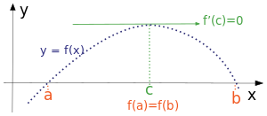
Mean Value Theorem |  | If $f$ meets the conditions of Rolle’s Theorem, then you can find ‘$c$’.  $$f^{'}\left(c\right)=\frac{f\left(b\right)-f(a)}{b-a}=\frac{∆y}{∆x}$$  $$f(b)=f\left(a\right)+\left(b-a\right)f'(c)$$ | 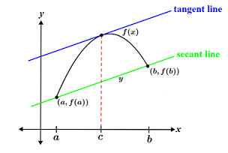
Intermediate Value Theorem |  | Assume $f$ is a continuous function with the interval $[a, b]$ as its domain.  If $f$ takes values $f\left(a\right)$ and $f\left(b\right)$at each end of the interval, then it also takes any value between $f\left(a\right)$ and $f\left(b\right)$ at some point within the interval. | 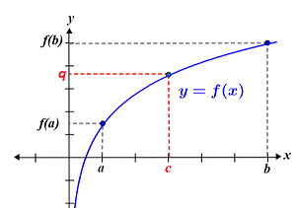
Calculating Differentials  (Tanget line approximation) |  | $$f\left(x+∆x\right)≈f\left(x\right)+∆y$$  $$since dy=f^{'}\left(x\right) dx$$  $$then ∆y≈f^{'}\left(x\right) ∆x$$  so  $$f\left(x+∆x\right)≈f\left(x\right)+f^{'}\left(x\right) ∆x$$  $$Relative Error=\frac{∆f}{f} in \%$$  Example: $\sqrt[4]{82}$  $$f\left(x\right)=\sqrt[4]{x}$$  $$f\left(x+∆x\right)=f\left(81+1\right)$$ | 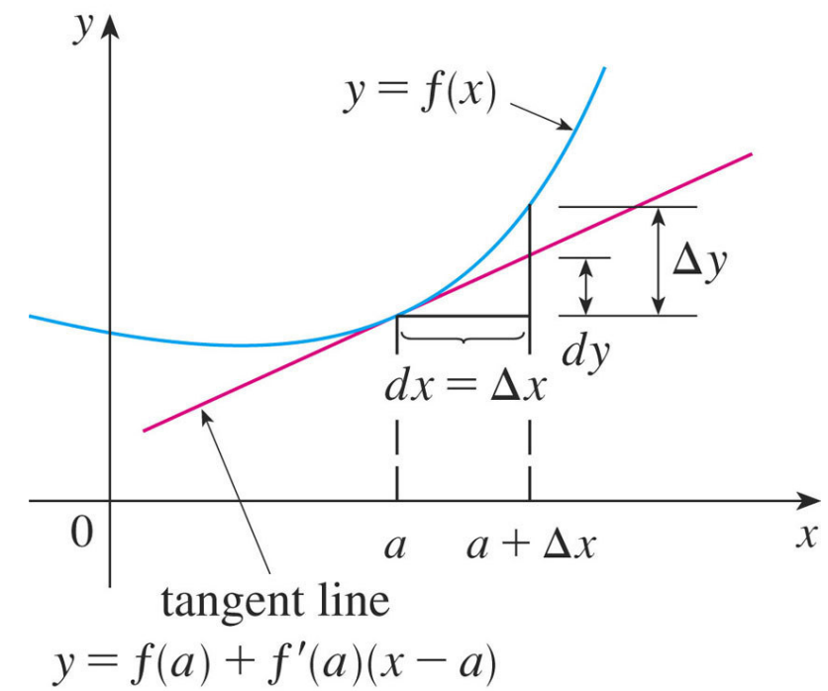
Newton’s Method |  | Finds zeros of $f$, or finds $c$ if $f(c)=0$.  $$x_{n+1}=x_{n}-\frac{f\left(x_{n}\right)}{f^{'}\left(x_{n}\right)}$$  Example: $\sqrt[4]{82}$  $$f\left(x\right)=x^{4}-82=0$$  $$start with x_{0}=3$$ | 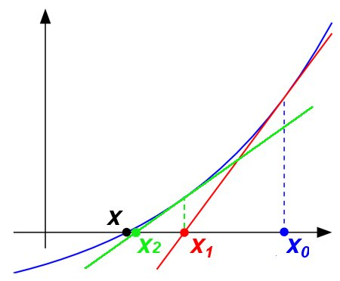
Related Rates |  | Steps to solve:  - Identify the known variables and rates of change.  $$x=15 m$$  $$y=20 m$$  $$x^{'}=2\frac{m}{s}$$  $$y^{'}=______\frac{m}{s}$$  - Construct an equation relating these quantities.  $$x^{2}+y^{2}=r^{2}$$  (Often uses the Pythagorean Theorem.)  - Differentiate both sides of the equation.  $$2xx^{'}+2yy^{'}=0$$  - Solve for the desired rate of change.  $$y^{'}=-\frac{x}{y} x^{'}$$  - Substitute the known rates of change and quantities into the equation.  $$y^{'}=-\frac{15}{20}⦁ 2=1.5 \frac{m}{s}$$ | 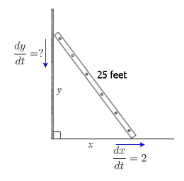
L’Hôpital’s Rule |  | $$If \lim_{x→c}{f\left(x\right)}=\lim_{x→c}{\frac{P\left(x\right)}{Q\left(x\right)}}$$  $$=\left\{\frac{0}{0},\frac{∞}{∞},0•∞,1^{∞},0^{0},∞^{0},∞-∞\right\},$$  $$but not \left\{0^{∞}\right\}, then$$  $$\lim_{x→c}{\frac{P\left(x\right)}{Q\left(x\right)}}=\lim_{x→c}{\frac{P^{'}\left(x\right)}{Q^{'}\left(x\right)}}=\lim_{x→c}{\frac{P^{''}\left(x\right)}{Q^{''}\left(x\right)}}=…$$

Numerical Methods
Riemann Sum | 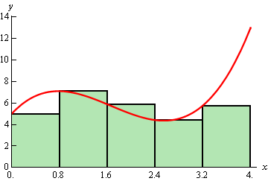 |  |  |  |  | $$P_{0}\left(x\right)=\int_{a}^{b}{f\left(x\right) dx}=\lim_{\left\|P\right\|→0}{\sum_{i=1}^{n}{f\left(x_{i}^{*}\right) ∆x_{i}}}$$  where $a=x_{0}<x_{1}<x_{2}<…<x_{n}=b$  and $∆x_{i}=x_{i}-x_{i-1}$  and $\left\|P\right\|=max\left\{∆x_{i}\right\}$  Types:  - Left Sum (LHS)  - Middle Sum (MHS)  - Right Sum (RHS)
Midpoint Rule  (Middle Sum) | 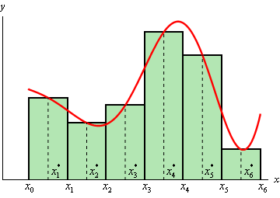 |  |  |  |  | $$P_{0}\left(x\right)=\int_{a}^{b}{f\left(x\right) dx} ≈\sum_{i=1}^{n}{f\left({\overline{x}}_{i}\right) ∆x=}$$  $$∆x \left[f\left({\overline{x}}_{1}\right)+f\left({\overline{x}}_{2}\right)+f\left({\overline{x}}_{3}\right)+…+f\left({\overline{x}}_{n}\right)\right]$$  where $∆x=\frac{b-a}{n}$  and ${\overline{x}}_{i}=\frac{1}{2}\left(x_{i-1}+x_{i}\right)=midpoint of \left[x_{i-1},x_{i}\right]$  Error Bounds: $\left|E_{M}\right|≤ \frac{K{(b-a)}^{3}}{24n^{2}}$
Trapezoidal Rule | 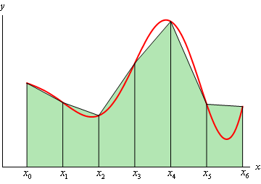 |  |  |  |  | $$P_{1}\left(x\right)=\int_{a}^{b}{f\left(x\right) dx} ≈$$  $$\frac{∆x}{2}\left[f\left(x_{0}\right)+2f\left(x_{1}\right)+2f\left(x_{3}\right)+…+2f\left(x_{n-1}\right)+f\left(x_{n}\right)\right]$$  where $∆x=\frac{b-a}{n}$  and $x_{i}=a+i∆x$  Error Bounds: $\left|E_{T}\right|≤ \frac{K{(b-a)}^{3}}{12n^{2}}$
Simpson’s Rule | 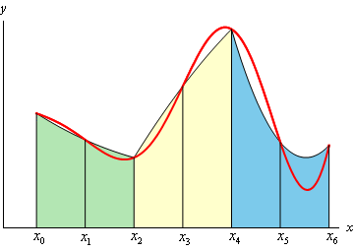 |  |  |  |  | $$P_{2}\left(x\right)=\int_{a}^{b}{f\left(x\right) dx}≈$$  $$\frac{∆x}{3}\left[f\left(x_{0}\right)+4f\left(x_{1}\right)+2f\left(x_{2}\right)+4f\left(x_{3}\right)+…+2f\left(x_{n-2}\right)+4f\left(x_{n-1}\right)+f\left(x_{n}\right)\right]$$  Where $n$ is even  and $∆x=\frac{b-a}{n}$  and $x_{i}=a+i∆x$  Error Bounds: $\left|E_{S}\right|≤ \frac{K{(b-a)}^{5}}{180n^{4}}$
TI-84 Plus |  | 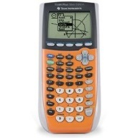 |  |  |  | [MATH] fnInt(f(x),x,a,b), [MATH] [1] [ENTER]  Example: [MATH] fnInt(x^2,x,0,1)  $$\int_{0}^{1}{x^{2} dx}=\frac{1}{3}$$
TI-Nspire CAS |  |  |  |  |  | [MENU] [4] Calculus [3] Integral  [TAB] [TAB]  [X] [^] [2] [TAB]  [TAB] [X] [ENTER]  Shortcut: [ALPHA] [WINDOWS] [4]
Integration |  |  |  | (See Harold’s Fundamental Theorem of Calculus Cheat Sheet)
Basic Integration Rules  (Integration is the “inverse” of differentiation, and vice versa.) |  |  |  | $$\int{f^{'}\left(x\right) dx=f\left(x\right)+C}$$  $$\frac{d}{dx}\int{f\left(x\right) dx}=f(x)$$
$$f\left(x\right)=0$$ |  |  |  | $$\int{0 dx=C}$$
$$f\left(x\right)=k=kx^{0}$$ |  |  |  | $$\int{k dx=kx+C}$$
1. The Constant Multiple Rule |  |  |  | $$\int{k f(x) dx=k\int{f(x) dx}}$$
2. The Sum and Difference Rule |  |  |  | $$\int{[f\left(x\right)±g\left(x\right)] dx}=\int{f\left(x\right) dx}±\int{g\left(x\right) dx}$$
The Power Rule$$f\left(x\right)=P_{n}\left(x\right)=kx^{n}+…$$ |  |  |  | $$\int{x^{n}}dx=\frac{x^{n+1}}{n+1}+C, where n≠-1$$  $$If n=-1, then\int{x^{-1}}dx=\ln\left|x\right|+C$$
The General Power Rule |  |  |  | If $u=g\left(x\right), and u^{'}=\frac{d}{dx}g(x)$ then  $$\int{u^{n}}u^{'}dx=\frac{u^{n+1}}{n+1}+C, where n≠-1$$
Reimann Sum |  |  |  | $$\sum_{i=1}^{n}{f(c_{i})}∆x_{i}, where x_{i-1}≤c_{i}≤x_{i}$$
Definition of a Definite Integral  (Area under curve) |  |  |  | $$\lim_{\left\|∆\right\|→0}{\sum_{i=1}^{n}{f\left(c_{i}\right)}∆x_{i}}=\int_{a}^{b}{f\left(x\right) dx}$$  $$where \left\|∆\right\|=∆x=\frac{b-a}{n}$$
Swap Bounds |  |  |  | $$\int_{a}^{b}{f\left(x\right) dx}=-\int_{b}^{a}{f\left(x\right) dx}$$
Additive Interval Property |  |  |  | $$\int_{a}^{b}{f\left(x\right) dx}=\int_{a}^{c}{f\left(x\right) dx}+ \int_{c}^{b}{f\left(x\right) dx}$$
First Fundamental Theorem of Calculus |  |  |  | $$\int_{a}^{b}{f\left(x\right) dx}=F\left(b\right)-F(a)$$
Second Fundamental Theorem of Calculus |  |  |  | $$\frac{d}{dx} \int_{a}^{x}{f\left(t\right) dt}= f(x)$$  $$\frac{d}{dx} \int_{a}^{g\left(x\right)}{f\left(t\right) dt}=f\left(g\left(x\right)\right)g^{'}\left(x\right)$$  $$\frac{d}{dx}\int_{g(x)}^{h(x)}{f\left(t\right) dt}=f\left(h\left(x\right)\right)h^{'}\left(x\right)- f\left(g\left(x\right)\right)g'(x)$$
Mean Value Theorem for Integrals |  |  |  | $$\int_{a}^{b}{f\left(x\right) dx}=f\left(c\right)\left(b-a\right) Find ‘c’.$$
Average Value of a Function |  |  |  | $$\frac{1}{b-a}\int_{a}^{b}{f\left(x\right) dx}$$
Integration Methods
1. Memorized |  |  |  |  | See Ron Larson’s 1-pager of common integrals
2. U-Substitution |  |  |  |  | $$\int{f\left(g\left(x\right)\right)g^{'}\left(x\right)dx=F\left(g\left(x\right)\right)+C}$$  Set $u=g\left(x\right), then du=g^{'}\left(x\right) dx$  $$\int{f\left(u\right) du=F\left(u\right)+C}$$  $u=$ _____ $du=$ _____ $dx$
3. Integration by Parts |  |  |  |  | $$\int{u dv}=uv-\int{v du}$$  $u=$ _____ $v=$ _____  $du=$ _____ $dv=$ _____  Pick ‘$u$’ using the LIATE Rule:  L – Logarithmic : $\ln{x}, \log_{b}{x}$  I – Inverse Trig.: $\sin^{-1}{x}, \cos^{-1}{x}, \tan^{-1}{x}, \sec^{-1}{x}, etc.$  A – Algebraic: ${ x}^{2}, 3x^{60}, \sqrt{x}, etc.$  T – Trigonometric: $\sin{x}, \cos{x}, \tan{x}, \sec{x}, \csc{x}, \cot{x}$  E – Exponential: $e^{x}, {19}^{x}$
4. Partial Fractions |  |  |  |  | $$\int{\frac{P(x)}{Q(x)} dx}$$  where $P\left(x\right) and Q\left(x\right)$ are polynomials.  Case 1: If degree of $P\left(x\right)≥Q\left(x\right)$  then do long division first.  Case 2: If degree of $P\left(x\right)<Q\left(x\right)$  then do partial fraction expansion.
5a. Trig Substitution for $\sqrt{a^{2}-x^{2}}$ |  |  |  |  | $$\int{\sqrt{a^{2}-x^{2}}} dx$$  Substutution: $x=a\sin{θ}$  Identity: $1-\sin^{2}{θ}=\cos^{2}{θ}$
5b. Trig Substitution for $\sqrt{x^{2}-a^{2}}$ |  |  |  |  | $$\int{\sqrt{x^{2}-a^{2}}} dx$$  Substutution: $x=a\sec{θ}$  Identity: $\sec^{2}{θ}-1=\tan^{2}{θ}$
5c. Trig Substitution for $\sqrt{x^{2}+a^{2}}$ |  |  |  |  | $$\int{\sqrt{x^{2}+a^{2}}} dx$$  Substutution: $x=a\tan{θ}$  Identity: $\tan^{2}{θ}+1=\sec^{2}{θ}$
6. Computer Algebra Systems (CAS) |  |  |  |  | TI-Nspire CX CAS Graphing Calculator  TI –Nspire CAS iPad app
7. Numerical Methods |  |  |  |  | Riemann Sum, Midpoint Rule, Trapezoidal Rule, Simpson’s Rule, various quadrature rules, TI-84 Calculator, etc.
8. WolframAlpha |  |  |  |  | WolframAlpha is the Google of mathematics. Shows steps. Free.
9. AI Chatbot |  |  |  |  | OpenAI ChatGPT, Microsoft Copilot, Google Gemini, etc.
Partial Fractions |  |  | (See Harold’s Partial Fraction Decomposition Cheat Sheets)
Condition |  |  | $$f\left(x\right)=\frac{P\left(x\right)}{Q\left(x\right)}$$  where $P\left(x\right) and Q\left(x\right)$ are polynomials  and degree of $P\left(x\right)<Q\left(x\right)$  If degree of $P\left(x\right)≥Q\left(x\right)$ then do long division first
Example Expansion |  |  | $$\frac{P\left(x\right)}{\left(ax+b\right){\left(cx+d\right)}^{2}\left(ex^{2}+fx+g\right)}$$  $$=\frac{A}{(ax+b)}+\frac{B}{(cx+d)}+\frac{C}{{(cx+d)}^{2}}+\frac{Dx+E}{(ex^{2}+fx+g)}$$
Typical Solution |  |  | $$\int{\frac{a}{x+b} dx=a ln\left|x+b\right|}+C$$

Sequences & Series | (See Harold’s Series Cheat Sheet)
Sequence | $\lim_{n→∞}{a_{n}}=L$ (Limit)  Example: ($a_{n}, a_{n+1}, a_{n+2}, …$)
Geometric Series | $$S=\lim_{n→∞}{\frac{a(1-r^{n})}{1-r} =\frac{a}{1-r} }$$  only if $\left|r\right|<1$  where $r$ is the radius of convergence  and $(-r, r)$ is the interval of convergence

Convergence Tests | (See Harold’s Series Convergence Tests Cheat Sheet)
Series Convergence Tests | - Divergence or $n^{th}$ Term  - Geometric Series  - p-Series  - Alternating Series  - Integral | - Ratio  - Root  - Direct Comparison  - Limit Comparison  - Telescoping Series

Taylor Series | (See Harold’s Taylor Series Cheat Sheet)
Taylor Series | $$f\left(x\right)=P_{n}\left(x\right)+R_{n}\left(x\right)$$  $$=\sum_{n=0}^{∞}{\frac{f^{\left(n\right)}(c)}{n!}}{(x-c)}^{n}+ \frac{f^{\left(n+1\right)}(x^{*})}{(n+1)!}{(x-c)}^{n+1}$$  where $x≤x^{*}≤c$  ($x^{*}$ is the worst case scenario or max. value of $f(x)$ in the range.)  and $\lim_{x→+∞}{R_{n}\left(x\right)=0}$

