**Harold’s AC Circuits**

**Cheat Sheet**

11 October 2025

**Circuit Laws**

|  |  |  |
| --- | --- | --- |
| **Circuit Law** | **Formula** | |
| **Kirchhoff’s Current Law (KCL)** | $$\sum_{i=1}^{n}{I_{i}}=0$$ $$I_{in1}+I_{in2}=I_{out1}+I_{out2}+I_{out3}$$ |  |
| The total current flowing into a node or junction must equal the total current flowing out of the node or junction.  (conservation of charge) | |
| **Kirchhoff’s Voltage Law (KVL)** | $$\sum_{i=1}^{n}{V_{i}}=0$$ $$V_{1}=V_{2}+V_{3}+V_{4}+V_{5}+V_{6}$$ |  |
| The sum of all voltages around a circuit loop is equal to zero.  (conservation of energy) | |
| **Ohm’s Law** |  |  |
| **Power** |  | An across (V) times a through (I) variable. $$Watt (W)=\frac{Volt (V)}{Ampere (A)}$$ |
| **Electrical Energy** | $$E=QV$$ $$E=VIt$$ $$P=I^{2}Rt$$ $$E=Pt$$ | $$Joule \left(J\right)=\frac{Watt \left(W\right)}{second \left(s\right)}$$ |

**Components in Series/Parallel**

|  |  |  |  |
| --- | --- | --- | --- |
| **Element** | **Resistor** | **Capacitor** | **Inductor** |
| **Component** |  | Toshin Kogyo 220μF Electrolytic Capacitor 63V dc, Radial, Through Hole -  1JUTSJ221M0 |  |
| **Symbol** | Vector clip art of RSA electronics capacitor symbol | Public domain vectors |  |  |
| **Denoted by** | $$R$$ | $$C$$ | $$L$$ |
| **Units** | Ω (Ohm) | F (Farad) | H (Henry) |
| **Equation** | $$R=\frac{V_{R}}{I}$$ | $$C=\frac{Q}{V_{C}}$$ | $$L=\frac{V_{L}}{\left(\frac{di}{dt}\right)}$$ |
| **Series** |  |  |  |
| $$R_{T}=R_{1}+R_{2}+R_{3}$$ | $$\frac{1}{C_{T}}=\frac{1}{C_{1}}+\frac{1}{C_{2}}+\frac{1}{C_{3}}$$ | $$L_{T}=L_{1}+L_{2}+L_{3}$$ |
| **Parallel** |  |  |  |
| $$\frac{1}{R_{T}}=\frac{1}{R_{1}}+\frac{1}{R_{2}}+\frac{1}{R_{3}}$$ | $$C_{T}=C_{1}+C_{2}+C_{3}$$ | $$\frac{1}{L_{T}}=\frac{1}{L_{1}}+\frac{1}{L_{2}}+\frac{1}{L_{3}}$$ |

**Impedance**

|  |  |  |  |  |
| --- | --- | --- | --- | --- |
| **Component** | **Units** | **Impedance (Z)** | **Phasor Notation** | **Complex Notation** |
| **Resistance (R)** | Ω (Ohm) | $$Z_{R}=R$$ | $$R ∠ 0°$$ | $$R+0j$$ |
| **Inductance (L)** | mH (Henry) |  |  |  |
| **Capacitance (C)** | µF (Farad) |  |  |  |
| **Impedance (Z)** | Ω (Ohm) |  |  |  |
| **Alternating Voltage (V)** | V (Volts) |  |  |  |
| **Alternating Current (I)** | A (Ampere) |  |  |  |
| NOTE: In circuits, $j$ is used to denote $\sqrt{-1}$ instead of $i$, so as not to confuse it with current. | | | | |

**Phasor Math**

|  |  |  |
| --- | --- | --- |
| **Circuit Law** | **Formula** | **TI-84 Calculator** |
| **Phasor**  **(Polar)** |  | [MODE] RADIAN  [MODE] $re^(θi)$ [2nd] [QUIT]  [8] [0] [2nd] [ex] [-] [3] [0] [2nd] [π] [$÷$] [180] [2nd] [i] [ENTER] |
| **Complex**  **(Rectangular)** | $$Z_{Re}+Z_{Im}j$$ | $$Example: 2+3i$$ [MODE] DEGREE  [MODE] a+bi  [2nd] [QUIT]  [2]+[3][2nd] [i] [ENTER] |
| **Addition** | 1. Convert from polar to rectangular form 2. Add real to real and imaginary to imaginary 3. Convert back from rectangular to polar form | |
| **Division** |  |  |
| **Rectangular $→$ Polar** |  | [MODE] DEGREE  [MODE] $re^(θi)$ [2nd] [QUIT]  [2] + [3] [2nd] [i] [ENTER]  [ANS] = 3.61e56.31i  [2] + [3] [2nd] [i] [ENTER]  [MATH][CPX][ ▶Polar] [ENTER] |
| **Polar $→$ Rectangular** |  | [MODE] RADIAN  [MODE] a+bi  [2nd] [QUIT]  8] [0] [2nd] [ex] [-] [3] [0] [2nd] [π] [$÷$] [180] [2nd] [i] [ENTER]  [ANS] = 69.28 – 40i  8] [0] [2nd] [ex] [-] [3] [0] [2nd] [π] [$÷$] [180] [2nd] [i] [ENTER]  [MATH][CPX][ ▶Rect] [ENTER] |

**Resonance**

|  |  |  |
| --- | --- | --- |
| **Term** | **Formula** | **TI-84 Calculator** |
| **Frequency (Hz)** | $$ω=2πf$$ $$\frac{ω°}{sec}=ω\left(\frac{π}{180°}\right) \frac{rad}{sec}$$ | [MODE] DEGREE  [MODE] RADIAN |
| **Resonance Frequency** | $$Z_{L}+Z_{C}=0$$ $$ω_{0}=\frac{1}{\sqrt{LC}}\frac{rad}{s}$$ $$f_{0}=\frac{1}{2π\sqrt{LC}}Hz$$ |  |

**AC Circuit Example #1: Series RLC**

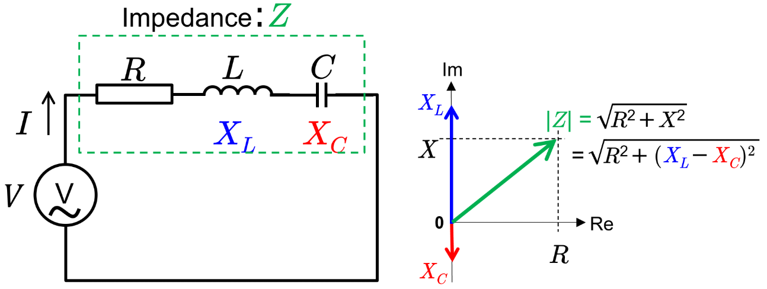

$$V=Z_{eq}I$$

$$V=\left(Z_{R}+Z_{L}+Z_{C}\right)I$$

$$V=\left(R+jωL+\frac{1}{jωC}\right)I=\left(R+jωL-j\frac{1}{ωC}\right)I$$

**AC Circuit Example #2: Parallel RLC**

**AC Circuit Example #3: Series (RL) and Parallel (RC)**

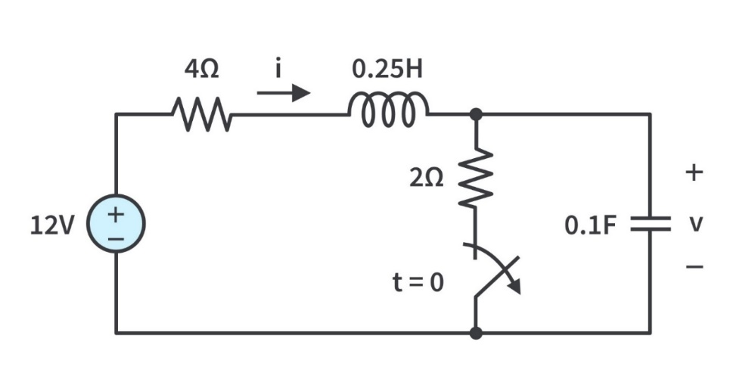

1. Determine the impedance from series and parallel components using complex notation.
$$Z_{eq}=\left(Z_{R1}+Z_{L}\right)+\left(\frac{1}{\frac{1}{Z_{R2}}+\frac{1}{Z_{C}}}\right)$$

$$Z_{eq}=\left(R_{1}+jωL\right)+\left(\frac{1}{\frac{1}{R_{2}}+\frac{1}{1/{jωC}}}\right)$$

2. Substitute values.
$$Z_{eq}=\left(4+(0.25)\left({10}^{-3}\right)ωj\right)+\left(\frac{1}{\frac{1}{2}-(0.1)({10}^{-6})ωj}\right)$$

$$Z_{eq}=\left(4+2.5•{10}^{-4}ωj\right)+\left(\frac{1}{0.5-{10}^{-7}ωj}\right)$$

$$Z_{eq}=\left(4+2.5•{10}^{-4}ωj\right)+\left(\frac{0.5}{{0.25+10}^{-14}ω^{2}}+\frac{{10}^{-7}ω}{0.25+{10}^{-14}ω^{2}}j\right)$$

$$Z_{eq}=\left(4+\frac{0.5}{0.25+{10}^{-14}ω^{2}}\right)+\left(2.5•{10}^{-4}ω+\frac{{10}^{-7}ω}{0.25+{10}^{-14}ω^{2}}\right)j$$

3. Convert from complex to polar notation.

$$Z_{eq}=Z_{Re}+Z_{Im}j$$

$$Z_{Re}=\left(4+\frac{0.5}{0.25+{10}^{-14}ω^{2}}\right)$$

$$Z_{Im}=\left(2.5•{10}^{-4}ω+\frac{{10}^{-7}ω}{0.25+{10}^{-14}ω^{2}}\right)$$

$$|Z_{eq}|=\sqrt{Z_{Re}^{2}+Z_{Im}^{2}}$$

$$θ=\tan^{-1}\left( \frac{Z_{Im}}{Z_{Re}}\right)$$

$$Z_{eq}=\left|Z_{eq}\right| ∠ θ$$

**Sources:**

* Electrical Technology (2020 Oct). Resistance, Capacitance & Inductance in Series-Parallel – Equation & Formulas. <https://www.electricaltechnology.org/2020/10/resistance-inductance-capacitance-series-parallel-formulas.html>
* LibreTexts Physics (2024). 9.6: Electrical Energy and Power. <https://phys.libretexts.org/Bookshelves/University_Physics/University_Physics_(OpenStax)/University_Physics_II_-_Thermodynamics_Electricity_and_Magnetism_(OpenStax)/09%3A_Current_and_Resistance/9.06%3A_Electrical_Energy_and_Power>
* Tech Web (2024). Resonant Circuits: Resonant Frequency and Q Factor. <https://techweb.rohm.com/product/power-device/si/18332/>